OTB 12/16

Club Secretary – Greg 9682 7779 President – Peter 9632 9203

Interested in sponsoring a team or advertising in this newsletter? – call one of the above numbers.

STATE CUP FINAL

This Tuesday sees McCredie’s premier League take on Lidcombe Churches in the State Cup final. The match will be played at 7pm at jones park, banks street merrylands.

The state cup is a short format game of 30 minute halves and takes entries from all divisions.

The mccredie boys have won 4 games to progress this far and are yet to concede a goal.

This will be our second state cup final, but our first since 2002, and we are yet to win one. Can we secure our first silverware for 2016?

Come down and show your support!

Calendar of Events

Coaches & Managers Meeting
Thursday June 2nd 7.30pm – Church Hall 486 Guildford Rd
Six a side tournament –
June Long weekend. GMUSC will endeavour to enter as many sides as possible so please keep these dates available
U6 – 12 Saturday 11th June
U13 – U18, AAM, O35, AAL Monday 13th June
Zone rep trials –
GMUSC is part of the southern zone and will compete in matches on Thursday nights in July against the northern zone.
U8, 9, 10, 11, 12 - Thursday 16th June
U8 Phillips Park 1 6.00pm
U9 Phillips Park 2 6.00pm
U10 Phillips Park 1 7.00pm
U11 Phillips Park 2 7.00pm
U12 Phillips Park 1 8.00pm
Club photos –
Information to follow soon

18th June 6 Black, 8 White, 11 Black, 11 Red, 12, 13 Black, 16, PL

25th June 6 White, 6 Red, 7, 8 Red, 9, 10 White, 13 White, 14, 15, 18

2nd July Challenge Cup (AAM)

AAL - TBA
National Titles trial dates –
The National Titles trials are for the NSW City side to compete in October against the other states and New Zealand. The tournament is a week long in the second week of the school holidays and will be held at Narrabeen.
National Titles Trial dates are as follows:
To be held at Jones Park, Banks St, Merrylands West
Under 14 Boys – 16th and 20th June, 5.30pm
Under 16 Boys – 21st and 27th June, 7pm
Under 18 Boys – 21st and 27th June, 7pm
Under 23 Men’s – 20th and 30th June, 7.30pm
Senior Men’s – 20th and 30th June, 7.30pm
To be held at Freame Park, Rees St, Mays Hill
Under 16 Girls – 15th and 23rd June, 5.30pm
Senior Ladies – 15th and 23rd June, 7.30pm
Nominations due by 29th May 2016

Lap a thon fundraising update

If you have not returned your lapathon sponsorship yet, please do so this week.

At this time we have raised $3203.10. Well done all.
____________________________________________________________________________________________

These envelopes will be given out by your team manager this week as we get ready for photo day!

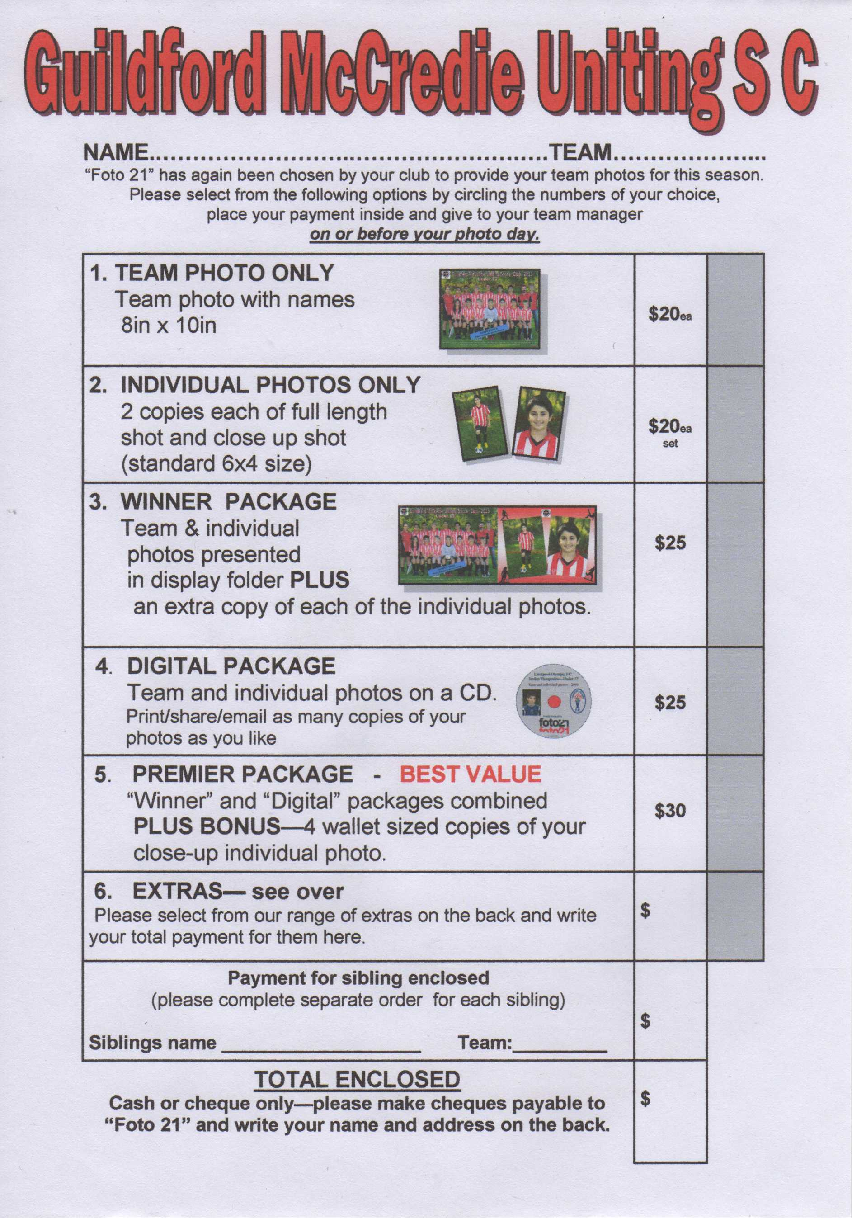

If you liked the music at the lapathon then why not let David Le Pow Newey aka DISCO DAVE host your next party.

RESULTS – 28th & 29th May 2016

U6 Red vs OLQP Falcons Yellow 7 - 0
What an impressive win, 7-0, with only 5 players, and playing in the rain. Great dribbling & attack by all the players, with great improvement from Jerone, getting into the action, and dribbling through defenders. Abatar, had an especially good game, not just with his usual strong kick and fast running, but also dribbling well, facing the goal in attack so that his dribbling & shooting were more on target, and making some great passes to his teammates. Lual & Roham scored 5 goals between them, and Izaac had a strong game in both offensive and defensive. Man of the Match: Abatar. Coach’s Award: Jerone. Goalscorers: Lual Deng 3, Abatar Gurung 2, Roham Taghianpour 2

U6 White vs Bye

U6 Black vs OLQP Falcons Red

U7 vs OLQP Falcons Yellow 5 - 2
The weather was miserable but we pushed hard with 5 determined players and showed that we were the stronger team on the field. Some powerful passing from Nour and Noah led to some wonderful shots taken by Abbas and Malik. Alex’s goal keeping kept them out other than two well-placed shots by their star player. Everyone ran hard and didn’t give up despite the weather and no subs. Alex earned his player of the match status by playing some powerful defence. Everyone played well!
Goal Scorers – Abbas Alkaabi 3, Malik Daniels 2
U8 Red vs Hills Spirit White 1 - 1
This was a tough game. The opposition were strong, but we played well & kept up. We had a few missed opportunities, and Jessie made some fantastic saves, so the score could have been different either way. In the end, the draw was a reasonable result. Well done team for working hard all game. Player of the match: Jessie. Coach's award: Zakariyah.
Goal scorer – Adhar Yaac 1

U8 White vs OLQP Falcons Blue 0 - 5
It was raining, it was an early start, it wasn't the way we wanted to play. They played well and we didn't. Unfortunately our quality of play is just not there at the moment. It's a tough job to coach through this, and the kids probably feel the challenge too. It will be a tough season for the team but chin up, we will keep fighting through this, have fun and get some good wins along the way. (-:

U9 vs OLQP Falcons Green 0 - 0
It was wet and very cold out there today. We were short a player, so, the kids were on to go the whole time. Malachi and Thomas were like fishermen, netting and scooping up the ball. Lucy and Hamza were tackling and blocking well. Ali E was a chameleon, he was all over the place, playing whatever was required. Fayez and Rhia were spear heading the attacks and gave the olqp goalie a good scare. Simon had energy to spare in the second half, tackling and chasing the balls down.
The kids amazed me today with their tenacity, skill, enthusiasm and determination. They gave 100% effort all through the game. The whole team deserve a good pat on the back. Job well done.
U10 White vs Bye

U11 Black vs Lidcombe Churches 1 - 0
A good 1-0 win in the cold rain, everyone put in a good effort with only 10 players. Winning goal from Ali F.
Player of the match, Christelle.
Goal scorers – Ali Fatlawi 1

U11 Red vs OLQP Falcons Blue 8 - 0
Here we are full team under the rain in the cold getting ready for the game. Our opponent wanted to forfeit because they were short in players. But we had an agreement to play with 7 players too and have a fair game. It's a beautiful feeling when you take a challenge upon your team and you're fully trusting that they won't let you down. And as the score show, 8 goals from 5 different players is the right way to do it.
Goal scorers – Mohammed Matar 3, Makuac Kuol 2, Matthew Youssef 1, Mustafa Elbizri 1, Baris Ozkartal 1

U12 vs OLQP Falcons Red 1 – 3
On a morning that started with messages advising that players were unavailable due to the weather conditions it didn’t look promising. Never mind though, we still had eleven players turn up and put a show. The team was facing OLQP Red who is sitting second on the ladder. The team today played a very good game in which we were able to create many chances to be able to score goals, but we only managed to net one ball, though the opposing goal keepers definitely got some saving practise in during the game. OLQP took the lead but the team was able to hit back with a great goal from Abdul. The team kept pace with the opposition and the game could have been won by either side. OLQP got two more goals in the first half, although the second was from an off side position. In the second half the game was scoreless as the team held their defence firm. Rody, Fayez and Abdul played well creating chances up front and young Yunus, playing on the right wing, ran well with the ball. It was good to also see Gregory run the ball and take on the opposition, something that has been missing from his game of late. Khan, playing on the other wing, played probably the best game that I have seen him play and earning him player of the match. Khan seemed to get involved in a lot of the play and being at the right place at the right time. Defensively our backs made up of Adam, Izabella, Yusuf and a new Player to the team named Paul had good games. Adam as usual scrambled in defence and stopped many attacking movements as well as helping Izabella and Paul defend their side of the field. Yusuf playing in the centre back position is improving in every game and seems to be reading the game a lot better. Christopher the keeper as usual played well and made some wonderful saves.
Goal scorer: Abdul Agha 1

U13 Black vs Granville Waratah 1 – 1
Training poorly will not win you a premiership. Overconfidence and narcissism will not win you a premiership. Complacency and underestimation of the opposition will not win you a premiership. This is a big wake up call as this was only Granville's 7th point all year. Not a good start to the second round. See you at training on Wednesday half an hour earlier than usual (5:30-7pm)
Goal scorer - Ibrahim Koroma 1

U13 White vs Bye

U14 vs Wentworthville Uniting 5 - 0
Strong games from Charlene, Qais, Mahmoud and Abdul today. Atilla scored a goal on debut and we had 3 subs – what’s not to like?
Goal scorers –Qais Sungkar 2, Mahmoud Jalloh 1, Joe Azzi 1, Atilla Yalcinkaya 1 .

U15 vs Pendle Hill Black 3 - 2
We got the win 3-2. We need to pass the ball around more and more goals will come. Man of the match Fred Bou Francis.
Goal scorers – Ahmad Saad Ekdawy 2, Jakob Kaihea 1

U16 vs Rydalmere FC 2 - 2
Wow! Every week we improve and this week we were phenomenal. Rydalmere did not know what hit them. And it started before the kick off with 13 players getting there early. Despite the cold and wet conditions we were pumped and played like we wanted to win. The momentum was with us early and then we capitalised on that when Beshoye scored a great goal after some great lead up work by Salem, Serge and Thomas. And then the unbelievable happened – Salem scored a left foot screamer that no-one could have stopped. And we go to half time 2-0 up! But there was still 35 minutes of football to go and we came out a little too relaxed and allowed Rydalmere to score 2 soft goals to equal. Never mind, the improvement is remarkable and we are now a very competitive 2nd Division team. Player of the game today was Aiden who never stops running or encouraging everyone!
Goalscorers: Beshoye Angoang 1, Salem Boustany 1

U18 vs Merrylands SFC Black 1 – 3
No report Goal scorer – Bashar Wannous 1

Challenge Cup vs Zimwarriors 1 – 2
Zimwarriors fielded a full and strong team today, so it was a tough game, but we did really well. We played hard, had good possession, and had some good advanced on goal. A few shots were unlucky misses. Their attack was not particularly strong, but they managed a lucky shot for one goal, and got us on a weak moment for another. They had a penalty shot, but Luke made an amazing save, (which makes the second week in a row)! In the end, Zim's pace & fitness meant that we just didn't manage to get ahead. But head up, fellas, we played well, and there's room to improve as we develop our teamwork & combinations. Goalscorer – Ridwan Rahmatullah 1

All Age Ladies vs Wenty Waratah 0 – 1
We did enough to win the game but a momentary lapse at the back and none of the half chances taken at the front and we lose our first game. In the second half we strung some passes together and maintained possession allowing us to pressure our opponents. My player of the match was Funda who worked hard all game. Monique again played well and Rana played some nice crosses and hit her corners really well.

Premier Reserves vs Chester Hill Sports 4 – 4
After a good first half where we were ahead 2 – 1 but we lost our discipline in the second half. We got a 4 – 1 lead early in second half and then decided to have fun and push forward. They scored a second and we still felt we had enough of a buffer to muck around. When they scored 2 quick goals with less than 10 minutes to go we finally realised what we put in jeopardy. We tried to regain our lead but an injury to their keeper helped them claim a point. The old saying of losing sight of the bigger picture. We went into this game seeking to address some issues and for the most part we did this in the first half. But as a unit we need to realise that we threw it away in the second half by focusing on the individual instead of what is best for the team. We have serious discipline and/or focus issues. We can defeat any opponent in our competition if we are focused and disciplined. Unfortunately, we have proven again with this result that until we as a squad address this issue we will be our own worst enemy.
Goal scorers – Francis Hoang 1, Mohamed Rahimi 1, Philip Rafter 1, An Dao 1

Premier League vs Chester Hill Sports 3 – 0 (before Chester Hill forfeited)
Goal scorer – Amarvir Batth 3

State Cup result 26th May

Premier League vs Wentworthville Uniting Gold 3 – 0
We did what was required without ever having to step out of second gear.
Goal scorer – Mohammed Shukur 3
Saturday 4th June 2016

U6 Red vs Wenworthville Uniting match cancelled

U6 White vs OLQP Falcons Red match cancelled

U6 Black vs St Columbas Castle Hill match cancelled

U7 vs Bye match cancelled

U8 Red vs Wentworthville Uniting Gold match cancelled

U8 White vs Wentworthville Uniting Blue match cancelled

U9 vs Wentworthville Uniting Gold match cancelled

U10 White vs Wentworthville Uniting Gold match cancelled

U11 Red vs Hills Spirit White match cancelled

U11 Black vs bye cancelled

U12 vs OLQP Falcons Blue match cancelled

U13 Black vs Guildford County at Everley 1 (Everley Rd., South Granville)
8.30am Kickoff (meet at Everley at 7.45am) (set up field)

U13 White vs Regents Park matched postponed due to ground closure by Auburn Council

U14 vs Regents Park at Everley 1 (Everley Rd., South Granville)
9.45am Kickoff (meet at Everley at 9.00am)

U15 vs Winston Hills at Everley 1 (Everley Rd., South Granville)
11.00am Kickoff (meet at Everley at 10.30am)

U16 vs Greystanes matched postponed due to ground closure by Auburn Council

U18 vs Auburn District matched postponed due to ground closure by Auburn Council

Challenge Cup vs Parramatta Salvation Army match cancelled

Premier League vs St Matthews Baulkham Hills match cancelled

Sunday 5th June 2016

All Age Ladies vs Winston Hills at Everley 1 (Everley Rd., South Granville)
3.00pm Kickoff (meet at Everley at 1.45pm)

Tuesday 31st May 2016

State Cup Final

Premier League vs Lidcombe Churches at Jones Park 1 (Banks St., Merrylands)
7.00pm kick off (meet at Jones at 6.30pm) (set up field)

