OTB 15/16

Club Secretary – Greg 9682 7779 President – Peter 9632 9203

Interested in sponsoring a team or advertising in this newsletter? – call one of the above numbers.

Calendar of Events

Club photos –
Information to follow soon

25th June 6 White, 6 Red, 7, 8 Red, 9, 10 White, 13 White, 14, 15, 18

2nd July Challenge Cup (AAM)

AAL - TBA
National Titles trial dates –
The National Titles trials are for the NSW City side to compete in October against the other states and New Zealand. The tournament is a week long in the first week of the school holidays and will be held at Narrabeen.
National Titles Trial dates are as follows:
To be held at Jones Park, Banks St, Merrylands West
Under 14 Boys – 20th June, 5.30pm
Under 16 Boys – 21st and 27th June, 7pm
Under 18 Boys – 21st and 27th June, 7pm
Under 23 Men’s – 20th and 30th June, 7.30pm
Senior Men’s – 20th and 30th June, 7.30pm
To be held at Freame Park, Rees St, Mays Hill
Under 16 Girls – 23rd June, 5.30pm
Senior Ladies – 23rd June, 7.30pm

Kings Sevens –
U13, 14, 16 & 18 - Sunday 24th July 2016
Meet at The Kings School at 8.00am
(Pennant Hills Rd., North Parramatta)

_________________________________________________________________________________

National Titles trials continue this week

Don’t forget to pay your manager for your team photos if you would like to purchase one.

PHOTOS CONTINUE THIS WEEK – make sure you are on time – don’t let your team down!
____________________________________________________________________________________________

These envelopes have been given out by your team manager. Please pay your team manager if you would like to purchase a photo
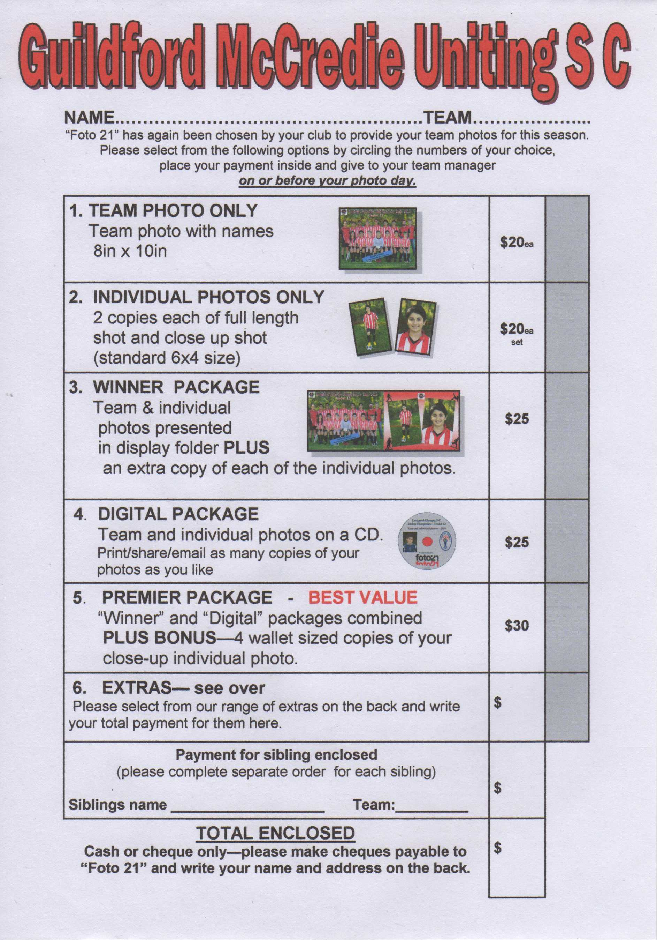

COMPETITION RESULTS – 18th & 19th June 2016

U6 Red vs Kings Old Boys 9 – 0
Man of the match: Jerone. Coach's award: Abatar.
Goal scorers: Jerone Johnson 3, Roham Taghianpour 2, Abatar Gurung 2, Izaac Chung 1, Lual Deng 1

U6 White vs St Columbas Castle Hill 9 – 1
Our goals were equally distributed between Daniel, Alex and Simon with Alex taking home the trophy. Great work by George Esber with his fantastic defending skills! Zen and Josh also did a great job at defending and tackling. Daniels passing this week was very impressive as it helped set up well earnt goals.
Goal scorers – Daniel Alouche 3, Alex Azar 3, Simon Taouk 3

U6 Black vs Wentworthville Uniting Wenty forfeited

U7 vs Wentworthville Uniting Gold McCredie forfeit
Unfortunately today counts as a forfeit as we only had 3 Players Malik, Nour and Charbel. We would like to thank Wentys under 7s who despite the weather had all TEN PLAYERS ARRIVE and were kind enough to lend us 3 so we could have a friendly match.
U8 Red vs Hills Spirit Blue

U8 White vs Hills Spirit Red 7 - 0
Great effort from most of the parents who turned up to today's photos at 8am. The early morning rain was going to be a real test for us parents, but well done to the 9 kids who turned up (Abbas, Badih, Dut, Lochlan, Kayley, Mark, Ryan, Samuel and Timmy). It was always going to be a tough game with the early morning cold and rain, but it was a game that we were hoping to win and although it took us a little time to get going, our kids did their job well. Dut broke through after about 10 mins of play and then Lochlan was able to hit the back of the net, being in the right place at the right time with a good strong kick. The goals then became more free flowing with Dut on fire today, although he still needs to learn how to pass the ball more often and at the right time. Ryan scored a goal mid way through the second half after a good pass from Dut. Samuel had his usual chances at goal, but is struggling to finish the job, can't wait for that to start changing and I expect more good quality goals from him as we head towards the back half of the season. Well done to the kids today!
Goal scorers: Dut Atak 5, Lochlan Duncan 1, Ryan Lu 1

U9 vs Bye

U10 White vs McCredie Black 0 – 4
The team tried hard today but not their best which cost them a loss. They had many opportunities to score but our opponents managed to stop it. The team is more comfortable in their playing positions now and with more practice they will be unstoppable. Better luck next time.

U11 Black vs McCredie White 4 - 0
The kids were disappointed with the loss in the final of the six-a-side tournament and they showed what they can do in today's game. A 4-0 win against our toughest opponent in the division, everyone played to the best of their ability and put in a huge effort with no substitutes.
Goal scorers – Duan Majok 2, Ali Fatlawi 1, Jad Kabout 1

U11 Red vs Hills Spirit Red 2 - 0
Goal scorers – Makuac Kuol 1, Matthew Youssef 1
U12 vs Kings Old Boys 1 - 0
Today the team turned up, all looking spick and span ready for their team photo on a winter’s day which promised to send down the rain as you dared look up into the sky. But we dared look up into the sky and the weather held off and a wonderful winters day prevailed for the team to play a game in which provided the first win for the year. After the photos were taken and while the team warmed up, one of the parents made a comment, “I have a feeling their going to win today”, a comment which I held in firm belief that today would be our day, and it was! With all players available and the reserve bench full, the team was hopeful of reversing the 6 goal loss from their last encounter against Kings Old Boys and today the team did just that, with a one goal to nil win. The team today dominated over Kings Old Boys throughout. All facets of the game were on display today. The running of the ball, the attacking, the defending, the accurate passing and playing as a team. What a wonderful game it was to watch today, but it was also frustrating to watch as the team squandered at least 7 goal scoring opportunities. The game was won in the midfield as the player of the match, Jye, controlled the midfield, shutting down the opposition and creating havoc with his runs through the centre of the field and setting up the forwards with gifted opportunities to put the ball in the back of the net. Every player played well today, which proves that the team is capable of winning and playing well. The team now has no excuses for not playing to this standard for the remainder of the season.
Goal scorer: Fayez Kabout 1

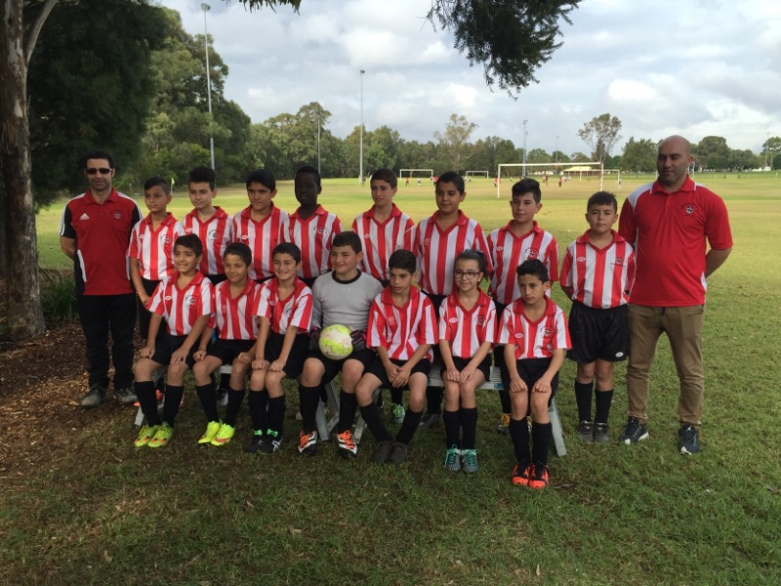

U13 Black vs Wenty Waratah 9 - 1
Another strong performance today from the boys. We passed really well, didn't panic and kept possession. Could've been more goals especially since we were 6-1 up at halftime but I am happy with the result. Man of the match - Abdul; he always picked the right option, who to pass to and when to pass or shoot and was everywhere in attack.
Goal scorers - Krish Shrestha 3, Abdul Farhan 2, Elias Matta 1, Ibrahim Koroma 1, Geetansh Kaushal 1, own goal 1
U13 White vs Toongabbie Black 1 - 7
We played the equal competition leaders today and took to the field with only 10 players, which thankfully increased to 11, midway through first half. Toongabbie knew they were in a game today. We played out of our skins in the first half, and even when we went behind we kept pressing hard. Eventually we got a penalty in the box, which Garang Angui calmly kicked into the back of the net. This meant we went into halftime equal 1 – 1. Unfortunately, the second half did not play out the same way. Toongabbie got on a roll, and no matter how hard we tried we just could not get back into the game. We kept trying until the end but to no avail. We may have lost today, but there was no dishonour in the football played or the effort shown.
Our player of the match was Garang Yai. Goal Scorer: Garang Angui 1

U13 White catchup vs Regents Park 0 – 7
A wet old Sunday to play the equal competition leaders. Again we took to the field with only 10 players. All the players who showed up demonstrated true team spirit and tried their best, but Regents Park was just too strong. We did create a few chances in the second half, when we hit the posts & cross bar but just couldn’t get the ball between the posts.
Just like on Saturday, we lost to a better team, but we played the best we could, putting in a strong effort against the odds.
Our player of the match was Ruben Yu.

U14 vs Rouse Hill Rams 6 - 1
Last round we drew 2-2 with Rouse Hill but today was a different story. It started with us conceding a penalty in the first minute, but before two minutes were over, Aakrist our super fill-in from the 13s, had saved it. Aakrist played brilliantly all match and was a unanimous player of the match. But Nedim was pretty good too, as was Jayden. Overall a satisfying result.
Goal scorers – Jayden Daily 2, Mahmoud Jalloh 2, Joe Azzi 1, own goal 1

U15 vs Guildford County 3 – 2
Playing with only 9 players today it was going to be a hard game. We started strong with Jakob scoring a nice goal. The team was playing great soccer and we were holding them out, but they got a goal back. Went into the half 1-1. At half time I told the team to work as a team and we will come home with some points. 5 min into the second half County scored their second goal but McCredie did not drop their heads. We lifted as a team. With 20 min to go we got an injury to young Chloe who had been playing a great game. My boys lifted to another gear and Jakob got his second. A few minutes later Jakob got his hat-trick and we went up 3-2. With 10 min to go the boys defended our goal and came come away with one of the best wins this year. I’m a very proud coach. Man of the match - Jakob Get better soon Chloe.
Goal scorer – Jakob Kaihea 3

U16 vs Ermington 0 - 9
Once again we ran onto the field with only 10 players. And those super 10 covered themselves in glory with their effort against a much stronger side. Joel was amazing in defence, he was the most motivated man on the field and played for 2 men. He was involved in the biggest collision of the year, and was the gutsiest on the field. While Beshoye was just as good and as motivated in attack first half and defence second half. He regularly ran from one end of the field to the other and was responsible for some great covering defence that kept Ermington pretty quiet in the second half. The impressive thing to come out of the game was that we didn’t drop our heads and give up. Serge and Tai in particular fought hard all game. But it was a great all round effort against the top team.

U18 vs Lidcombe Waratah 4 – 2
Goal scorers – Bashar Wannous 3, Anthony Gwee 1

Challenge Cup vs Living Grace Lions 1 - 4
Goal scorers – Zeeshan Mirza 1

Premier Reserves vs Lidcombe Churches 8 – 0
Goal scorers - Adem Stevens 2, Virinder Chaggar 2, Francis Hoang 1, Gerard McKeown 1, James Rosandi 1, Paul Zacharia 1

Premier League vs Lidcombe Churches 7 - 1
Goal scorers - Mohammed Shukur 3, Jay Mazraeh 2, William Wark 1, Adem Stevens 1

All Age Ladies vs Pendle Hill washed out
Saturday 25th June 2016

U6 Red vs McCredie Black at Everley mini (Everley Rd., South Granville)
9.00am Kickoff (meet at Everley at 8.15am FOR TEAM PHOTO)

U6 White vs Wentworthville Uniting at Freame mini (Rees St, Mays Hill)
9.00am Kickoff (meet at Everley at 8.00am FOR PHOTO)

U6 Black vs McCredie Red at Everley mini (Everley Rd., South Granville)
9.00am Kickoff (meet at Everley at 8.30am) (set up field)

U7 vs Kings Old Boys at Everley mini (Everley Rd., South Granville)
10.00am Kickoff (meet at Everley at 9.00am FOR TEAM PHOTO) (dismantle field)

U8 Red vs St Columbas Castle Hill at Everley mini (Everley Rd., South Granville)
10.00am Kickoff (meet at Everley at 9.30am FOR TEAM PHOTO) (set up field at 9.00am)

U8 White vs Lidcombe Churches at Phillips 1 (Martin St., Lidcombe)
10.00am Kickoff (meet at Phillips at 9.30am)

U9 vs Hills Spirit Red at Everley 2 (Everley Rd., South Granville)
11.00am Kickoff (meet at Everley at 10.00am FOR TEAM PHOTO)

U10 White vs Lidcombe Churches at Everley 1 (Everley Rd., South Granville)
12.00pm Kickoff (meet at Everley at 11.30am) (set up field)

U11 Red vs Lidcombe Churches at Phillips 1 (Martin St., Lidcombe)
11.00am Kickoff (meet at Phillips at 10.30am)

U11 Black vs Hills Spirit at Eric Mobbs 2 (Excelsior Ave., Castle Hill)
11.00am Kickoff (meet at Eric Mobbs at 10.30am)

U12 vs Wentworthville Uniting at Freame (Rees St., Mays Hill)
12.00pm Kickoff (meet at Freame at 11.30am)

U13 Black vs Auburn FC at Webbs 2 (Webbs Ave., Auburn)
11.00am Kickoff (meet at Webbs at 10.15am)

U13 White vs Greystanes at Everley 1 (Everley Rd., South Granville)
8.30am Kickoff (meet at Everley at 8.00am FOR TEAM PHOTO) (set up field at 7.30am)

U14 vs Winston Hills Bears at Everley 1 (Everley Rd., South Granville)
9.45am Kickoff (meet at Everley at 9.00am FOR TEAM PHOTO)

U15 vs Pendle Hill White at Everley 1 (Everley Rd., South Granville)
11.00am Kickoff (meet at Everley at 10.00am FOR TEAM PHOTO)

U16 vs Pendle Hill White at Binalong 4 (Binalong Rd., Old Toongabbie)
11.00am Kickoff (meet at Binalong at 10.30am)

U18 vs Merrylands SFC White at Everley 2 (Everley Rd., South Granville)
12.30am Kickoff (meet at Everley at 11.30am FOR TEAM PHOTO)

Challenge Cup vs Hills Spirit at Everley 1 (Everley Rd., South Granville)
Kick off at 1.15pm (Meet at Everley at 12.45pm) (dismantle field)

Premier League vs Wentworthville Uniting at Freame (Rees St., Mays Hill)
(Reserves Kick off at 1.15pm Firsts at 3.15pm) (Meet at Everley at 12.45pm)

Sunday 26th June 2016

All Age Ladies vs Kellyville Kolts at Girraween 1 (Octavia Rd., Girraweeen)
1.00pm Kickoff (meet at Girraween at 12.15pm)

