OTB 19/16

Club Secretary – Greg 9682 7779 President – Peter 9632 9203

Interested in sponsoring a team or advertising in this newsletter? – call one of the above numbers.

THIS WEEK IS THE FINAL COMPETITION ROUND FOR JUNIOR TEAMS

Please make sure that all jerseys are collected by the manager following your last game and returned to Greg within 7 days.

Calendar of Events

Grand finals –

Saturday 27th August

NSWCFA Grandfinals
2016 Grandfinal to be held at Marconi Stadium, ‎Marconi Rd, Bossley Park

Saturday 3rd September

GDSFA Grandfinals

Sunday 4th September

AAL’s grandfinal @ Melita Stadium

National Titles –

The 2016 National Titles will be held at Sydney Academy of Sport & Recreation at Narrabeen from 25th September until 29TH September 2016.

Annual Presentation Evening –

Friday 11th November 2016

Holroyd UC Hall (486 Guildford Rd., Guildford 6.30pm



With last week’s rain, Guildford McCredie’s Premier League team was confirmed as minor premiers. This is a first for our club and a great achievement.
After winning the State Cup and the six a side – there is just one trophy left!

We wish all the guys all the very best of luck in the upcoming semi final series.



No games on the weekend due to the terrible Sydney weather soaking all the fields.

On the 24th though some of our teams competed in the Kings Sevens – the 14s winning it.

Here are a couple of pics from the day

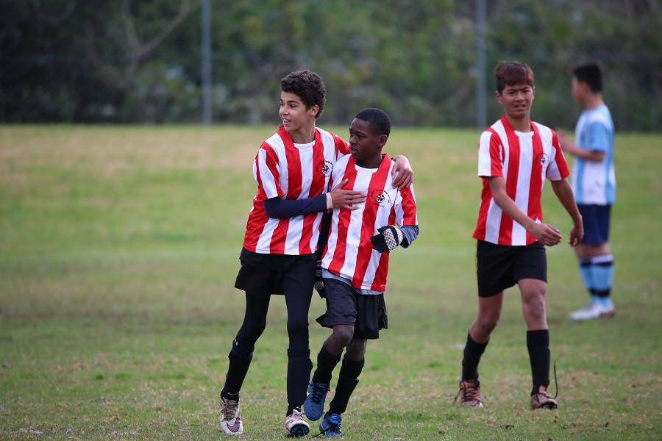

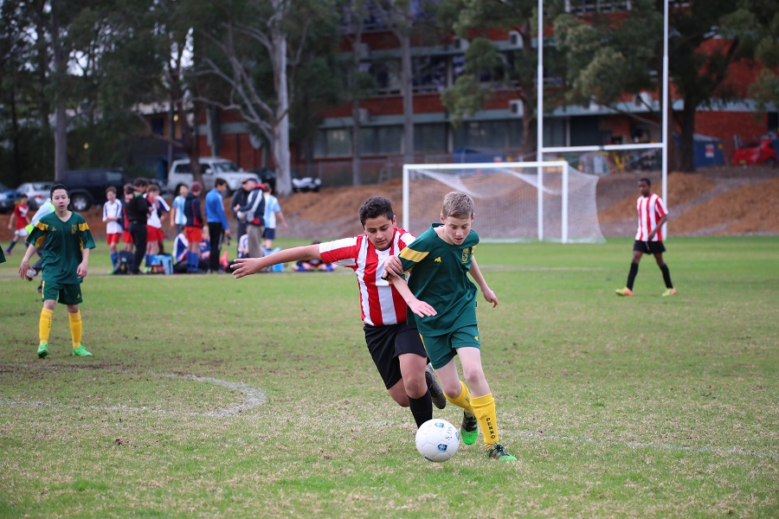
Saturday 13th August 2016

U6 Red vs St Columbas Castle Hill at Eric Mobbs 2 (Excelsior Ave., Castle Hill)
9.00am Kickoff (meet at Eric Mobbs at 8.30am)

U6 White vs Hills Spirit Red at Everley mini (Everley Rd., South Granville)
10.00am Kickoff (meet Everley at 9.30am) (set up & dismantle field)

U6 Black vs Bye

U7 vs Lidcombe Churches Gold at Phillips (Martin St., Lidcombe)
9.00am Kickoff (meet at Phillips at 8.30am)

U8 Red vs Hills Spirit at Eric Mobbs 2 (Excelsior Ave., Castle Hill)
10.00am Kickoff (meet at Eric Mobbs at 9.30am)

U8 White vs OLQP Falcons Blue at Everley 2 (Everley Rd., South Granville)
10.00am Kickoff (meet Everley at 9.30am) (set up field field)

U9 vs Wentworthville Uniting Gold at Everley 2 (Everley Rd., South Granville)
11.00am Kickoff (meet at Everley at 10.30am) (dismantle field)

U10 White vs Bye

U11 Red vs OLQP Falcons Blue at Everley 1 (Everley Rd., South Granville)
12.00pm Kickoff (meet at Everley at 11.30am) (dismantle field)

U11 Black vs Lidcombe Churches at Everley 3 (Everley Rd., South Granville)
11.00am Kickoff (meet Everley at 10.30am) (set up field)

U12 vs Wentworthville Uniting at Everley 3 (Everley Rd., South Granville)
12.00pm Kickoff (meet Everley at 11.30am) (dismantle field)

U13 Black vs Wenty Waratah at Ted Burge 1 (Centenary Rd., Sth Wentworthville)
8.30am Kickoff (meet at Ted Burge at 7.45am)

U13 White vs Regents Park at Everley 1 (Everley Rd., South Granville)
8.30am Kickoff (meet at Everley at 8.00am) (set up field)

U14 vs Rouse Hill Rams at Everley 1 (Everley Rd., South Granville)
9.45am Kickoff (meet at Everley at 9.00am)

U15 vs Winston Hills Bears at McCoy (Mimosa Ave., Toongabbie)
10.45am Kickoff (meet at McCoy at 10.15am)

U16 vs Ermington at George Kendall 2 (Trumble St., Ermington)
11.00am Kickoff (meet at Kendall at 10.30am)

U18 vs Lidcombe Waratah at Everley 2 (Everley Rd., South Granville)
12.30pm Kickoff (meet at Everley at 12.00pm) (set up & dismantle field)

Challenge Cup season completed

Premier Reserves Elimination semi vs St Barnabas Broadway at Freame (Rees St., Mays Hill)

1.00pm Kickoff (meet at Freame at 12.15pm)

Premier League Major semi vs St Barnabas Broadway at Freame (Rees St., Mays Hill)
3.00pm Kickoff (meet at Freame at 12.15pm)

Sunday 14th August 2016

All Age Ladies vs Pendle Hill Tigers at Commercial 2 (Commercial Rd., Kellyville)
3.00pm Kickoff (meet at Commercial at 2.15pm)

