OTB 21/16

Club Secretary – Greg 9682 7779 President – Peter 9632 9203

Interested in sponsoring a team or advertising in this newsletter? – call one of the above numbers.

Calendar of Events

Grand finals –

Saturday 27th August

NSWCFA Grandfinals
2016 Grandfinal to be held at Marconi Stadium, ‎Marconi Rd, Bossley Park

Saturday 3rd September

GDSFA Grandfinals

Sunday 4th September

AAL’s grandfinal @ Melita Stadium

National Titles –

The 2016 National Titles will be held at Sydney Academy of Sport & Recreation at Narrabeen from 25th September until 29TH September 2016.

Annual Presentation Evening –

Friday 11th November 2016

Holroyd UC Hall (486 Guildford Rd., Guildford 6.30pm

Results

Saturday 20th August & Sunday 21st August 2016

Thanks to Dorothy for all the action shots!

U8 Red vs St Columbas Castle Hill 1 - 0
Goalscorer: Adhar Yaac 1.

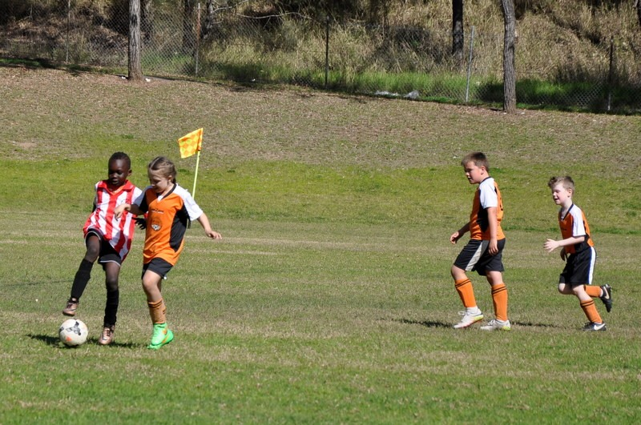

U8 White vs Lidcombe Churches 0 – 2
It was a tough fought game today and the better team on the day won. Well done to our kids for a great season and their achievement in making the semi final. Enjoy the offseason and hopefully we'll see you all again next year.

U10 White vs Wentworthville Uniting 6 - 0
Today’s semi final against Wentworthville got off to a flying start, with Sajjad scoring in the first minute of play. We had a number of chances to increase our lead before half time but squandered a number of chances. Half time 1-0. After a bit of a rev up at half time the boys responded well scoring 5 more goals to nil in the second half, winning 6-0. Well done to all the boys, it was a great achievement to make the grand final. Man of the match: Sajjad Karimi.
Goal scorers : Sajjad Karimi 3, Daniel Kvesic 2, Fouad Ayoub 1

U11 Black vs Hills Spirit 2 – 3
A very tough semi final loss, though the team tried their best we lost 3-2 in golden goal extra time.
We only had 9 players at kickoff, during the game a few more showed up and I truly believe that if we had the full squad from the start we would have won. We had two penalties called against us, one came in extra time, though Hussain put in a big effort to save the penalty the ball ended up spinning and rolled inside the near post. Ali Fahme equalised at 1-1 then Jad scores the dramatic late equaliser at 2-2, with Jean-Pierre assisting on both goals.
Very proud of how far the kids have come from the first trial match.
Goal scorers – Ali Fahme 1, Jad Kabout 1

U11 Red vs Lidcombe Churches 0 – 1

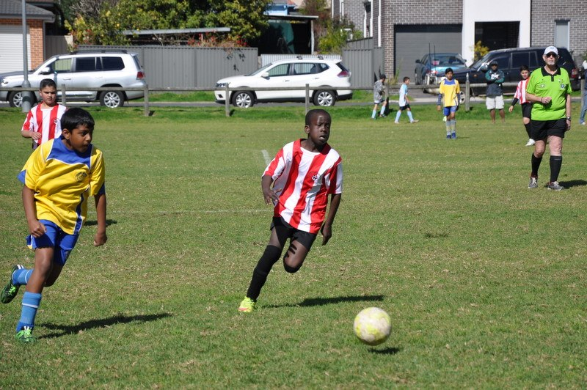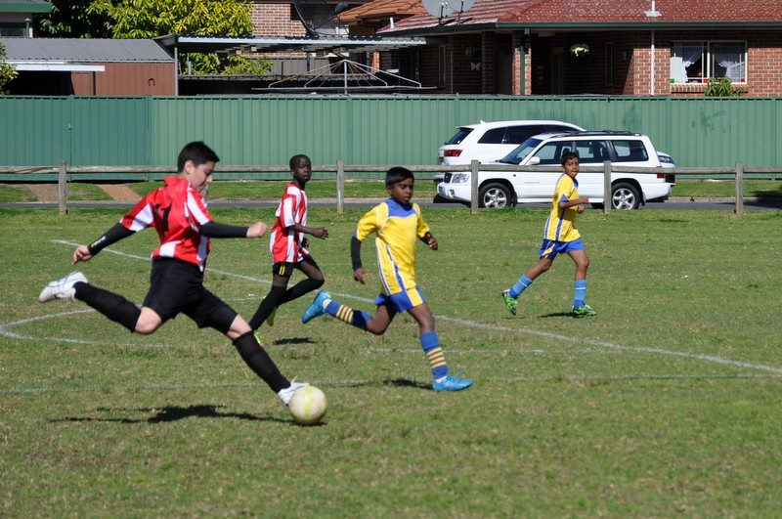

U13 Black vs Auburn FC 3 – 2
At the start of the season, the team had a goal to win 2 games; the major semi final and the grand final. I wasn't sure whether the boys were up for this game after last week's lethargic performance and going down 0-1 after 5 minutes was very disappointing. However we dug deep, showed character and we pulled one back with 10 minutes before the half. I asked the boys at halftime how much they wanted to win and how much they wanted to play in the grand final and they answered with 2 goals in the next 5 minutes and grinded out the win. A fantastic game from all but special mentions to Ibra, Mounir, Deng, Thyson and man of the match - Geetansh. One more game boys, one more and the championship is rightfully ours!
Goal scorers - Mounir Hadid 2, Ibrahim Koroma 1

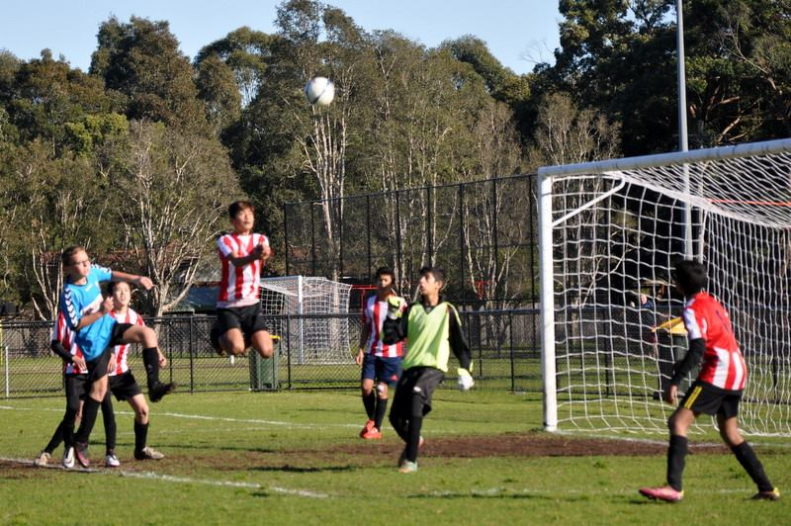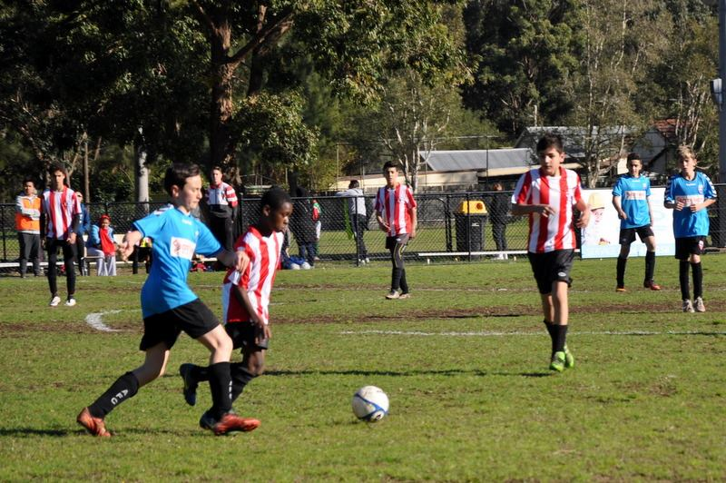

U14 vs Greystanes 10 – 0
Wow, Greystanes never knew what hit them. Unfortunately they didn’t die straight away and did suffer. Our boys were on fire. Every pass connected, every decision was correct and every shot went in. After 5 mins we were 3 -0 up. At half time it was 6. We scored 4 more in the next 15 minutes but as Greystanes got silly and some fouls were committed we backed off and played the sensible game. Every player played really well but these few deserve extra special mention. Nedim was clearly up for the game from the beginning and took control of midfield. Qais kept the first half and when called upon to make the only save of the match, he saved it and ensured Greystanes would get nothing from today. Abdul played some superb balls, Joe finished all opportunities in the first half and Nuno set up goals for others before clinically finishing 3 of his own and taking player of the match. On to next week now guys.
Goal scorers – Joe Azzi 4, Mahmoud Jalloh 3, Nuno Salsinha 3
U18 vs Merrylands SFC Black 0 – 1
I am proud of the way everyone fought until the end. This was a great game to watch. It was an intense game, played at a high level and at times, a furious pace. We never took a backward step, continually probing and breaking the opposition defence, but full credit to Merrylands, they scrambled well and kept us from scoring many times. At the other end, our defence was a little slow at clearing in the first half, but in the second, they hit their straps and Merrylands found it impossible to go around or through. With 15 minutes to go some poor marking allowed Merrylands to head home a goal from a corner. I didn’t have to tell you there was plenty of time left, you have developed into a strong minded, confident team. You knew you were good enough to score with the time remaining. Despite injuries and near exhaustion, every player lifted and gave more, forced the errors, and put ourselves in positions to equalise. But it was not to be. I was gutted, so I can just imagine how you all felt. But you didn’t let anyone down, not our supporters, not me, not yourselves. I spoke to the Auburn and Rouse Hill coaches before the game. Neither wanted you to get through because they are scared to play you. This speaks volumes for the respect that you have earned throughout the year. Stand tall, stand proud. A gutsy team, a great team. Well done on your achievements this year.

Premier Reserves semi vs Wentworthville Uniting 1 – 2
Goal scorer – Virinder Chaggar 1

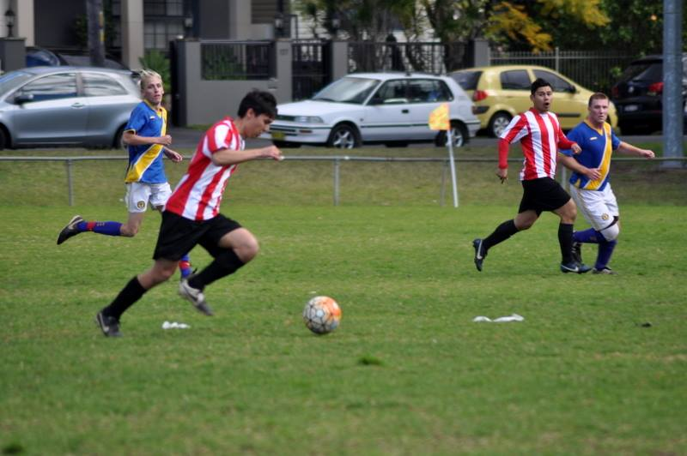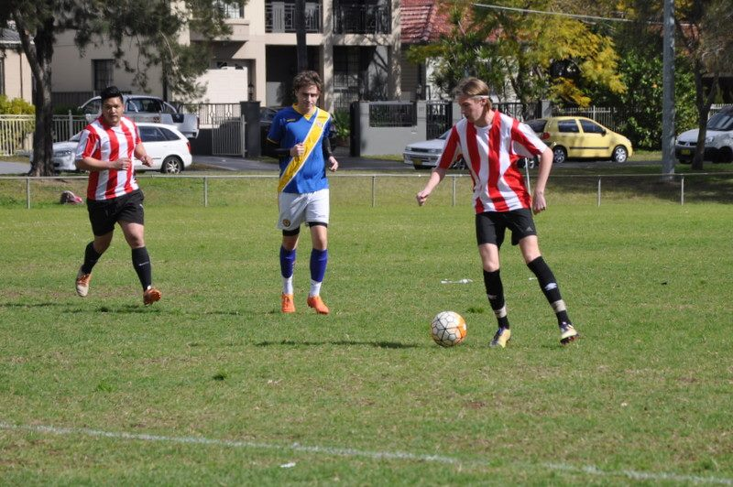

Premier League semi vs Wentworthville Uniting 1 – 2
Goal scorers – Jay Mazraeh 1

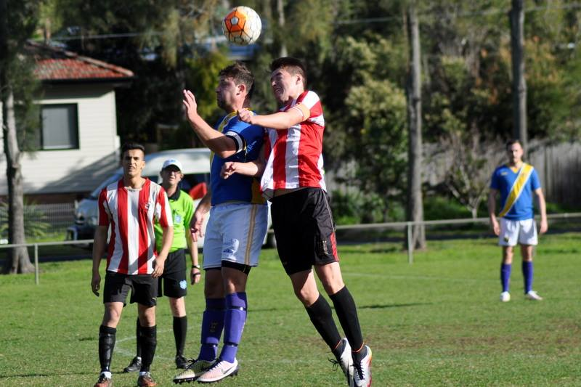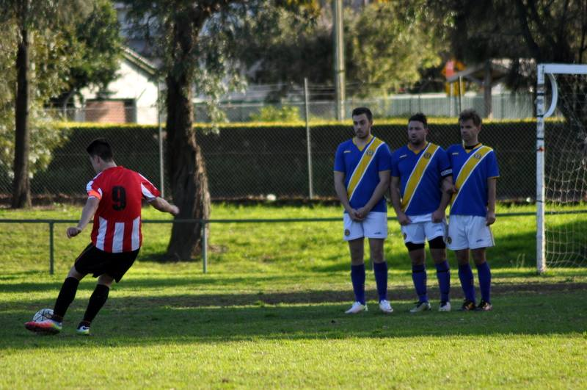

All Age Ladies vs Pendle Hill Tigers 0 - 2
We were matching and even getting on top of Pendle Hill for the first 30 minutes. There were very few attacking raids from either side but what there were, were ours. And then a moment of madness and we are playing the next hour with ten players and without the player that gets the ball more than all others. The girls battled bravely but it was always going to be a tough second half. A win is now required over Kellyville for us to get the opportunity to have another crack at Pendle Hill next week.
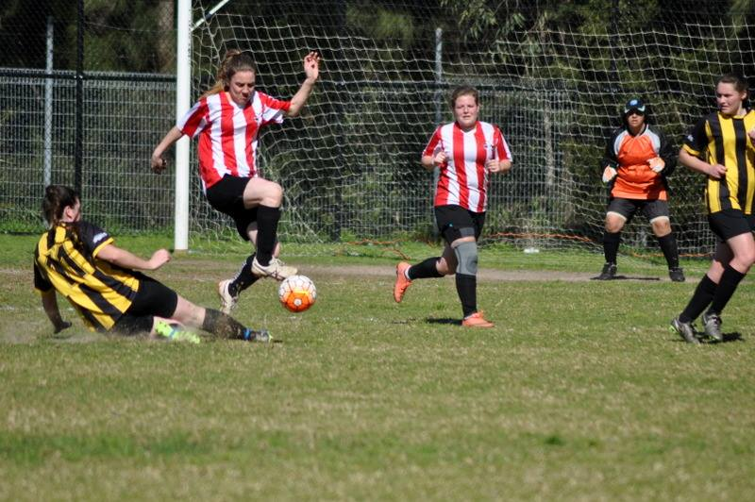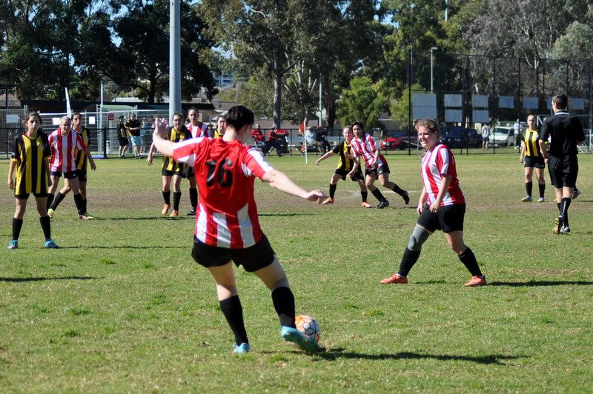
Marconi Stadium – good luck 8s and 10s
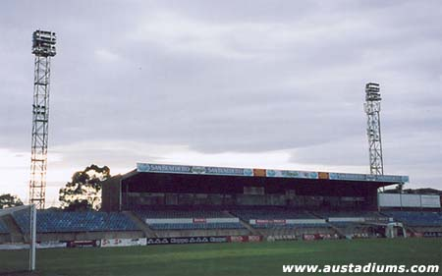

Saturday 27th August 2016

U8 Red Grand Final no game (washed out) – Grand final on Saturday 3rd September

U10 White Grand final no game (washed out) – Grand final on Saturday 3rd September

U13 Black no game – Grand final on Saturday 3rd September

U14 elimination final vs Pendle Hill Tigers at Coleman 1 (Georges Ave., Lidcombe)
10.10am kick off (meet at Coleman at 9.20am)

Sunday 28th August 2016

All Age Ladies elimination final vs Kellyville Kolts at Guildford West Sportsground (Foray St., Guildford West)
12.30pm kick off (meet at Guildford West at 11.45am)

Saturday 3rd September 2016

U8 Red Grand Final vs Hills Spirit at Marconi Stadium (Marconi Rd., Bossley Park)
8.00am Kickoff (meet at Marconi at 7.30am)

U10 White Grand final vs Hills Spirit at Marconi Stadium (Marconi Rd., Bossley Park) 11.00am kick off (meet at Marconi at 10.30am)

U13 Black no game – Grand final on Saturday 3rd September

U14 TBA

