OTB 23/16

Club Secretary – Greg 9682 7779 President – Peter 9632 9203

Interested in sponsoring a team or advertising in this newsletter? – call one of the above numbers.

Grand Final Results

Wednesday 7th September 2016

U8 Red vs Hills Spirit White 0 - 3
Sadly, we didn't win. But the kids played their hearts out and I'm proud of them! Runners Up though; that's still pretty good!

Saturday 9th September 2016

U10 vs Hills Spirit 3 - 0
Goal scorers – Goal scorers: Daniel Kvesic 2, Fouad Ayoub 1
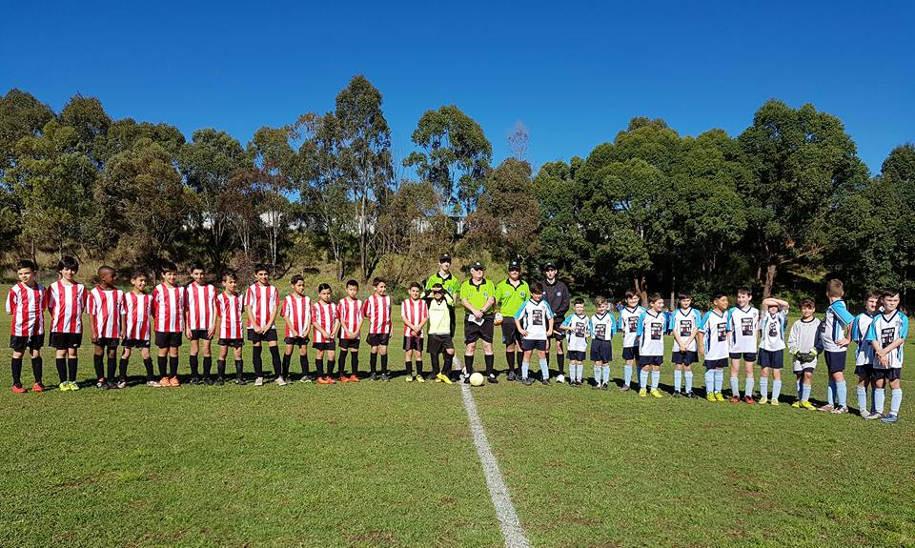

U10 White – our 2016 premiers!

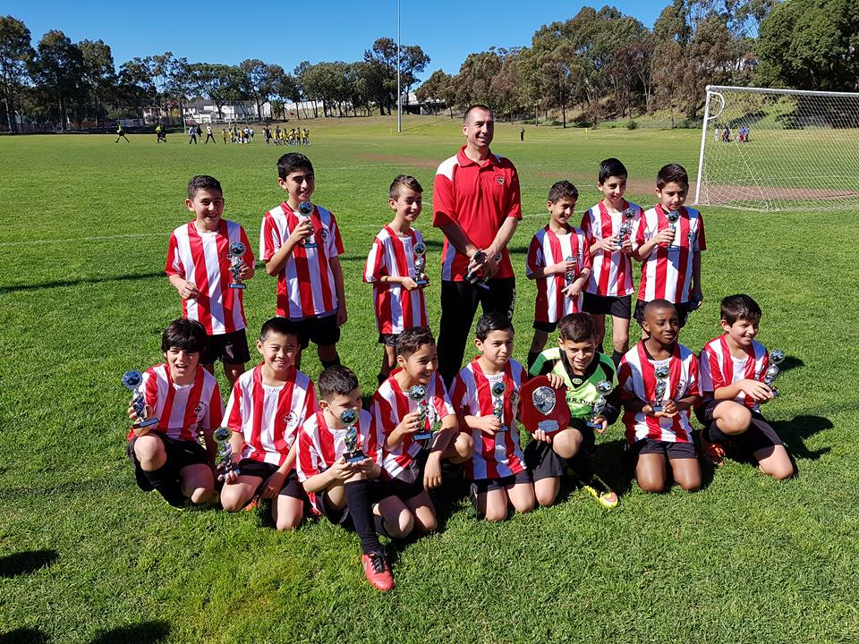

U13 Black vs Auburn FC 1 – 2
Thank you to the enormous crowd today, parents, grandparents, friends, club committee and half the Granville Public School staff! We nearly did it – we will next year!!
Goal scorers – Ryan Booker 1

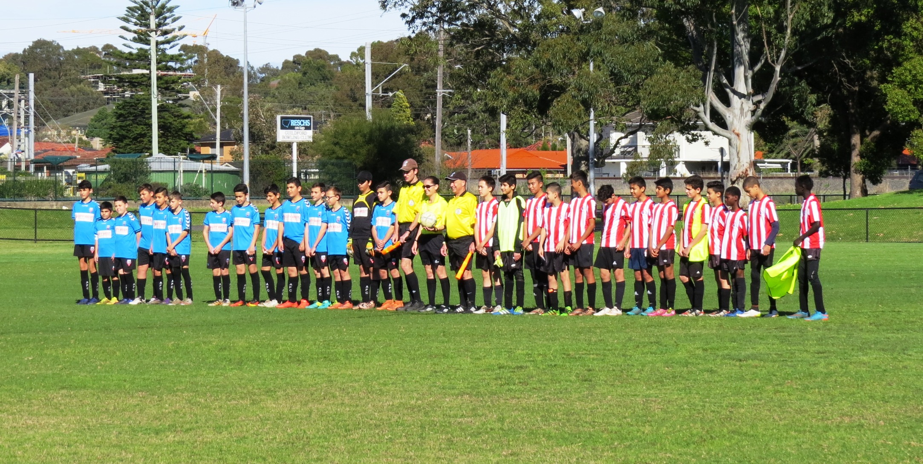

U13 Black – gallant U13/2 runners up.

