OTB 9/16

Club Secretary – Greg 9682 7779 President – Peter 9632 9203

Interested in sponsoring a team or advertising in this newsletter? – call one of the above numbers.

LAP A THON This Wednesday

All teams need to be at Granville Park Wednesday at 5.45

All coaches and managers need to be at Granville Park at 5.30pm

Players will run from 6pm to 7pm

All players will receive lollies and a drink to keep them going

A Barbeque will be going so there is no need to cook dinner on Wednesday!

Coaches and Managers – please ensure your players know to get there at 5.45pm.

It may also be an idea to bring

- a set of bibs, jerseys, inside out/jerseys (to tell your kids from others as they run past in the dark)
- a pen
- a clipboard
- a chair
- 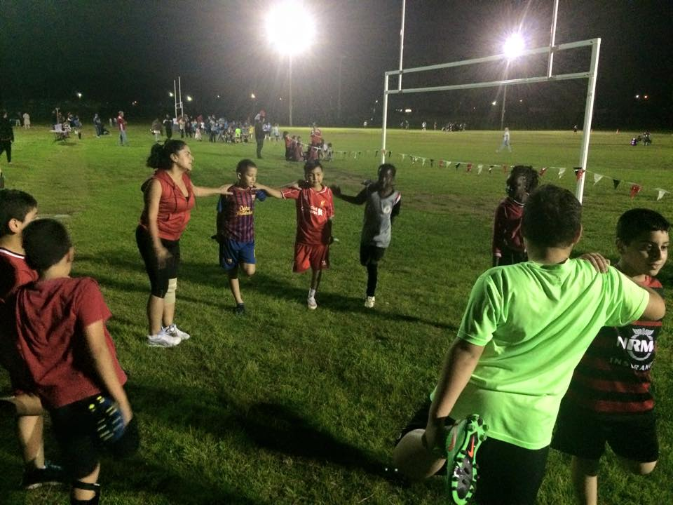 U10s 2015 – stretching prior to lapathon 2015

Calendar of Events

Lapathon –
No junior training on this night, all teams will meet at Granville Park at 5.45. Please get your sponsors organised – see back of newsletter
Wednesday 11th May

Zone rep trials –
GMUSC is part of the southern zone and will compete in matches on Thursday nights in July against the northern zone.
U8, 9, 10, 11, 12 - Thursday 16th June

Club photos –
Information to follow soon

18th June 6 Black, 8 White, 11 Black, 11 Red, 12, 13 Black, 16, PL

25th June 6 White, 6 Red, 7, 8 Red, 9, 10 White, 13 White, 14, 15, 18, CC

AAL - TBA
National Titles trial dates –
The National Titles trials are for the NSW City side to compete in October against the other states and New Zealand. The tournament is a week long in the second week of the school holidays and will be held at Narrabeen.
National Titles Trial dates are as follows:
To be held at Jones Park, Banks St, Merrylands West
Under 14 Boys – 16th and 20th June, 5.30pm
Under 16 Boys – 21st and 27th June, 7pm
Under 18 Boys – 21st and 27th June, 7pm
Under 23 Men’s – 20th and 30th June, 7.30pm
Senior Men’s – 20th and 30th June, 7.30pm
To be held at Freame Park, Rees St, Mays Hill
Under 16 Girls – 15th and 23rd June, 5.30pm
Senior Ladies – 15th and 23rd June, 7.30pm
Nominations due by 29th May 2016

Six a side tournament –
June Long weekend. GMUSC will endeavour to enter as many sides as possible so please keep these dates available
U6 – 12 Saturday 11th June
U13 – U18, AAM, O35, AAL Monday 13th June

RESULTS – Round 7th & 8th May 2016

U6 Red vs OLQP Falcons Red 8 – 1
Another strong win, 8-1. Roham was on fire today, scoring 5 goals through good, strong dribbling and strong, accurate shooting. Lual and Abatar played strong in attack, and Izaac was great at both attacking as a forward, and defending and tackling as a back. Aydin, Leigh Shah and George showed good improvement too, managing to keep up with a fast moving game, by getting to the ball a number of times. Leigh Shah had a shining moment with a strong dribble through defenders in the middle of the field, bringing the ball to another attack. Well done boys!
Man of the Match: Roham Taghianpour; Coach’s Award: Leigh Shah Aflak
Goal scorers: Roham Taghianpour 5, Lual Deng 2, Abatar Gurung 1.

U6 White vs OLQP Falcons Yellow 12 – 0
Great work by the team this week with a 12-0 victory over Falcon Yellows. The boys worked on tackling and passing this week as our less experienced players rose to the occasion. Fabulous effort by Joshua and George Tangi who exceeded all expectations with a massive 7 goals between them. George Esber was no less than impressive with his defensive skills despite a minor injury. Simon and Daniel kept up the striking with Simon scoring twice and Daniel 3 times. Another shout out to our new team member Rayaan who also worked hard. Finally, lots of love to our star player Alex who has fallen sick this week.
Goal scorers – Joshua Jaitani 4, Daniel Alouche 3, George Tangi 3, Simon Taouk 2

U6 Black vs Kings Old Boys 8 - 0
Big effort today with no reserves and to win 8/0 was great. Yusuf was on fire with 3 goal and our player of the match Bentley’s 3 goal in first half got us excited & got our encouragement award. Gethyn had some great runs keep it up buddy, Mobin picked up 1 goal and was close a few more times. Aydin again was getting amongst the action growing with confidence every week, Rushil also got 1 goal and showed his strength in winning the ball, great game blacks was a big effort from you all keep it up.
Goal scorers – Yusuf Hadi 3, Bentley Buenen 3, Rushil Limbu 1, Mobin Kamyabi 1

U7 vs OLQP Falcons 5 - 5
We had a magnificent game today we only had 4 players at kick off and then Malik came 10 mins in despite getting back from a cruise that morning. Noah and Sunday were unstoppable both running all over the field and both scoring 2 goals. George and Fidaa defended like champs and Malik was unstoppable til he became so tired we had to put him in the goals. Player of the match Sunday.
Goal Scorers - Noah Bosanac 2, Sunday Makuedi 2, Malik Daniels 1
U8 Red vs Hills Spirit Blue 10 – 0
It was nice to have a strong 10-0 win this week! We dominated the game, having possession of the ball much of the game, and staying strong in our attack, but it was partly because the opposition was weaker. There is still much room for improvement – players needing to look around, pass better, and play better in position and in teamwork. But our strengths came through clearly: Adhar, Omar, Joey, Patrick and Lachlan playing strong in our attack, especially with 5 goals from Adhar. Wek, Talitha, Lachlan and Joey also played strong in defence, winning balls, tackling well, and running back to defend. Zak and Jessie had great games too, getting into the action, showing great improvements in both tackling, winning balls, and dribbling and passing through to attack. Well done guys. Keep it up.
Player of the Match: Adhar – strong, persistent attack, good, accurate shooting;
Coach’s Award: Omar – good improvements in shooting (including scoring 2 goals), assisting in attack and running into space to create passing and shooting opportunities.
Goalscorers: Adhar Yaac 5; Omar Elbizri 2; Patrick Matta 2; Lachlan Lin 1.

U8 White vs Hills Spirit Red 8 - 0
Great game today by the kids. Ryan and Daniel played goalies and didn't let a goal through. They were supported very well with strong defence from the whole team. What was pleasing to start seeing is the team playing together and helping each other out. We still have lots to improve, but every player is getting better at working together with some excellent passing today and looking out for each other. Good to see the goal scoring being shared across a few different players getting themselves into good scoring positions. Let's keep this up as next week will be a really good test for us.
Goal scorers: Dut Atak 3, Samuel Chamoun 2, Lochlan Duncan 1, Badih Ayoub 1, Ryan Lu 1

U9 vs Wentworthville Uniting Blue 0 - 5
Another gorgeous day to play soccer. The team played well and marked their players. Thomas, Fayez, Isaiah, Benjamin, Dylan and Simon were very determined that no goals would get past them. Ali E, Malichi, and Moustafa broke away a couple of times, but Wenty had the upper hand. The team is steadily improving. They held their own in the first half, but they got tired and dispirited quickly. We still need to work on fitness, passing, and not giving up. Keep it up team.
Player of the match- Fayez Fahme

U10 White vs McCredie Black 4 - 2
It's always a hard game when the two teams are from the same club! But their can only be one winner and u10 proved that today. U10 gave it their best effort and it was a pleasure to watch. Well played.
Goal scorers: Joshua Depares 2, Sajjad Karimi 1, Fouad Ayoub 1

U11 Black vs McCredie White 2 – 4
Another game with only 9 players and against the best opposition yet. Everyone gave a big effort but this week the numbers finally caught up with us, a 4-2 loss. We'll learn from this, a lot of things to work on in training. Sean with a goal and an assist, Jean-Pierre with the other goal.
Goal scorers – Ali Fatlawi 1, Jean Pierre Kortas 1

U11 Red vs Hills Spirit Red 4 - 1
We decided to keep our team at the top of the list and we did it. We have been challenged last week and we proved ourselves as players who know what they’re doing. We controlled the game from the beginning, played well and got what we wanted. Job well done boys and girls.
Goal scorers – Makuac Kuol 3, Mustafa Elbizri 1

U12 vs Hills Spirit 0 - 3
The U12's today played Hills Spirit who are leading the competition. The team held fast throughout the first half defending very well and shutting down the attacking raids from the opposition. The team had very little chances in the first half but the chances that were created should have given us something in return, but it was not to be. In the second half the team started well but after we lost a player to injury, Hills Spirit showed us why they are leading the competition. They put three goals into the back of the net, one goal coming from a well taken free kick that would have caused night mares and made the hairs on the back of the neck of any Western Sydney Wanderers supporter stand up. We unfortunately lost some structure in the game but the team still had chances to get a couple of goals. The players hit the post and crossbar but the ball just would not make contact with the net. Still proud of the team, but we need to play consistently for the whole match and not just for half a game.

U13 Black vs Auburn FC 0 – 1
It's disappointing that we lost today as it’s our first loss of the season however it's more disappointing that we were the better team and should've won. Ibra, Abdul and Mounir played well up front pestering the Auburn backs and causing problems. Ryan was very solid at the back saving us on numerous occasions. Man of the match - Kobe for constantly tackling and showing great character on the field.

U13 White vs Toongabbie White 2 - 2
We dominated field position & possession but our finishing in front of goal could have been better. Julian & Garang Angui did some nice crosses from out wide into goal unfortunately there was nobody there to take advantage. Generally the midfield & backs worked well together but a couple of defensive errors led to Toongabbie scoring. Our newest player Garang Yai joined us for the first time today & fitted in well. Glen was our player of the match. He held the centre of the field well defensively & pushed us forward a number of times. He worked hard when in striker role.
Goal Scorers: Ruben Yu 1, Garang Angui 1

U14 vs Winston Hills Bears 7 - 2
At half time we were 4 – 1 up but to be honest the team with the best strikers was winning, not necessarily the best team. In the second half we played better, got more passes away and scored more goals. Joey and Mahmoud up front were awesome and unstoppable. Andrew was just as good at the back. Daniel however, was player of the match for keeping his position, and utilizing his team mates with a good passing game.
Goal scorers – Mahmoud Jalloh 3, Joe Azzi 3, Nedim Fazlic 1.

U15 vs Kellyville Kolts 10 – 3
Very happy with today’s game. We came out strong and scored in the first 5min and we did not look back going into half time 7-1. We changed keeper so that Tahlia could have a run and she ran for the whole of the second half. By the end of the game we won 10-3. Man of the match went to Dylan.
Goal scorers - Jakob Kaihea 4, Ahmad Saad Ekdawy 4, Ryan Carder 2

U16 vs Pendle Hill White 1 - 3
Today our young men produced a remarkable performance and were unlucky not to win. With only 10 on the field it was always going to be hard but the effort everyone put in was very impressive. Joel was like Superman at the back, stopping everything, and he was ably assisted by a very gutsy performance from his fellow defenders. Especially Declan who had his best game of the year. Matty scored another cracking goal after a beautiful cross from Serge. There could’ve been more if it wasn’t for the intense marking of Matt. Thomas and Salim soldiered on with injuries and sickness and the rest of the team ran until they had nothing left and still didn’t give up. Don’t be disappointed lads, with a full team on the field we would have won that game.
Goal scorer – Matthew Richards 1

U18 vs Merrylands White 7 - 3
Well, we knew we had it in us, and finally we won. Not the best opposition, but we played well.
Goal Scorers: Vehid Dupovac 2,Alan Trad 1, Bashar Wannous 1, Hassan El Hallak 1, Will Booker 1, Own Goal 1

Challenge Cup vs St Marys Spirit 1 – 6
It was another hard game with key players away or injured. We had 12 players today, but a few were playing with injuries, especially Phil & Max. In the circumstances, we can still hold our heads up – we fought hard and did our best, a lot of the time with players playing out of their natural positions to fill in for someone else. This is why the opposition could break through our defense by relying mostly on the attack of their 2 key midfielders. Still, we made the most of the situation, even testing out our players around different positions. Phil & Max made some fantastic saves in goal; Aydin, Tully, Jeff and Basheer did their best in offense; and Oli managed a few good shots and assists in only a short time in attacking centre mid. We’re again thankful for our new players, Moh, Max and Tully; now we need to get to know each others game and learn to play to each others’ strengths.
Goalscorer: Aydin Tokdogan 1

All Age Ladies (Pres. Cup) vs Auburn FC 0 – 2
Up against it this afternoon with some key injuries and a first division opponent for round 1 of our knockout competition.We were beaten, but only to a very early goal and a very late goal. Most of the match was a test of our defence to be sure but for the majority of the match, it stood up to the test. Hendrika is a sensational keeper and she proved that again today. Elise played some superb passes in the second half and Sarah Irving was close to best on park. Back to the comp next week in which we are clear on top, undefeated and a rare home game.

Premier Reserves vs Macarthur Wasps 3 - 1
Another tough test. Even though we were 2 up for the majority of the game the opposition were always fighting and we knew that they were still in with a chance if we eased off them. Great efforts from Adem and Paul.
Goal Scorers - Virinder Chaggar 2, own goal 1

Premier League vs Macarthur Wasps 1 – 0
Once again another tough test from a well-structured opponent. And even though we were rueing multiple missed opportunities we walked away with the points due to a solid effort from everyone. This was a much different game than we have had so far this season. This was the first team that did not try and match us at playing with the ball. They held off us and got bodies behind the ball when we had possession. The boys had to work hard in all aspects of the game today and we are all proud of their efforts. This was good practice on breaking down defensively stubborn opponents which we will encounter more frequently due to our position on the table as teams will now be wary of us. Thank you too to the number of club members who were there to support us this afternoon – much appreciated.
Goal Scorers – Mohammed Rahimi 1

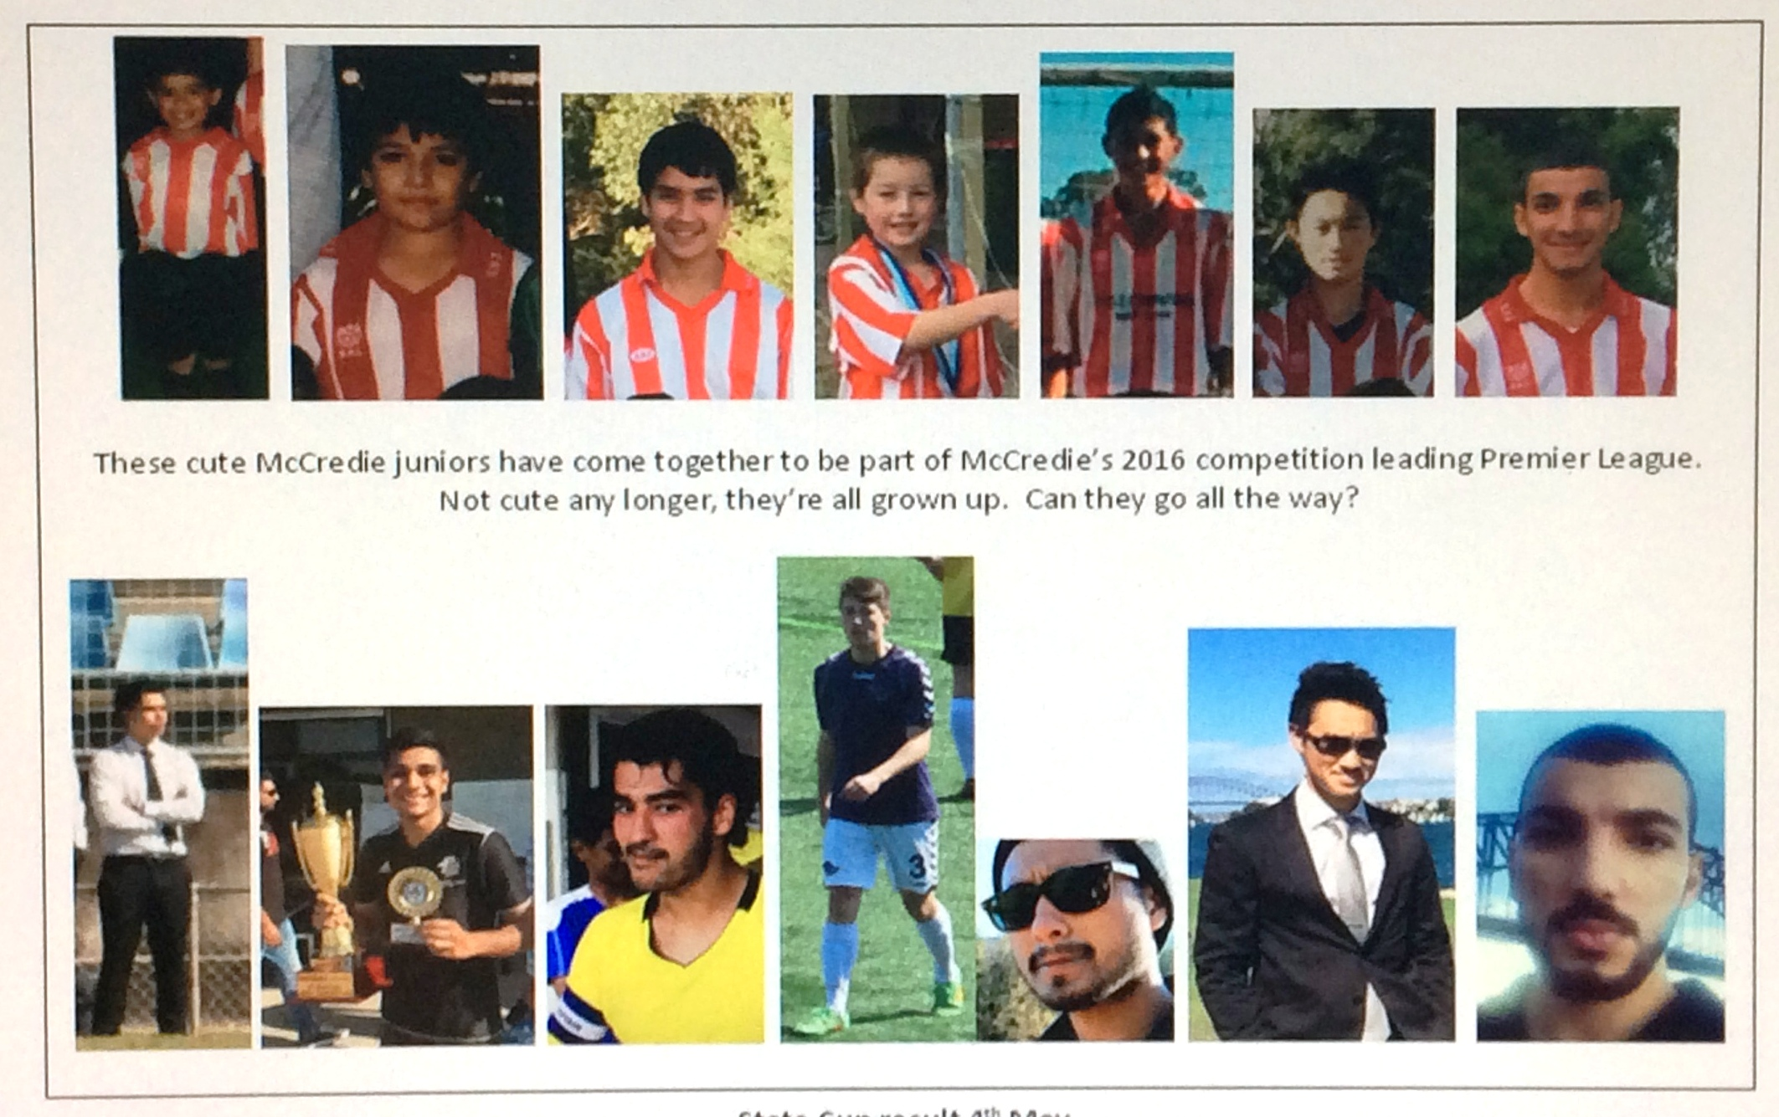

State Cup result 4th May

Premier League vs Wentworthville Uniting Blue 4 - 1
Dominated them early through nice quick and fluid passing. We were 3 nil up early in the first half and we then took it easy. Second half they scored a goal through some lazy passing by us but we quickly responded to kill off any dreams they may of had. Next match next Thursday night against Wenty PL
Goal Scorers: - Virinder Chaggar 2 , Mohammed Shukur 1, Mohammed Al Delaimi 1
Saturday 14th May 2016

U6 Red vs OLQP Falcons Blue at Daniel 2 (Daniel St., Greystanes)
9.00am Kickoff (meet Daniel at 8.30am)

U6 White vs Kings Old Boys at Everley (mini) (Everley Rd., South Granville)
9.00am Kickoff (meet at Everley at 8.30am) (set up field)

U6 Black vs Hills Spirit Red at Everley (mini) (Everley Rd., South Granville)
10.00am Kickoff (meet at Everley at 9.30am) (dismantle field)

U7 vs Hills Spirit White at Kellyville 7 (Memorial Ave., Kellyville)
10.00am Kickoff (meet at Kellyville at 9.30am)

U8 Red vs St Columbas Castle Hill at Eric Mobbs 2 (Excelsior Ave., Castle Hill)
12.00pm Kickoff (meet at Eric Mobbs at 11.30am)

U8 White vs Lidcombe Churches at Everley 2 (Everley Rd., South Granville)
9.00am Kickoff (meet at Everley at 8.30am) (set up field)

U9 vs OLQP Falcons Blue at Everley 2 (Everley Rd., South Granville)
10.00am Kickoff (meet at Everley at 9.30am)

U10 White vs Lidcombe Churches at Phillips 1 (Martin St., Lidcombe)
11.00am Kickoff (meet at Phillips at 10.30am)

U11 Red vs Lidcombe Churches at Everley 3 (Everley Rd., South Granville)
11.00am Kickoff (meet at Everley at 10.30am) (set up & dismantle field)

U11 Black vs Hills Spirit at Everley 2 (Everley Rd., South Granville)
11.00am Kickoff (meet at Everley at 10.30am) (set up field)

U12 vs Lidcombe Churches at Everley 2 (Everley Rd., South Granville)
12.00pm Kickoff (meet at Everley at 11.30am) (dismantle field)

U13 Black vs Rouse Hill Rams at Commercial Road 2 (Commercial Rd, Kellyville)
11.40am Kickoff (meet at Commercial at 11.00am)

U13 White vs Winston Hills at Everley 1 (Everley Rd., South Granville)
8.30am Kickoff (meet at Everley at 7.45am) (set up field)

U14 vs Greystanes at Everley 1 (Everley Rd., South Granville)
9.45am Kickoff (meet at Everley at 9.00am)

U15 vs Bye

U16 vs Merrylands SFC at Merrylands Park 3 (Burnett St., Merrylands)
1.30pm Kickoff (meet at Merrylands at 1.00pm)

U18 vs Pendle Hill at Everley 1 (Everley Rd., South Granville)
12.30pm Kickoff (meet at Everley at 12.00pm) (dismantle field)

Challenge Cup vs Sao Paulo Merrylands at Ron Darcy (Cabramatta Ave., Miller)

1.15pm Kickoff (meet at Ron Darcy at 12.45pm)

Premier League vs St Barnabas Broadway at Tempe 4 (Holbeach Ave., Tempe)
(Reserves Kick off at 1.15pm Firsts at 3.15pm) (Meet at Tempe at 12.45pm)

Sunday 15th May 2016

All Age Ladies vs Holroyd Rangers at Everley 1 (Everley Rd., South Granville)

3.00pm kick off (meet at Everley at 2.15pm) (dismantle field)

Thursday 12th May 2016

State Cup Round 2

Premier League vs Wentworthville Uniting P/L at Phillips 3 (Martin St., Lidcombe)
7.00pm kick off (meet at Phillips at 6.30pm)
This year’s annual lapathon, our club’s only significant additional fundraiser will be held on 11th May in lieu of training.

LAPATHON

Sponsorship form

Wednesday 11th May, 2016

Name | Telephone number | Amount per lap  or the sponsor may choose to donate a total amount. | Total donation
Total amount collected

It is expected that players will complete not more than 30 laps

On the 11th May all teams will meet at Granville Park at 5.45 and run from 6pm to 7pm.

During the night all players will receive lollies and drinks and a BBQ will operate. This is our only significant fundraiser and it is expected that all players will participate and seek sponsorship prior to the night. This is how we are able to maintain the lowest fees in the district.

Players not attending will not be eligible for special awards at the end of the season.

