OTB 10/17

Club Secretary – Greg 9682 7779 President – Peter 9632 9203

Interested in sponsoring a team or advertising in this newsletter? – call one of the above numbers.

Check out our website and like us on Facebook.

www.mccredie.org.au/soccer

LAPATHON

Thank you to everyone who was sponsored last week, helped with the organisation and smooth running of the event, purchased sausages or ran around the oval.

Money is still coming in and I will update you with how much we raised next newsletter.

If you haven’t returned your sponsorship or would like to make a late contribution, please pass your money to your team manager this week.

In the mean time the following laps were run – great job all

Age | Name | Most laps | Age | Name | Most laps
U6 | Ahmad Agha | 17 | U13 | Aaran Batth | 27
U7 | George Esber, Farooz Maqsoodi | 20 | U14 | Mounir Hadid | 29
U8 | Nour –Eldine Matar | 23 | U15 | Mehdi Jaffari, Mahmoud Jalloh | 30
U9 | Xavier Kaarsberg | 23 | U16 Girls | Sharlene Muru-Tucker | 21
U10 | Paulo Penaia, Stella Fitpatrick | 22 | AAM | Andy Chung | 25
U11 | Ali Fatlawi, Sajjad Karimi | 24 | AAL | Laura Burden | 8
U12 | Fraz Maqsoodi | 21

27th May
Team Photos – U6 White, U7 Black, U8, U9 White, U11, U13, U14/1, U14/3, CC, SC

27th May
Junior catchup round – teams (U6,7,8,9,10,11) will play two games that day

29th May
Coaches and Managers Meeting (7.15pm 486 Guildford Rd)

30th May
National Titles trials commence for U23, AAM @ Jones Park

8th June
National Titles trials commence for U14 boys @ Jones Park

10th June
six a side for U6, 7, 8, 9, 10, 11, 12 and AAL

12th June
Six a side for U13, 14, 15, 16, AAM, O35, AAL catch up round

18th June
Kings Sevens Tournament – interested coaches (U12 to 16 speak to Greg)

19th June
National Titles trials commence for U16 and 18 boys @ Jones Park

26th June
National Titles trials commence for U16 girls & AAL @ Freame Park



IMPORTANT NOTICES
- If for any reason your child is unable to play or attend training you MUST inform your coach or manager AS SOON AS POSSIBLE.

- If you have questions regarding your team ask your manager.

- If it is raining on a Saturday morning call the team manager to see if the game is on. Most often games will still be on so do not just stay at home, you will be letting your child's team down!!!

- Please assist the coach and manager, they are working unpaid for your child. There may be nets to put up or pull down, corner posts to stick in, players to be picked up (particularly if a parent has more than one child playing in different teams) or shirts to wash.

- This Club, the NSW Churches Football Association and Granville District SFA have high expectations of our parents and players. Please support our teams, but no abuse of players or officials will be tolerated and bans or fines could result.

Greg Wark – Secretary 9682 7779

RESULTS – State Cup 18th May 2017

Premier League vs Columna 12 – 0
Goal scorers – William Wark 4, Virinder Chaggar 2, Mick Massih 1, Amarvir Batth 1, Mohamed Al Delaimi 1, Luke Sungkar 1, Francis Hoang 1, own goal 1

RESULTS – 20th May 2017

U6 Red vs OLQP Falcons Yellow 1 - 5
Another defeat for the U6 Reds today. Good effort from Aiden touching the ball many times and throwing in some big, strong kicks across the field. Emaan took control of the ball from the opposition multiple times and Charlie tried to get amongst the mass pairs of feet surrounding the ball. Logan's good positional play as defender and following the coach's instructions worked well for the team. Mete scored an amazingly skillful and accurate goal into the corner of the goal post in the second half. Emily and Amir did a great job defending our goals with their handy work. Extra training needed this week to prepare the kids for the double match coming up next weekend. Good effort U6 Reds!
Goal scorer – Mete Bedir 1

U6 White vs Wentworthville Uniting 8 - 1
The Under 6 White's continued their winning streak this week with another great game. Daniel scored within the first minute, the first of 7 amazing goals for him today. Our player of the match was Lukacs Bausse who scored his very first goal today! Julian set up our first goal for Daniel to score and played an active game throughout both halves. Akshan was an excellent goalie and saved a goal today. William also did some great kicking and defending. Akshan was right in there playing the ball and making great kicks. Noah continued to improve on his game and contributed well to our success. Well done again team, keep going strong!
Goal scorers – Daniel Depares 7, Lukacs Bausse 1

U7 Red vs OLQP Falcons Blue 6 - 2

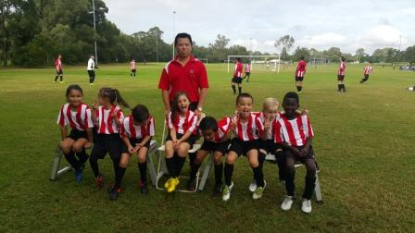

We are so happy the sun came out so that we could have our team photo and act a little silly.
It was a harder game this week with some strong players on the other team but our under 7 reds played hard and it is proof in the score. Abatar had some great kicks and lochie and dani were our goal keepers and saved several goals each. Carissa was an enthusiastic player, Lual and izaac were both strong in attacking and defending. Our player of the match is nevaeh mateaki for staying focused all through the game, getting into the action to tackle and kick, great team contribution. The coach award this week is awarded to Jacob Ali for posting hard, some of his biggest kicks, runs and dribbles so far . Well done Nevaeh and Jacob. As always we have the wonderful support of our mums and dads.
Goal scorers – Abatar Gurung 4, Lual Deng 2, Izaac Chung 1

U7 White vs Lidcombe Churches Blue 9 - 1
Convincing win today against Lidcombe with a whopping 9-1 score. Star of the match was Charbel Taouk scoring his first ever goal only to sneak in another one in the second half. Joshua excelled today at strategically positioning himself, George Esber again showed off his defending skills while Daniel set up a few goals and saved others from going in. George Tangi also worked hard at defending. Alex impressed the crowed as he aggressively saved all bar one ball that went his way.
Goal scorers - Simon Taouk 4, Daniel Alouche 2 and Charbel Taouk 2, Alex Azar 1

U7 Black vs St Columbas Castle Hill Black 2 - 4
Another well played game today which we were unlucky not to win. With a wet soggy field we were a bit slow to get going. There was some great passing from all players today along with some great saves in goals from Aiden and Gethyn. Yusuf once again scoring a great goal along with Bentley slotting 1 in as well. Rushil showed us once again his great defensive skills and Brendon is really coming along with confidence. Telissa-lee with her speed was getting right in there today. Our man of the match is Zak who was close to scoring and not afraid to get in and have a go.
Goal scorers – Yusuf Hadi 1, Bentley Buenen 1

U7 Grey vs St Columbas Castle Hill Orange 2 – 0

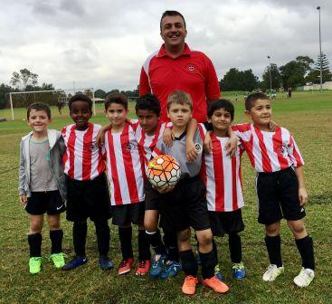

A great turn around from last week. Our attack was very strong which kept the opposing side in their half for most of the game. Although we were controlling the ball, the first half ended with neither side scoring as our attempts were just off target. We also dominated the second half and well done to Aaron and Jason for each scoring a goal. Mohammed and Sarim had some good runs at the front and some nice attempts at scoring. Nikolas and Moussa also put in great defensive efforts which kept the ball away from our goals (although Stefan was not too happy with this).The Man of the Match was Sarim. From start to finish he chased the ball, marked players and provided scoring opportunities by getting up front and calling out for the ball. Every single player did an awesome job today. I would also like to thank all of the parents for their organisation, support and encouragement today.
Goal Scorers: Aaron Kidane 1, Jason Azar 1

U8 vs Bye

U9 Red vs Wentworthville Uniting Blue 4 – 0
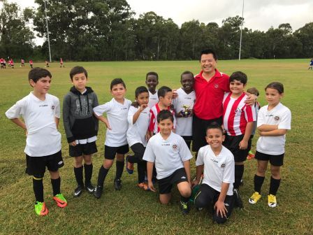
This morning I was so proud of the little men and little lady Telitha in our team for being so organised disciplined and easy at the photo shooting. It felt like we really function as a team. And the team photo turned out so nice.
At the game we continued with the same team spirit. Good passing unbreakable defending and proving one more time that we deserve to be at the top of the ladder. Adhar was granted player of the match for his good scoring and Simon the coach award for his constant effort at any position he is in. I would also like to acknowledge the beautiful turn out at the lapathon and the effort every player did running and collecting money for our club. It was a fantastic night and we all enjoyed it.
Goal scorer – Adhar Yaac 3, Patrick Matta 1

U9 White vs St Columbas Castle Hill 1 - 5
We now face a good strong test of character early in the season. After a dream start we are stare down the barrel of 4 losses in a row. The team today we met in round 1 beating them 16-1 but today with a few extra players on their side they've turned it around dominating us all game. Xavier stood out today for a man of the match type performance and scoring our team's only goal. It's good to face this early in the season so the team can bounce back and be at their peak performance as we progress through the season and hopefully the finals.
Goal scorer: Xavier Kaarsberg 1

U10 vs OLQP Falcons Blue 5 – 0
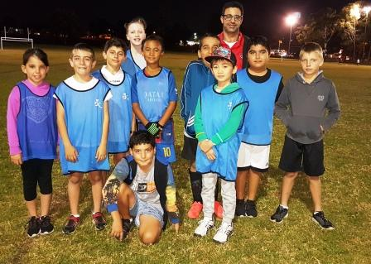
Once again very happy with the efforts that the team put together today to record a good win and the way the players are understanding the importance of holding their positions during the game. Individual play is still very prominent and although this might ordinarily be a good thing, more team play is required. The threading of more passes between players leading up to a goal or a set move would be as good a spectacle to watch as an individual play. Some players need to trust their instincts and take a chance in dribbling the ball instead of just kicking the ball with eyes shut. We will work on improving these parts of our game. A great effort from Paulo scoring the five goals, but player of the match went to Simon Elzain for his clean sheet as goal keeper in the first half and for his defending and attacking efforts in the second half.
Goal scorer - Paulo Santiago Penaia 5

U11 vs Lidcombe Churches Blue 10 - 0
Goal scorers - Joey Farah 4, Jack Spina 1, Dylan Lu 1, Joshua Depares 1, Jean Paul Azar 1, Ali Fatlawi 1, Daniel Kvesic 1

U12 vs Toongabbie Demons 17 - 0
Today's game U12's went home with a successful win, the team played well together. Mohammed placed three well deserved goals, Fraz also had three goals, Safal had two really good goals, Mathew had three goals, one of which from out of the box and straight in the corner, Mustafa had two goals and also had some really good team work with his assists, junior also mad two really good goals and Mackuac had two strong goals. All in all it was a good game, however the team still has room for improvement with the offsides and clearing and passing the ball.
Goal scorers- Mohammed Matar 3, Fraz Maqsoodi 3, Safal Thapa 2, Matthew Youssef 3, Mustafa Elbizri 2, Junior Penaia 2, and Makuac Kuol 2

U13 vs Toongabbie White 2 - 4
There's not a lot I can say about this match. We were the better side but didn't take our chances. A few errors at the back put us on the back foot 3-1. With a second half fight back on the cards we held the ball well in the second half. Unfortunately a late goal from the opposition ended all hope of a miracle come back.
Man of the match: Abdul
Goals : Abdul Agha 1, Duan Majok 1

U14/1 vs Pendle Hill Tigers 0 – 4
We didn't deserve this score line as we played pretty well. We attacked for most of the second half however let Pendle Hill off with a couple of soft goals. We need to fix up our positional play and our marking so we can be ready for them next time. Don't panic boys, playing the top 3 teams in 3 weeks is hard but hopefully we can get back to winning this week

U14/3 vs Wentworthville Uniting White 0 – 6
Unfortunately we were down three players today, due to sickness. The nine who took the field played their hearts out & we were unlucky to go in at half time down 0-1. In the second half as we tired our opponent took advantage. We didn’t give up & kept trying to the final whistle. Whole team was the player of the match.

U16 vs Merrylands SFC 2 – 3
Heartbreaking. We were two nil up and playing really well. Lots of good passing through midfield, which we have lacked up until now and two well taken goals. Then a mistake and a gift, but still we should have been OK. But we actually fell apart and played some of our worst football as Merrylands gained momentum and were in front with three goals in 15 minutes. We need to play for the full match and can’t switch off. Sharlene didn’t and was awesome today. Nick worked hard in an unfamiliar role and it was nice to see Mehdi get his first goal.
Goal scorers – Thomas Taouk 1, Mehdi Jaffari 1

Challenge Cup vs Darling Street Anglican 1 – 6
Goal scorer - ?

Sydney Cup Reserves vs Wentworthville Uniting Gold 4 - 2
Great effort by everyone and a deserved win. We still need to get there at 12.30 as it took us till half-time to get our shape due to not knowing who was playing due to late attendances.
Goal scorers: Mohammed Abdul Hamid 3, Yilmaz Ada 1

Sydney Cup Firsts vs Wentworthville Uniting Gold 1 – 2
What a difference. We actually had fresh players for first grade and we finally were competitive. This was our first time really playing together and we only lost it in the last 2 minutes when we got over eager chasing the winning goal. Fantastic effort by everyone
Goal Scorer: Ahmad Abdul Hamid 1

Premier Reserves vs St Barnabas Broadway 2 – 3
A really average performance today cost us the three points. There were times where we looked really good but unfortunately those moments weren't often enough.
Goal scorers - Virinder Chaggar 1, Reinaldo Capizzi 1

Premier League vs St Barnabas Broadway 2 - 1
It is the first time in 3 years that we have beaten this team and it felt great. We pushed from the starting whistle and deserved the three points. Thank you to all the reserves who stayed back and helped out. Special mention to Gerry who played all of reserves and then backed up and played all of firsts
Goal scorers - William Wark 1, James Rosandi 1

All Age Ladies Div 2 vs Glenwood Redbacks 0 – 1
A much more pleasant afternoon this week as we competed with our opponents for the whole match, showed some key improvements in some of our core skills and lost only by a goal (scored whilst our sweeper recovered on the sideline). Sayde had a wonderful afternoon making three tackles in the first minute and going all game in the same vane. Laura H played well and Kiwi is amazing in the back. It is too easy to take Henny for granted in goals too, she genuinely isn’t playing out of her league- she is A grade quality all the way!

U14 State Cup vs Hurlstone Park Wanderers 0 – 2
Entered the state cup for some extra soccer and a chance for the boys to play a good level against different opponents.

_________________________________________________________________________________

RAIN – WHAT TO DO

It’s raining, it’s Saturday!! Is the game on??

Your manager will know if the game is on, give them a call. Very rarely is a decision made before Friday evening. If I have not called your manager, the game is on, even if it is raining!

Most often games will still be on so do not just stay at home, you will be letting your child's team down!!!

It’s raining and it’s training tonight!! Is training on??

If the ground is closed you cannot train, even if it’s not raining!! Parents and players call the manager or coach.

Granville Park is now in Cumberland Council (not Parramatta) – wet weather line 9294 1418
__________________________________________________________________________________________.
State Cup Round 1
Wednesday 24th May 2017

Sydney Cup (Phil) vs Parramatta St Patricks Green at Jones 1 (Banks St., Merrylands)
6.30pm Kickoff (Meet at Jones at 6.00pm) (set up field)

PLEASE NOTE THAT OUR YOUNGER TEAMS HAVE TWO GAMES THIS SATURDAY TO CATCH UP THE ROUND 1 WASHOUT

(U6 Red, 6 White, 7 Black and 9 Red have all received forfeits this Saturday afternoon)
Saturday 27th May 2017

U6 Red vs OLQP Falcons Red at Daniel 2 (Daniel St., Greystanes)
11.00am kick off (meet at Daniel at 10.30am)

U6 White vs OLQP Falcons Yellow at Everley (mini) (Everley Rd., South Granville)

9.00am Kickoff (meet at Everley at 8.30am for team photo and to set up field)

U7 Red vs OLQP Falcons Red at Daniel 2 (Daniel St., Greystanes)
9.00am kick off (meet at Daniel at 8.30am)
AND

U7 Red vs Wentworthville Uniting Gold at Everley (mini) (Everley Rd., South Granville)

4.00pm Kickoff (meet at Everley at 3.30pm)

U7 White vs Kings Old Boys at Homelands (mini) (Homelands Ave., Telopea)

10.00am Kickoff (meet at Homelands at 9.30am)
AND

U7 White vs St Columbas Castle Hill Orange at Everley (mini) (Everley Rd., South Granville)

3.00pm Kickoff (meet at Everley at 2.30pm)

U7 Black vs OLQP Falcons Blue at Everley (mini) (Everley Rd., South Granville)
10.00am Kickoff (meet at Everley at 9.15am for team photo)

U7 Grey vs St Columbas Castle Hill Black at Everley (mini) (Everley Rd., South Granville)
11.00am Kickoff (meet at Everley at 10.30am)
AND

U7 Grey vs Wentworthville Uniting at Freame (mini) (Rees St., Mays Hill)
3.00pm Kickoff (meet at Freame at 2.30pm)

U8 vs Wentworthville Uniting Gold at Freame (Rees St., Mays Hill)
10.00am Kickoff (meet at Freame at 9.30am)
AND

U8 vs Wentworthville Uniting Gold at Everley 2 (Everley Rd., South Granville)

2.00pm Kickoff (meet at Everley at 1.00pm for your team photo)

U9 Red vs Lidcombe Churches at Phillips 2 (Martin St., Lidcombe)

11.00am Kickoff (meet at Phillips at 10.30pm)

U9 White vs Wentworthville Uniting Gold at Everley 2 (Everley Rd., South Granville)

11.00am Kickoff (meet at Everley at 10.00am for team photo and to set up field)
AND

U9 White vs Wentworthville Uniting Blue at Freame (Rees St., Mays Hill)
2.05pm Kickoff (meet at Freame at 1.30am)

U10 vs Wentworthville Uniting Gold at Freame (Rees St., Mays Hill)
12.00pm Kickoff (meet at Freame at 11.30am) (dismantle field)
AND

U10 vs OLQP Falcons Red at Everley 2 (Everley Rd., South Granville)

3.00pm Kickoff (meet at Everley at 2.30pm)

U11 vs Wentworthville Uniting at Everley 2 (Everley Rd., South Granville)

12.00pm Kickoff (meet at Everley at 11.00am for team photo) (set up field)
AND
U11 vs Lidcombe Churches Gold at Everley 2 (Everley Rd., South Granville)
4.00pm kick off (meet at Everley at 3.30pm) (dismantle field)

U12 vs Lidcombe Churches at Phillips 1 (Martin St., Lidcombe)

10.00am Kickoff (meet at Phillips at 9.30am)

U13 vs Dundas United at Everley 1 (Everley Rd., South Granville)

8.30am Kickoff (meet at Everley at 7.45am to set up field and have team photo at 8.00am)

U14/1 vs Rydalmere FC at Everley 1 (Everley Rd., South Granville)

11.00am Kickoff (meet at Everley at 10.15am for team photo)

U14/3 vs Greystanes FC at Everley 1 (Everley Rd., South Granville)

9.45am Kickoff (meet at Everley at 9.00am for team photo)

U16 vs Pendle Hill Tigers White at Binalong 3 (Binalong Ave., Old Toongabbie)

11.00am Kickoff (meet at Binalong at 10.15am)

Challenge Cup (Moey) vs Columna at Everley 3 (Everley Rd., South Granville)
3.15pm kick off (meet at Everley at 2.30pm for team photo) (dismantle field)

Sydney Cup (Phil) vs St Barnabas Broadway at Everley 1 (Everley Rd., South Granville)
(Reserves Kick off at 1.15pm Firsts at 3.15pm) (Meet at Everley at 12.45pm)
PHOTO AT 2.45pm (dismantle field)

Premier League (Adem/Wil) vs Castle Hill Baptist at Eric Mobbs 2 (Excelsior Ave., Castle Hill)
(Reserves Kick off at 1.15pm Firsts at 3.15pm) (Meet at Eric Mobbs at 12.45pm)

Sunday 28th May 2017

All Age Ladies vs Premier Spurs at Davis 6 (Davis Rd.,Marayong )

9.00am Kickoff (meet at Davis at 8.15am)

2017 NATIONAL TITLES PLAYER TRIAL DATES
2017 NATIONAL TITLES PLAYER TRIAL DATES
The National Titles Player, Coach & Manager nominations for 2017 are now open.
The 2017 National Titles will be held at Sydney Academy of Sport
& Recreation at Narrabeen from 24th September to 28th September 2017
Players, Coaches and Managers will be expected to live at Narrabeen for the duration of the competition.
The cost of the competition will be $750 per person, this includes
Accommodation, linen, meals, player kit and tournament fee.
To trial for the National titles, please fill out the attached form and bring with you to the trials
http://cfasydney.com.au/2017-national-titles-player-trial-dates/
To be held at Jones Park, Banks St, Merrylands
Under 14 Boys –8th and 13th June, 7pm
Under 16 Boys – 19th and 20th June, 7pm
Under 18 Boys – 19th and 20th June, 7pm
Under 23 Men’s –30th May and 1st June, 7.30pm
Senior Men’s – 30th May and 1st June, 7.30pm
To be held at Freame Park, Rees St, Mays Hill
Under 16 Girls – 26th and 27th June, 6pm
Senior Ladies – 26th and 27th June, 7.30pm

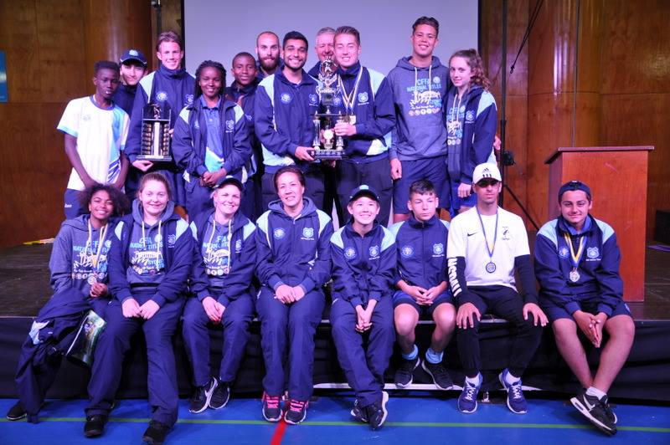

McCredie players and coaches at last year’s National Titles.

