OTB 13/17

Club Secretary – Greg 9682 7779 President – Peter 9632 9203

Interested in sponsoring a team or advertising in this newsletter? – call one of the above numbers.

Check out our website and like us on Facebook.

www.mccredie.org.au/soccer

A picture taken in every soccer loving home on the long weekend.

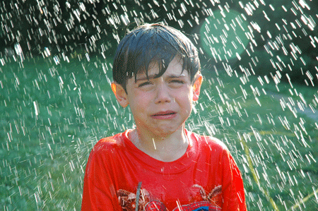

______________________________

Junior club Hoodies are now in stock ($35) purchase from the canteen
sizes 6, 10, 12, 14
(size 8 should be available within a week or two)

13th June
National Titles trials commence for U14s @ Jones Park at 7pm

14th June
State Cup semi final Premier League – 7pm Jones Park (details in the newsletter)

14th June
Zone trials U8, 9 at 6pm, U10, 11 at 7pm Jones Park 2 (Banks St., Merrylands)

18th June
Kings Sevens Tournament – U14/1 & U15

19th June
National Titles trials commence for U16 and 18 boys @ Jones Park 7pm

26th June
National Titles trials commence for U16 girls (6pm) & AAL (7.30pm) @ Freame Park

Wednesday 14th June 2017
State Cup semi final

Premier League (Adem/Wil) vs Greystanes United at Jones 1 (Banks St., Merrylands)
7.00pm kick off (meet at 6.30pm) (set up field)

Saturday 17th June 2017

U6 Red vs Lidcombe Churches Gold at Phillips 2 (Martin St., Lidcombe)

11.00am Kickoff (meet at Phillips at 10.30am)

U6 White vs Lidcombe Churches Blue at Everley (mini) (Everley Rd., South Granville)

9.00am Kickoff (meet at Everley at 8.30am) (set up field)

U7 Red vs McCredie White at Everley (mini) (Everley Rd., South Granville)

11.00am Kickoff (meet at Everley at 10.30am) (dismantle field)

U7 White vs McCredie Red at Everley (mini) (Everley Rd., South Granville)

11.00am Kickoff (meet at Everley at 10.30am) (wear white)

U7 Black vs McCredie Grey at Everley (mini) (Everley Rd., South Granville)

10.00am Kickoff (meet at Everley at 9.30am)

U7 Grey vs McCredie Black at Everley (mini) (Everley Rd., South Granville)
10.00am Kickoff (meet at Everley at 9.30am) (wear white)

U8 vs OLQP Falcons Blue at Everley (mini) (Everley Rd., South Granville)
11.00am Kickoff (meet at Everley at 10.30am) (set up field)

U9 Red vs McCredie White at Everley 2 (Everley Rd., South Granville)

12.00pm Kickoff (meet at Everley at 11.30am) (dismantle field)

U9 White vs McCredie Red at Everley 2 (Everley Rd., South Granville)

12.00pm Kickoff (meet at Everley at 11.30am) (wear white)

U10 vs Bye

U11 vs Bye

U12 vs Lidcombe Waratah at Everley 1 (Everley Rd., South Granville)

8.30am Kickoff (meet at Everley at 7.45 to set up field)

U13 vs Guildford County at Everley 1 (Everley Rd., South Granville)

9.45am Kickoff (meet at Everley at 9.15am)

U14/1 vs Pendle Hill Tigers at Everley 1 (Everley Rd., South Granville)

11.00am Kickoff (meet at Everley at 10.15am) (dismantle field)

U14/3 vs Wentworthville Uniting Black at Jones 1 (Banks St., Merrylands)

9.40am Kickoff (meet at Jones at 9.00am)

U16 vs Greystanes FC at Alpha Rd (Alpha Rd., Greystanes)

1.30pm Kickoff (meet at Alpha at 1.00pm)

Sydney Cup (Phil) vs Kings Old Boys at Homelands Reserve (Homelands Ave., Telopea)
(Reserves Kick off at 1.15pm Firsts at 3.15pm) (Meet at Homelands at 12.45pm)

Premier League (Adem/Wil) vs Wentworthville Uniting at Freame (Rees St., Mays Hill)
(Reserves Kick off at 1.15pm Firsts at 3.15pm) (Meet at Freame at 12.45pm)

Sunday 18th June 2017

All Age Ladies vs Wenty Waratahs at Coleman 1 (Georges Ave., Lidcombe)

3.00pm Kickoff (meet at Coleman at 2.15pm)

Kings Sevens

Under 14 and Under 15

Required players will be spoken to by your coach.

Players are required at The Kings School (Pennant Hills Rd., North Parramatta) by 8am for registration

Managers please ensure you have the player’s player ID cards.

2017 NATIONAL TITLES PLAYER TRIAL DATES
2017 NATIONAL TITLES PLAYER TRIAL DATES
The National Titles Player, Coach & Manager nominations for 2017 are now open.
The 2017 National Titles will be held at Sydney Academy of Sport
& Recreation at Narrabeen from 24th September to 28th September 2017
Players, Coaches and Managers will be expected to live at Narrabeen for the duration of the competition.
The cost of the competition will be $750 per person, this includes
Accommodation, linen, meals, player kit and tournament fee.
To trial for the National titles, please fill out the attached form and bring with you to the trials
http://cfasydney.com.au/2017-national-titles-player-trial-dates/
To be held at Jones Park, Banks St, Merrylands
Under 14 Boys –8th and 13th June, 7pm
Under 16 Boys – 19th and 20th June, 7pm
Under 18 Boys – 19th and 20th June, 7pm
Under 23 Men’s –30th May and 1st June, 7.30pm
Senior Men’s – 30th May and 1st June, 7.30pm
To be held at Freame Park, Rees St, Mays Hill
Under 16 Girls – 26th and 27th June, 6pm
Senior Ladies – 26th and 27th June, 7.30pm

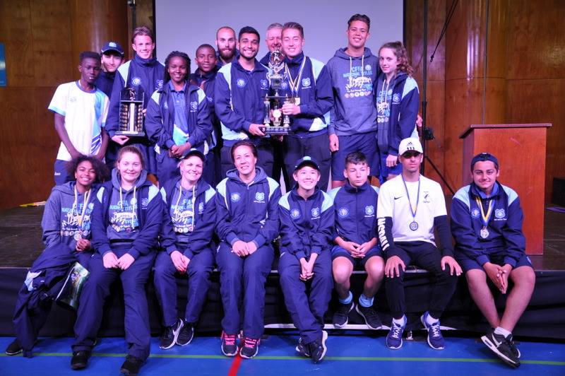

McCredie players and coaches at last year’s National Titles.

IMPORTANT NOTICES
- If for any reason your child is unable to play or attend training you MUST inform your coach or manager AS SOON AS POSSIBLE.

- If you have questions regarding your team ask your manager.

- If it is raining on a Saturday morning call the team manager to see if the game is on. Most often games will still be on so do not just stay at home, you will be letting your child's team down!!!

- Please assist the coach and manager, they are working unpaid for your child. There may be nets to put up or pull down, corner posts to stick in, players to be picked up (particularly if a parent has more than one child playing in different teams) or shirts to wash.

- This Club, the NSW Churches Football Association and Granville District SFA have high expectations of our parents and players. Please support our teams, but no abuse of players or officials will be tolerated and bans or fines could result.

Greg Wark – Secretary 9682 7779

_________________________________________________________________________________

RAIN – WHAT TO DO

It’s raining, it’s Saturday!! Is the game on??

Your manager will know if the game is on, give them a call. Very rarely is a decision made before Friday evening. If I have not called your manager, the game is on, even if it is raining!

Most often games will still be on so do not just stay at home, you will be letting your child's team down!!!

It’s raining and it’s training tonight!! Is training on??

If the ground is closed you cannot train, even if it’s not raining!! Parents and players call the manager or coach.

Granville Park is now in Cumberland Council (not Parramatta) – wet weather line 9294 1418
__________________________________________________________________________________________

