OTB 14/17

Club Secretary – Greg 9682 7779 President – Peter 9632 9203

Interested in sponsoring a team or advertising in this newsletter? – call one of the above numbers.

Check out our website and like us on Facebook.

www.mccredie.org.au/soccer

Junior club Hoodies are now in stock ($35) purchase from the canteen
sizes 6, 10, 12, 14
(size 8 should be available within a week or two)

13th June
National Titles trials commence for U14s @ Jones Park at 7pm

18th June
Kings Sevens Tournament – U14/1 & U15

19th & 20th June
National Titles trials for U16 and 18 boys @ Jones Park 7pm

22nd June
National Titles trials for U14 boys night 2 @ Jones Park 7pm

26th June
National Titles trials commence for U16 girls (6pm) & AAL (7.30pm) @ Freame Park

RESULT STATE CUP SEMI FINAL – 14th June 2017

Premier League vs Greystanes United 1 - 0
Completely dominated first half however dropped off in the second. The better team definitely won and with only 25 minutes halves, it's hard to score multiple goals. One more win to go
Goal scorer - Angus Chance 1

RESULTS – 17th June 2017

U6 Red vs Lidcombe Churches Gold 0 – 8
A disappointing match as we were short a couple of players but the 5 kids; Charlie, Christian, Jeremias, Logan and Mete, still put in all the energy they had to play the full game and never gave up! Christian and Charlie both bravely defended our goals, catching a few close kicks. Jeremias built up more confidence in the 2nd half to engage in the game. Logan held his position as defender with some strong kicks. Mete, our player of the match, showed his amazing ball skills, almost scoring twice after running the ball up the entire field on his own.
Fantastic effort from our little men today!

U6 White vs Lidcombe Churches Blue 5 - 0
The under 6 White's have continued our winning streak this week and won again! Our man of the match was William Livingstone who as goalie in our first half saved an amazing seven goals!! Our goal scorers this week were Daniel, Ahmad and Isaac, with Julian scoring 2 goals this week. Lukacs put is some great long kicks and Akshan was a great defender and kicker. Noah played really well, getting in and taking back possession. Well done boys, another great game
Goal scorers: Julian Azar 2, Daniel Depares 1, Ahmad Agha 1, Isaac Alameddine 1

U7 Red vs McCredie White 1 - 4
It was a tough game for our players this week, not only were the opposition strong and fast our team has not played or trained for two weeks. Our captain was Danielle this week. Jerone and Izaac were both defending and kicking well. Mardin and Jacob had good kicks through the game. Lochie did well saving 3 goals. Despite the score all the children had fun and enjoyed playing as a team. Once again our mums and dads are a great support to our entire team. Player of the week goes to Danielle for saving goals and getting in on the action. Coach’s award goes to Abatar for fighting hard in attack and defense.
Goal scorer – Lual Deng 1

U7 White vs McCredie Red 4 - 1
Played U7 Reds today who put in 100% effort and a great challenge. They demonstrated some great foot work but it wasn't enough to defeat the Whites. The U7 whites executed a strategy put together in training which saw them hold possession of the ball for the majority of the game. Bad luck for the Reds today who demonstrated outstanding sportsmanship. Player of the match was Alex as he demonstrated quality defending!
Goal scorers - Daniel Alouche 2, Simon Taouk 2

U7 Black vs McCredie Grey 4 – 5
This was a great contest! We had some big injuries to Bentley and Brendon but they both got back out there and played on. Yusuf scored two goals and did a great header and Telissa scored a goal and secured player of the match. Everyone played a great game, good team effort.
Goal scorers – Yusuf Hadi 2, Telissa Lee Buenen 1, Bentley Buenen 1

U7 Grey vs McCredie Black 5 – 4
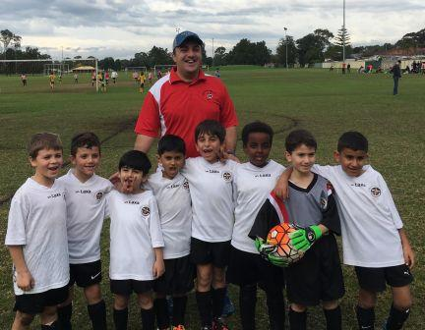

Great performances from both sides today. Our attack was very strong in the first half which led us to have a lead of 5-1 at half time, however it was our defence in the second half that ensured the win. Every week our team is improving, which shows that those cold Tuesday evening training sessions are paying off. But this also means that its getting harder to pick a Man of the Match. Today I'm going to single out two 'Men of the Match', Mohammad and Aaron. Mohammad played very well at the front and scored 5 goals. Aaron as always was also very strong up front, attacking opposition players, and setting up goals. Nikolas had some good runs today and his defensive play helped get the ball forward. Jason displayed some wonderful strategic play in the first half to get the ball forward and set up goals. Jason also made some amazing saves as goal keeper in the second half. Stefan also made some great saves as goal keeper in the first half and had some nice touches on the ball in the second half. Sarim made some great tackles and was wonderful in defence. Aimar kept chasing the ball and made some nice tackles as well. Aysam provided his best efforts in defence. Well done everyone!
Goal scorer – Mohamed Al Musawi 5

U8 vs OLQP Falcons Blue 3– 1
We came into today with 3 of our core players missing against a team that dominated us in round 2 defeating us 4-1. So to come out today and win 3-1 just shows how much everyone on the team has developed over the last few weeks. Nour once again was sensational in goals. The opposition just couldn’t get it past him. Great job Nour. Sundes was amazing as per usual up front bagging a hatrick. And what about William today he played a position that was foreign territory to him he stepped up and played our centre back and wasn’t he great. The opposition just couldn’t get it past him he continuously shut them down and what about that boot he was able to clear the ball half the length of the field every time he got it. Farhan, Raphael, Husein and George had great games in the midfield they never gave up and tackled and ran all over. Thank You to Bentley and Telissa from the Under 7s who came and played for us today they both did awesome especially considering they came straight on the field after just finishing playing another game. William was our Player of the Match today. Well done William.
Goal Scorer: Sundes Thapa 3

U9 Red vs McCredie White 3 - 0
We played a beautiful game today versing our own club. We've witnessed many foot skills good passing and many attempts to score. Joseph man of the match played till the last bit of power and scored two amazing goals and Adhar scored one goal. All the team made an excellent contributions to the win especially Lachlan who won the coach’s award and Omar. Well done Reds
Goal scorers – Joey Farah 2, Adhar Yaac 1

U9 White vs McCredie Red 0 – 3

U10 vs Bye

U11 vs Bye

U12 vs Lidcombe Waratah 4 - 1
This week we had a really good game, Guildford had a good win, the team played well despite the slippery wet field and really pushed for a win. We had a lot great opportunities and really good clearances, and shoots put in by the team. Junior made two goals, Khalif put in one goal and Mohammed also scored a goal as well. We had three goals in the first half and one in the second. Leaving us with a four - one win
Final score 4-1
Scorers: Junior Penaia 2, Khalif Reigal 1, Mohammed Matar 1

U13 vs Guildford County 16 - 0
This was always going to be a high scoring game, there was no other way it was going to turn out, with the opposition only turning up 3 minutes to go before kick off. Taking the lead quite early in the game thanks to a well worked team goal and finish by Greg, we set out for dominance throughout the rest of the game. Regardless of the big score we did not stay in position today which was the only fault I could pick out from our game. At one stage i had 6 strikers and it was frustrating to watch the counter attacks against us. You can clearly see the efforts in training are starting to pay off on the field. A great effort from everyone including our regular goal keeper Chris Germanos who came out in the second half and scored. Very happy with the performance and a good game to help boost our goal average. Man of the match: Mustafa (Neymar)
Goal Scorers: Abdul Agha 5, Rody Aboeid 4, Ramel Franci 2, Aaran Batth 2, Gregory Farah 1, Christopher Germanos 1, Mustafa Alizada 1
U14/1 vs Pendle Hill Tigers 0 - 3
If we had Pendle Hill's striker, we would've came out on top because we were very even with them. We came out firing in the first 10 minutes and had them very nervous. We are so close to these teams, it's just unfortunate that we keep playing these top 3 teams

U14/3 vs Wentworthville Uniting Black 0 - 6
Today we welcomed a new player, Liem Phan, to our team. Our opponents today, are the competition leaders who have not conceded a goal all season, so it was a tough match for Liem to make his debut for the club. The boys tried their best and created a few chances along the way. Whilst we did lose, the score line does not tell the full picture, as it was a great effort against a very good team. Ruben was our player of the match. His effort as goalie in the second half was great to watch.

U16 vs Greystanes FC 9 - 1
The team played very well today, being quick to the ball and denying Greystanes any chance to get into the game. Mehdi, Jeffrey, Andrew and Serge had particularly strong games.
Goal scorers – Joe Azzi 4, Mahmoud Jalloh 2, Mehdi Jaffari 1, Serge Boustany 1, Emtiaz Akbari 1

Sydney Cup Reserves vs Kings Old Boys 2 - 2
Important match as it was us in 3rd place with Kings in 5th with only 3 points between us. We started off strongly and should have finished them off in the first half but we only went into halftime 2-1 up. They equalised early in the second half and we managed to hold on. A draw doesn’t damage our chances of finals but a win would have given us a buffer.
Goal scorers: - Jeff Eker 1, Akhil Menezes 1

Sydney Cup Firsts vs Kings Old Boys 4 – 7
Tough afternoon as we didn’t have much luck. A few miss touches and not moving to the ball saw us give away some cheap goals. Losing Abdul early didn’t help as we were light on defenders today. The positives to be taken from the second half were that we managed to match it with them 3-3. When we string our passes together we were able to get around them and get our chances. Unfortunately, we didn’t keep to that game plan. Every time we scored we then pushed too far forward and everyone tried to score which meant we were out of position. We still need to learn how to play as a team and hold our positions. Special thanks to Jakob and Mahmoud who helped us out by going keeper.
Goal scorers: - Hedayat Mohamed 2, An Dao 1, Ahmad Abdul Hamid 1

Premier Reserves vs Wentworthville Uniting 1 - 4
Lack of finishing in front of goal again cost us today as the defence can only hold them out for so long. The defence was very good today and hopefully we are still in the top 4
Goal scorer - William Wark 1

Premier League vs Wentworthville Uniting 7 - 2
Always helps when the other team doubles up but we were fantastic when the ball did the moving with minimal touches from all players. If we play like that, we will take out this comp
Goal scorers - Adem Stevens 2, Willem Booker 2, William Wark 1, Mick Massih 1, Chiri Grewel 1

RESULTS – 18th June 2017

All Age Ladies Div 3 vs Wenty Waratah 2 – 1
We finally got the result we deserved! Wenty must be wondering how they will ever beat us, but they were unlucky to strike us with our full defensive line intact. Funda, Thuzar, Jenna and Sayde all had strong games, Nyanut played the perfect ball to Thuzar who finished it like she had finished a thousand like it before and Funda played the perfect cross to Rana for her to control and then volley it with her LEFT foot into the net from 20 yards. Nancy though was player of the match for the involvement she had, the quality of her passes and the sheer improvement in her game. Not a bad afternoon out!
Goal scorers – Thuzar Oo 1, Rana Karakus 1

Kings Sevens

This is a seven a side tournament played on The Kings Schools fields against other clubs from around Sydney, Academy teams and school teams. It is seven a side and 14 minute matches. This year our U14s and U15s took part (our U15s all play U16s on Saturdays). Our club has had considerable success at this tournament in the past and this year that has continued!

U14s

Game 1 v Newington Gunners 1-0
Goal scorer - Ibrahim Koroma 1

Game 2 v Kings 1-2
Goal scorer - Ibrahim Koroma 1

Game 3 v Pennant Hills 1-1
Goal scorer - Ibrahim Koroma 1

Game 4 v Epping FC 1-0
Goal scorer - Rahim Kamara 1

SEMI v Epping FC 1-1 (won on penalties 2-1)
Goal scorer - Rahim Kamara 1 (Abdul Jalloh 1, Abdul Farhan 1)

FINAL v Newington Gunners 3-0
Goal scorers - Ibrahim Koroma 1, Abdul Jalloh 1, Mounir Hadid 1

Fantastic performance by all and just a great day out. The boys got better and better throughout the day and really impressed me with their passing and energy. Special mention goes to Aakrist who was MVP for the tournament; he saved 3 out of 4 penalties in the semi final and saved countless other point blank saves in the other games. Well done boys, you should be proud!

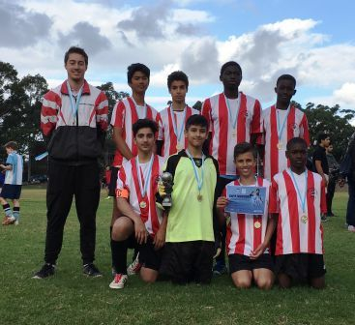

U15s

Game 1 v Epping FC 3-0
Goal scorers – Joe Azzi 1, Mehdi Jaffari 1, Emtiaz Akbari 1

Game 2 v Expendables 0 - 4

Game 3 v Kings 0 - 1

Game 4 v Kellyville United 4 - 0
Goal scorers – Joe Azzi 2, Emtiaz Akbari 1, Mahmoud Jalloh 1

SEMI v Kings 0 – 1

We were defending champions but unfortunately The Expendables were way too good this year. We played well in the games against Epping and Kellyville, got a touch up by the Expendables and conceded two soft goals in the games against Kings. Chris May in goals was outstanding, Mahmoud had a strong tournament as did Mohamed and Emtiaz enjoyed the chance to grab two more goals to add to his goal Saturday. Sharlene was probably my player of the day though. I love the way she just does “her thing”, controls the ball, passes to her team, marks her man and doesn’t try and do the impossible. We could all learn from that. A fun day and hugest congratulations to the 14s – great effort, you guys were awesome in the final.

Friday 23rd June 2017
Catch up match

All Age Ladies/3 vs Wenty Waratah at Webbs 2 (Webbs Ave., Auburn)
7.30pm kick off (meet at Webbs at 6.45pm)

Saturday 24th June 2017

U6 Red vs Lidcombe Churches Blue at Everley (mini) (Everley Rd., South Granville)

10.00am Kickoff (meet at Everley at 9.30am)

U6 White vs OLQP Falcons Blue at Daniel (Daniel St., Greystanes)

9.00am Kickoff (meet at Daniel at 8.30am)

U7 Red vs McCredie Grey at Everley (mini) (Everley Rd., South Granville)

9.00am Kickoff (meet at Everley at 8.15am) (set up field)

U7 White vs Wentworthville Uniting Gold at Freame (mini) (Rees St., Mays Hill)

10.00am Kickoff (meet at Freame at 9.30am)

U7 Black vs Wentworthville Uniting Blue at Everley (mini) (Everley Rd., South Granville)

11.00am Kickoff (meet at Everley at 10.30am) (dismantle field)

U7 Grey vs McCredie Red at Everley (mini) (Everley Rd., South Granville)
9.00am Kickoff (meet at Everley at 8.30am) (wear white)

U8 vs Western Sydney Academy at Freame (Rees St., Mays Hill)
9.00am Kickoff (meet at Freame at 8.30am)

U9 Red vs Wentworthville Uniting Gold at Everley 2 (Everley Rd., South Granville)

10.00am Kickoff (meet at Everley at 9.30.00am) (set up field)

U9 White vs Wentworthville Uniting Blue at Freame (Rees St., Mays Hill)

11.00am Kickoff (meet at Freame at 10.30am)

U10 vs OLQP Falcons Red at Everley 2 (Everley Rd., South Granville)
11.00am Kickoff (meet at Everley at 10.30am)

U11 vs Lidcombe Churches Gold at Everley 1 (Everley Rd., South Granville) 12.00pm Kickoff (meet at Everley at 11.30am)

U12 vs Merrylands SFC at King Park (Newman St., Merrylands) 8.30am Kickoff (meet at King at 8.00am)

U13 vs Lidcombe Waratah at Coleman 1 (Georges Ave., Lidcombe) 10.15am Kickoff (meet at Coleman at 9.45am)

U14/1 vs Auburn District at Progress (Chisolm Rd., Auburn) 10.40am Kickoff (meet at Progress at 10.00am)

U14/3 vs Regents Park at Everley 1 (Everley Rd., South Granville) 9.30am Kickoff (meet at Everley at 8.45am to set up field)

U16 vs Dundas United at Everley 1 (Everley Rd., South Granville)

10.45am Kickoff (meet at Everley at 10.00am)

Sydney Cup Reserves vs Mortdale Oatley Baptist

Sydney Cup Firsts vs Sutherland Reformed at Beaumont (Bexley Rd., Bexley North)
(Reserves Kick off at 1.15pm Firsts at 3.15pm) (Meet at Beaumont at 12.45pm)

Premier League (Adem/Wil) vs Greystanes United at Everley 1 (Everley Rd., South Granville)
(Reserves Kick off at 1.15pm Firsts at 3.15pm) (Meet at Everley at 12.45pm) (Dismantle Field)

Sunday 25th June 2017

All Age Ladies vs Holroyd Rangers at Girraween 3 (Toongabbie Rd., Girraween)

11.00am Kickoff (meet at Girraween at 10.15am)

Tuesday 27th June 2017
State Cup Final

Premier League vs Wentworthville Uniting at Jones Park (Banks St., Merrylands)
7.30pm kick off (meet at Jones at 6.30pm) (set up field)

2017 NATIONAL TITLES PLAYER TRIAL DATES
2017 NATIONAL TITLES PLAYER TRIAL DATES
The National Titles Player, Coach & Manager nominations for 2017 are now open.
The 2017 National Titles will be held at Sydney Academy of Sport
& Recreation at Narrabeen from 24th September to 28th September 2017
Players, Coaches and Managers will be expected to live at Narrabeen for the duration of the competition.
The cost of the competition will be $750 per person, this includes
Accommodation, linen, meals, player kit and tournament fee.
To trial for the National titles, please fill out the attached form and bring with you to the trials
http://cfasydney.com.au/2017-national-titles-player-trial-dates/
To be held at Jones Park, Banks St, Merrylands
Under 14 Boys –8th and 13th June, 7pm
Under 16 Boys – 19th and 20th June, 7pm
Under 18 Boys – 19th and 20th June, 7pm
Under 23 Men’s –30th May and 1st June, 7.30pm
Senior Men’s – 30th May and 1st June, 7.30pm
To be held at Freame Park, Rees St, Mays Hill
Under 16 Girls – 26th and 27th June, 6pm
Senior Ladies – 26th and 27th June, 7.30pm

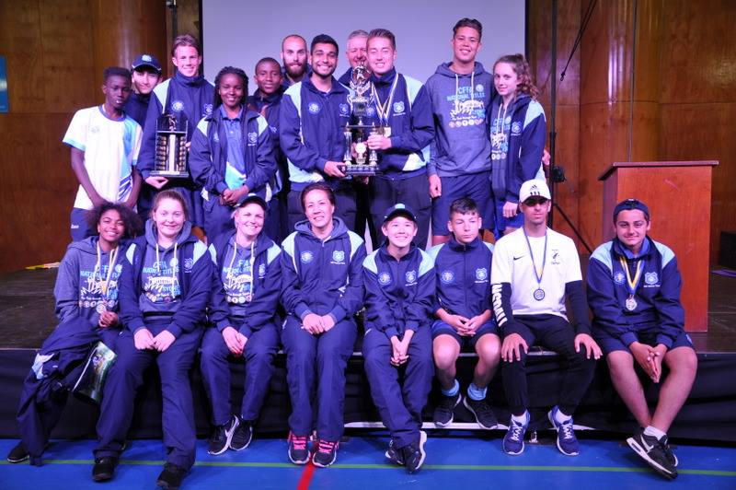

McCredie players and coaches at last year’s National Titles.

IMPORTANT NOTICES
- If for any reason your child is unable to play or attend training you MUST inform your coach or manager AS SOON AS POSSIBLE.

- If you have questions regarding your team ask your manager.

- If it is raining on a Saturday morning call the team manager to see if the game is on. Most often games will still be on so do not just stay at home, you will be letting your child's team down!!!

- Please assist the coach and manager, they are working unpaid for your child. There may be nets to put up or pull down, corner posts to stick in, players to be picked up (particularly if a parent has more than one child playing in different teams) or shirts to wash.

- This Club, the NSW Churches Football Association and Granville District SFA have high expectations of our parents and players. Please support our teams, but no abuse of players or officials will be tolerated and bans or fines could result.

Greg Wark – Secretary 9682 7779

_________________________________________________________________________________

RAIN – WHAT TO DO

It’s raining, it’s Saturday!! Is the game on??

Your manager will know if the game is on, give them a call. Very rarely is a decision made before Friday evening. If I have not called your manager, the game is on, even if it is raining!

Most often games will still be on so do not just stay at home, you will be letting your child's team down!!!

It’s raining and it’s training tonight!! Is training on??

If the ground is closed you cannot train, even if it’s not raining!! Parents and players call the manager or coach.

Granville Park is now in Cumberland Council (not Parramatta) – wet weather line 9294 1418
__________________________________________________________________________________________

