OTB 15/17

Club Secretary – Greg 9682 7779 President – Peter 9632 9203

Interested in sponsoring a team or advertising in this newsletter? – call one of the above numbers.

Check out our website and like us on Facebook.

www.mccredie.org.au/soccer

Junior club Hoodies are now in stock ($35) purchase from the canteen
sizes 6, 10, 12, 14
(size 8 should be available within a week or two)

26th & 28th June
National Titles trials commence for U16 girls (6pm) & AAL (7.30pm) @ Freame Park

27th June
State Cup Final Guildford McCredie vs Wentworthville Uniting

26th August
Grand finals

24th – 28th September
National Titles at Narrabeen

They are at it again!

Our McCredie juniors are all grown up!

Premier League has qualified for their second State Cup final in two years as they seek to defend their title from last season.

Come down and support them this Tuesday night – 7.30pm kick off (25 minute halves)

Jones Park, Banks St., Merrylands

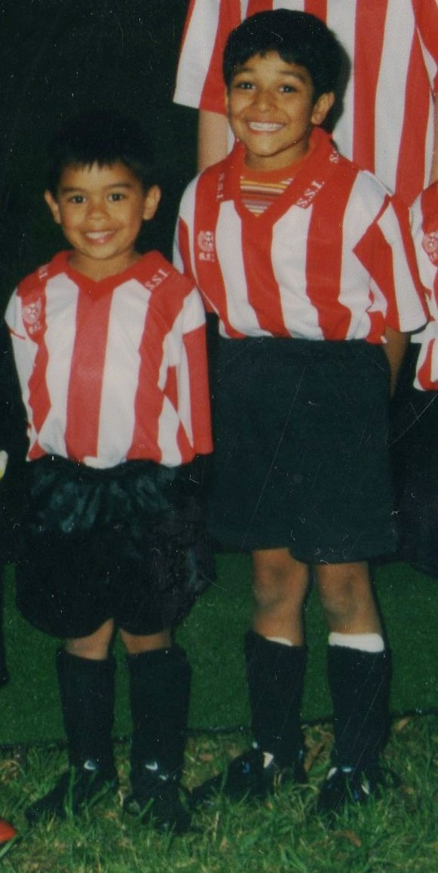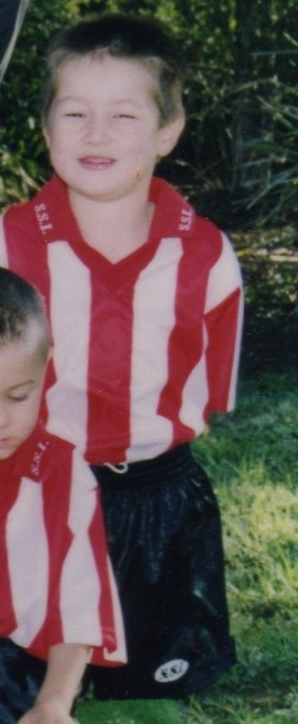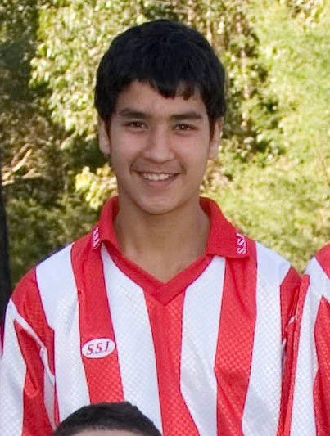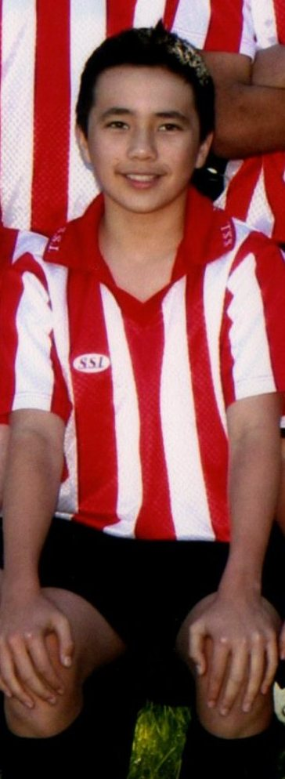

U6 1999 U6 2003 U6 2006 U15 2006 U14 2008 U14 2013 U17 2014

Then
&
Now!

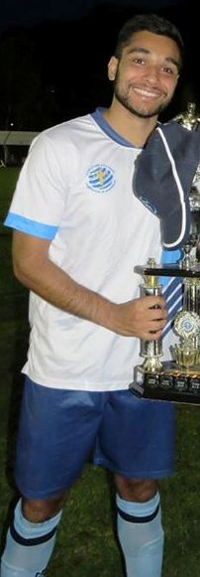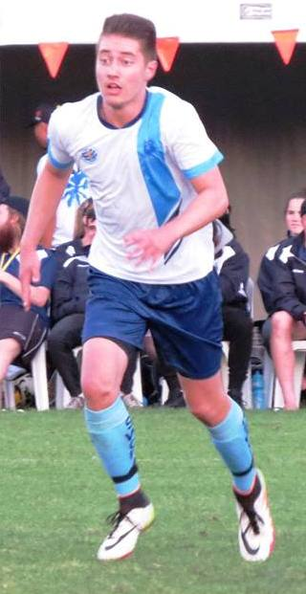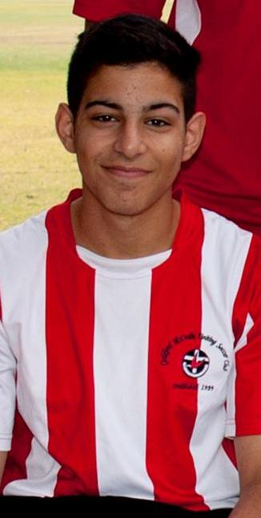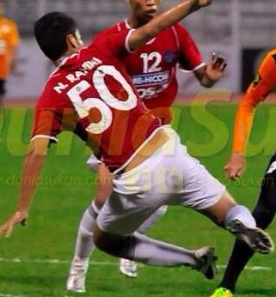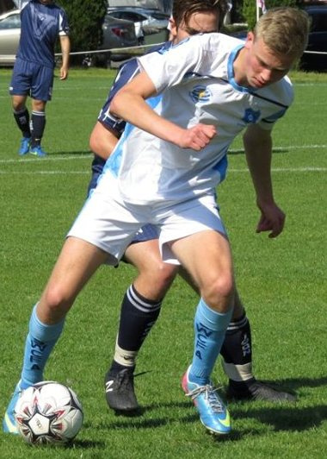
RESULTS – 23rd June (Ladies catchup match)

All Age Ladies Div 3 vs Wenty Waratah 0 - 0
We played well and dominated the match but couldn’t get the goal we needed. Laura Burden was outstanding all match and Nancy continues to improve each week. Kayla and Thuzar also had strong games.

RESULTS – 24th June 2017

U6 Red vs Lidcombe Churches Blue 0 – 1
Emily and Christian were both amazing goal keepers today with both of them saving shots from Lidcombe who were a fair challenge against our Reds. Mete had some good runs today but failed to hit goal, often finding it hard to control the ball with his quick pace. Logan had an outstanding game yet again. Soccer is a team sport and it is unfair to expect one or two players to pull the weight of the team. Unlucky Reds, we'll keep working on it!
Player of the match: Logan

U6 White vs OLQP Falcons Blue 4 - 3
Today's game was a nail biter for Guildford. We faced a tougher opposition in our second match against OLPQ Blue who we thrashed in our first game. It came down to the wire and thankfully we were able to win by 1 point. Our man of the match was Ahmad Agha who with his great ball skills was able to take possession of the ball a number of times throughout the game. He certainly deserves the title this week. In the first half we had Ahmad and William kick great goals and in our second half we had Daniel and Julian score for the team. The boys played well and are learning to pass to each other. Akshan again was a solid player along with Lukacs who jumps in to the crowd to do his bit. Noah also played a good game and was our goalie in the first half. All of the boys have so much energy even after the game!! Well done, we remain undefeated!!
Goal scorers: Ahmad Agha 1, William Livingstone 1, Daniel Depares 1, Julian Azar 1.

U7 Red vs McCredie Grey 4 – 5
It was an early start for our players and it showed in the first half, however the second half saw an amazing change. Lochie was our team captain this week. Izaac and Mardin were our goal keepers. Lual had a massive run across the field. Abatar and Jerone made great saves in the second half and Dani and Neveah were had some great kicks this week.
Player of the week is Abatar Coach’s award goes to Lual.
Goal scorers – Abatar Gurung 2, Lual Deng 1, Jerone Johnson 1

U7 White vs Wentworthville Uniting Gold 1 - 2
Tough game today against Wenty Uniting Gold. Mccredie put up a good fight possessing the ball for the majority of the game. A luck goal saw Wenty defeat us 2-1. Daniel showed off his fancy foot work while Zen, Mustafa, Charbel, Simon and George demonstrated their commitment with impressive defending skills. Player of the match went to Alex again this week. The choice was easy for Ola and Henry as Alex was just outstanding on all fronts. Great effort boys!
Goal scorer – Daniel Alouche 1

U7 Black vs Wentworthville Uniting Blue 8 – 1
It was a great game played by the whole team today so we gave everyone player of the match.
Goal scorers: Yusuf Hadi 3, Bentley Buenen 3, Farooz Maqsoodi 1, Telissa Lee Buenen 1

U7 Grey vs McCredie Red 5 – 4
A great contest today made up of wonderful performances from both teams. We were definitely the stronger side in the first half but we need to work on making our second half performance just as good. The Man of the Match today was Jason. In the first half Jason had some great runs, set up goals and defended amazingly. After some early jitters he made some wonderful saves as goal keeper and ensured our victory. Special mention also goes to Nikolas for his defensive efforts, and for scoring a goal. Stefan made some wonderful saves as goal keeper in the first half, and some nice runs in the second half that almost resulted in a goal or two. Aaron (1 goal) and Mohammad (3 goals) also had a great game up front. Its wonderful to see the growing confidence in Sarim and Aimar who also did well in defence. Aysam chased the ball well today. Special thanks goes to the parents for their support from the sidelines (Thank you John-Paul for your assistant coaching from the side lines which helped the boys). Well done everyone!
Goal Scorers: Mohammad Al Musawi 3, Aaron Kidane, 1, Nikolas Dimitrou 1

U8 vs Western Sydney Academy 0 - 7
There’s not much to say about today - it sucks to lose. We were really unlucky not to score as Sundes had some awesome runs up front. Sunday, our player of the match, ran hard all game – attacking and defending. Farhan and Noah tackled well and George did his best in goals against a strong attack. There are a few things we need to work on at training - both theory and practical so be prepared and on time because we’ll be starting at 5:00pm as Sarah and I have a game at 6:45pm.

U9 Red vs Wentworthville Uniting Gold 2 - 1
We witnessed some good soccer skills today. A true team work facing a component so eager to win. our players held their positions good and worked together to win the game. Hadi our youngest player, showed a big improvement and effort today. Zakariyah was so switched on and deserved the Coach award. well done Zak!!! As for the player of the match it was presented to Simon for an outstanding job as goal keeper. Good on you Joey for being such a strong player in today's game Adhar Lachlan Patrick Wek Telitha Omar and Omeid even while sick showed a good team work. So proud of you all
Goal scorers – Adhar Yaac 2

U9 White vs Wentworthville Uniting Blue 0 – 2
No report

U10 vs OLQP Falcons Red 2 – 0
After twenty one days since the team last played due to wet weather and a bye, the concern for today’s game was that the players would be affected by the lack of game time causing them to become tired and complacent. Fortunately these conditions did not take hold and the team performed very well to win two goals to nil. The first half was a tight affair with the scores locked at nil all. The second half started with an individual goal being scored from the kick off. Paulo was passed the ball from the kick off and he dribbled the ball past four or five defenders to have a shot at goal and beating the keeper. The second goal was scored by Joseph after some very good lead up work by Paulo. Every player performed today, whether playing in defence or in attack. A few errors were also made but the players supported each other and these errors did not impact on the score sheets. Sam, our keeper kept well considering boredom was his biggest opponent today. Our defensive players, Thomas, Hussain, Joseph, Koray and Yusuf kept the defensive line tight, not allowing the opposition to have many shots on goal. Alex, Simon, Lucy, Taylor, Stella and Paulo controlled the midfield and the wide play, while Dylan and Alex played up front. A special mention today for our player of the match, Stella. Stella has shown that her game improves every week. Today, Stella played on the wing, and with ball at her feet, Stella took on the opposition drippling past them and then as they came at her again, she rolled the ball onto her right foot and crossed the ball into the penalty area to our waiting attackers. It is satisfying to see a player eventually having enough confidence in themselves to take on the opposition. The outcome may not always be the way you want it, but at least you have a go.
Goal scorers – Paulo Penaia 1, Joseph Semaan 1

U11 vs Lidcombe Churches Gold 2 – 1
Man of the match Ali Fatlawi
Goal scorers: Sajjad Karimi 1, Jean Paul Azar 1

U12 vs Merrylands SFC 9 - 0
This week our team played a really strong game, we had great positioning and all team players worked really well together to achieve the wanted outcome. Middle fielders and the defenders played really wellMohammed scored three really good goals, Jean Pierre also placed one goal, Mustafa along with Junior and Safal all put one goal each and Makuac scored two leaving us with a great result. The whole team played exceptional game, we had numerous shots that were on target and opportunities we unfortunately missed, however we were the stronger side, great job to all the players.
Goal scorers: Mohammed Matar 3, Makuac Kuol 2, Mustafa Elbizri 1, Junior Penaia 1, and Safal Thapa 1

U13 vs Lidcombe Waratah 0 - 2
Very hard game for our side. Not getting 50/50 calls and not taking our chances cost us in the end. Disappointing result as we really need to start hammering towards to the finals.
Anyway, the season still goes on. Man of the Match : Abdul Agha and Adam Depares

U14/1 vs Auburn District 1 - 7
Playing the undefeated top team with only 11 players we knew we would struggle a bit but the boys hung in there. The score line doesn't reflect how the boys played as we matched them in certain parts. Unfortunately they kept scoring in pairs and it got away. Rahman was fantastic up front slotting a deserved goal and Ryan and Krish were solid in the back. Boys I keep saying if we rule out those silly unnecessary mistakes, we won't leak nearly as many goals
Goal scorer - Abdul Farhan 1

U14/3 vs Regents Park 1 - 4
We had another tough game today, against the joint leaders of the competition. We started well enough and after some good team work and passing sequences produced a nice through ball to Elias, who finished it off with a clinical shot for a nice team goal. So we led 1-0. We surrendered the lead when after some desperate defence had successfully snuffed out a Regents Park raid, we then failed to clear the ball away from our goal well enough. This gave Regents Park possession in our half of the field, which they took advantage of to even up the game. We created a few more half chances before half time, which may have been more productive, if we had of tried to go around the Regents Park defenders, who occupied the centre of the field. Instead, we kept trying to battle our way through them. Consequently we would lose possession and then have to chase the ball around the field to get it back. So we went in at half time 1-1. In the second half, we created a few more half chances, with a breakaway on the counter attack being the best opportunity we had to score. Unfortunately, we again failed to clear the ball away from our goal well enough, especially when we kicked the ball towards the top of the box, where the Regents Park players took full advantage to score 3 unanswered goals. At times, we just kick the ball forward, rather than passing to a team mate, again giving hard won possession away too easily, making it harder for ourselves. The boys tried their best and we showed again today, that we can compete. Liem & Sharfil were our joint players of the match. They worked well together on the right combining effectively in defence & offensively when playing out from the back.
Goal Scorer: Elias Matta 1

U16 vs Dundas United 2 – 2
We have a tough month playing the top 4 sides in a row. But we have started well pushing the undefeated competition leaders today and sharing the points. We were 2-0 up though so it could have been better. We made two errors in defence and they scored twice. Well done to them, but it’s unlucky on our side. We were very good overall today with a brilliant first goal built up through the midfield, down the left and finished clinically. Jeffrey had a man of the match performance today whilst Mahmoud was also very strong.
Goal scorers – Joe Azzi 1, Mehdi Jaffari 1

Sydney Cup Reserves vs Mortdale/Oatley Baptist 2 - 4
We can’t afford to have a poor first half conceding 3 goals to the team coming 1st if we are serious about making the finals. Second half we started strong and played like how we knew we could. Unfortunately, we then returned to our previous poor habits.
Goal scorer: - Ahmad Abdul Hamid 1, An Dao 1

Sydney Cup Firsts vs Sutherland Reformed 2 - 10
The first 20-25 minutes of the 1st half we were dominant. We looked for each other, passed sharply and quickly, were controlled on the ball, didn’t allow them to pressure us and deserved our 2 goals. Unfortunately, that’s when our legs gave out and we couldn’t keep that momentum going. Unfortunately, this is to be expected when the majority of us were doubling up.
Goal scorer: An Dao 2

Premier Reserves vs Greystanes United 1 – 1 when match abandoned following injury
Unfortunately with their keeper breaking both his tibia and fibula early in the second half, play could not continue which was lucky for Greystanes as we had all the momentum and would've taken the game. G finished a lovely goal with his back putting the keeper the wrong way but unfortunately that was our keeper.
Goal scorers – William Wark 1

Premier League vs Greystanes United match postponed following an ambulance being called in reserves

RESULTS – 25th June 2017

All Age Ladies Div 3 vs Holroyd Rangers 4 – 0
Our first decisive victory, on the back of solid defence, some nice passes to our strikers and some clinical finishing. All on top of a much improved team performance and a couple of missing Holroyd players. Kate got to everything first, Kiwi shut down every attack, Sarah made some great runs down the right and Jenna and Laura finished well, and what about Funda’s solo run and finish! Hope you enjoyed the milkshake!
Goal scorers – Jenna Nowlan 2, Laura Herbert 1, Funda Sezgin 1

_________________________________________________________________________________

RAIN – WHAT TO DO

It’s raining, it’s Saturday!! Is the game on??

Your manager will know if the game is on, give them a call. Very rarely is a decision made before Friday evening. If I have not called your manager, the game is on, even if it is raining!

Most often games will still be on so do not just stay at home, you will be letting your child's team down!!!

It’s raining and it’s training tonight!! Is training on??

If the ground is closed you cannot train, even if it’s not raining!! Parents and players call the manager or coach.

Granville Park is now in Cumberland Council (not Parramatta) – wet weather line 9294 1418
__________________________________________________________________________________________

State Cup Final
Tuesday 27th June

Premier League vs Wentworthville Uniting at Jones 1 (Banks St., Merrylands)
7.30pm kick off (meet at Jones at 6.30pm)

Wednesday 28th June – Ladies catch up match

All Age Ladies vs Holroyd Rangers at Guildford West Sportsground 2 (Foray St., Guildford West)
7.30pm Kick off (meet at Guildford West at 6.45pm)

Saturday 1st July 2017

U6 Red vs Kings Old Boys at Homelands (mini) (Homelands Ave., Telopea)

10.00am Kickoff (meet at Homelands at 9.30am)

U6 White vs Parramatta St Patricks at Everley (mini) (Everley Rd., South Granville)

9.00am Kickoff (meet at Everley at 8.15am) (set up field)

U7 Red vs Wentworthville Uniting Gold at Freame (mini) (Rees St., Mays Hill)

9.00am Kickoff (meet at Freame at 8.30am)

U7 White vs St Columbas Castle Hill Orange at Eric Mobbs 2 (Excelsior Ave., Castle Hill)

10.00am Kickoff (meet at Eric Mobbs at 9.30am)

U7 Black vs Lidcombe Churches at Everley (mini) (Everley Rd., South Granville)

10.00am Kickoff (meet at Everley at 9.30am)

U7 Grey vs Wentworthville Uniting Blue at Everley (mini) (Everley Rd., South Granville)

11.00am Kickoff (meet at Everley at 10.30am) (dismantle field)

U8 vs Lidcombe Churches at Everley 2 (Everley Rd., South Granville)

9.00am Kickoff (meet at Everley at 8.00am to set up field)

U9 Red vs Wentworthville Uniting Blue at Freame (Rees St., Mays Hill)

12.00pm Kickoff (meet at Freame at 11.30am)

U9 White vs St Columbas Castle Hill at Everley 2 (Everley Rd., South Granville)

10.00am Kickoff (meet at Everley at 9.30am)

U10 vs OLQP Falcons Red at Everley 2 (Everley Rd., South Granville)
11.00am Kickoff (meet at Everley at 10.30am)

U11 vs Lidcombe Churches Blue at Everley 3 (Everley Rd., South Granville) 11.00am Kickoff (meet at Everley at 10.00am to set up field)

U12 vs Auburn FC Black at Everley 1 (Everley Rd., South Granville) 8.30am Kickoff (meet at Everley at 7.45am to set up field)

U13 vs Auburn District at Everley 1 (Everley Rd., South Granville) 9.45am Kickoff (meet at Everley at 9.15am)

U14/1 vs Parramatta City at Everley 1 (Everley Rd., South Granville) 11.00am Kickoff (meet at Everley at 10.15am)

U14/3 vs Toongabbie White at Girraween 1 (Octavia Rd., Girraween) 11.45am Kickoff (meet at Girraween at 11.15am)

U16 vs Merrylands SFC at Merrylands 2 (Burnett St., Merrylands)

11.55am Kickoff (meet at Merrylands at 11.15am)

Sydney Cup Firsts vs St George Rowing at Everley 1 (Everley Rd., South Granville)
(Reserves Kick off at 1.15pm Firsts at 3.15pm) (Meet at Everley at 12.45pm) (Dismantle Field)

Premier League vs St Barnabas Broadway at Tempe 4 (Holbeach Rd., Tempe)
(Reserves Kick off at 1.15pm Firsts at 3.15pm) (Meet at Tempe at 12.45pm)

Sunday 25th June 2017

All Age Ladies vs Ropes Crossing at Ropes Crossing 5 (Guild Place, Ropes Crossing)

11.00am Kickoff (meet at Ropes Crossing at 10.15am)

IMPORTANT NOTICES
- If for any reason your child is unable to play or attend training you MUST inform your coach or manager AS SOON AS POSSIBLE.

- If you have questions regarding your team ask your manager.

- If it is raining on a Saturday morning call the team manager to see if the game is on. Most often games will still be on so do not just stay at home, you will be letting your child's team down!!!

- Please assist the coach and manager, they are working unpaid for your child. There may be nets to put up or pull down, corner posts to stick in, players to be picked up (particularly if a parent has more than one child playing in different teams) or shirts to wash.

- This Club, the NSW Churches Football Association and Granville District SFA have high expectations of our parents and players. Please support our teams, but no abuse of players or officials will be tolerated and bans or fines could result.

Greg Wark – Secretary 9682 7779

2017 NATIONAL TITLES PLAYER TRIAL DATES
2017 NATIONAL TITLES PLAYER TRIAL DATES
The National Titles Player, Coach & Manager nominations for 2017 are now open.
The 2017 National Titles will be held at Sydney Academy of Sport
& Recreation at Narrabeen from 24th September to 28th September 2017
Players, Coaches and Managers will be expected to live at Narrabeen for the duration of the competition.
The cost of the competition will be $750 per person, this includes
Accommodation, linen, meals, player kit and tournament fee.
To trial for the National titles, please fill out the attached form and bring with you to the trials
http://cfasydney.com.au/2017-national-titles-player-trial-dates/
To be held at Jones Park, Banks St, Merrylands
Under 14 Boys –8th and 13th June, 7pm
Under 16 Boys – 19th and 20th June, 7pm
Under 18 Boys – 19th and 20th June, 7pm
Under 23 Men’s –30th May and 1st June, 7.30pm
Senior Men’s – 30th May and 1st June, 7.30pm
To be held at Freame Park, Rees St, Mays Hill
Under 16 Girls – 26th and 28th June, 6pm
Senior Ladies – 26th and 28th June, 7.30pm

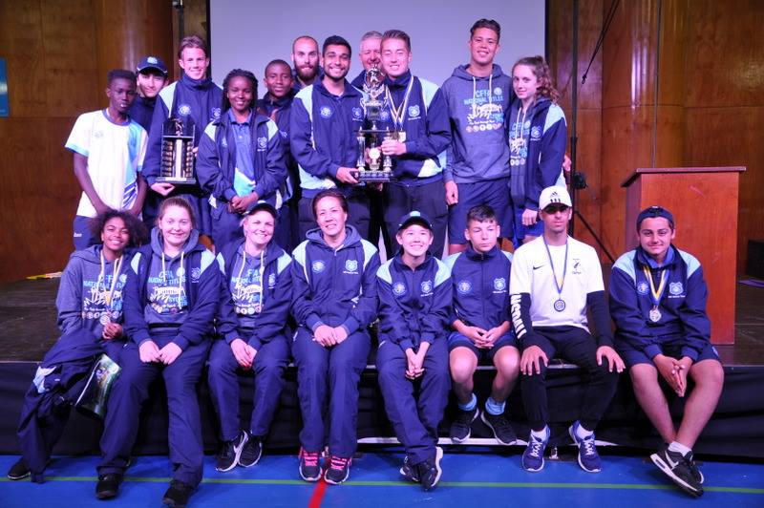

McCredie players and coaches at last year’s National Titles.

