OTB 23/17

Club Secretary – Greg 9682 7779 President – Peter 9632 9203

Interested in sponsoring a team or advertising in this newsletter? – call one of the above numbers.

Check out our website and like us on Facebook.

www.mccredie.org.au/soccer

Junior club Hoodies are now in stock ($35) purchase from the canteen
sizes 6, 10, 12, 14

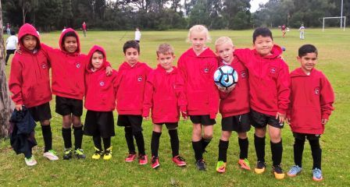

Under 7 Black – rocking their hoodies!

26th August CFA Sydney
Grand finals

2nd September GDSFA
Grand finals

24th – 28th September
National Titles at Narrabeen

10th November
Annual Presentation night

RESULTS – 19th August 2017

U6 Red season finished

U6 White vs Lidcombe Churches Gold 2 – 2 (won on corners)
Today we met our match and just managed to get the win on corners. So proud of the effort of all of the boys. Our man of the match was Julian for his strong ball control and wonderful goal. Akshan, Lukacs and Noah did great defending work. Ahmed and Daniel had some beautiful runs to goal. Can't wait to the final next week!
Goal Scorers: Daniel Depares 1, Julian Azar 1

U7 Red vs McCredie Grey 3 - 4
No report

U7 White vs McCredie Black 4 - 1
Great 4-1 win for the boys today against McCredie Blacks. The boys went in with a 'must win' attitude and worked towards this every minute of the game. Each and every player stepped up and therefore managed to dominate the entire game. Mustafa took player of the match as his 'never give up' attitude was very evident. His defence was exceptional! George E, Alex, Josh and George T impressed the crowd with their defending, stopping the opponents in their tracks. Congratulations to Zen for an amazingly courageous goal and to Simon for scoring 3. Another huge shout out to Daniel for setting up goals and being an all round good sportsman.
Goal scorers – Simon Taouk 3, Zen Shamaa 1

U7 Grey vs McCredie Red 4 - 3
It was a hard fought victory today, with both teams putting in their best performances. 1-3 at half time it seemed like we were facing sure defeat but the boys did not give up and put in a strong attack in the second half. Everyone, was exceptional today. You all had moments that were worthy of 'Man of the Match'. Mohammad showed great team spirit and nominated Aaron for Man of the Match. We all agreed with him as Aaron ran non-stop, tackled hard, made great goal and corner kicks, and a lot more without a rest. Nikolas also put in a Man of the Match performance in defence. He also ran non-stop, shutting down our oppositions attacks and cleared the ball from our half with some rocket kicks (almost scoring a goal from half way). Mohammad scored two goals today (one of them being the winner), and kept pressure on our opposition's defenders and goal keeper with some great runs. Jason was instrumental in stopping attacks and kept getting the ball forward. Stefan, Moussa and Sarim were great defenders today, they tackled hard and passed the ball well. Nikolas, Sarim and Moussa defended so well that Stefan did not have to touch the ball as goal keeper in the second half. Thank you to our wonderful cheer squad of parents whose support helped us get through this nail biter of a game. Great job everyone!!!!
Goal scorers – Mohamed Al Musawi 3, Jason Azar 1

U7 Black vs McCredie White

U8 vs Wentworthville Uniting Blue 1 - 1 (lost on penalties 1-2)
We went into today just proud of the whole team for making it this far, considering only 5 of the boys had ever played in a soccer league before. We went into the first half strong; everyone kept their positions and we had the opposition scared. An excellent through ball from Sunday down the line to Sundes who then made an amazing cross to Husein where he, being in the perfect position, slotted it in for a goal that put us 1-0 up for the whole first half. A combination of fierce attack and impenetrable defence from every single player, Noel, Sunday, Sundes, Husein, Fidaa, Farhan, Noah, Christian, Siar, George, Raphael and Nour, kept the other team panicking until the very end. It was only in the last 10 minutes where the boys got a bit tired, the field got a bit crazy and we unluckily conceded placing us at 1-1 at fulltime. What followed was the most nail-biting 10 minutes of Under 8 Golden Goal history ever; it was amazing to watch these kids keep on fighting despite being so tired. Unfortunately neither team had completely secured another goal and all that was left were the dreaded Penalty Shoot-outs. Our goalkeeper Nour, who had been amazing all game (all season), was unlucky to miss 2 very well placed low, hard and impossible to save goals. We secured 1 of 3 penalties, thanks to William, but unfortunately that wasn’t enough today. However, while we may not have won our semi-final, Sarah and I feel like we have won simply by being your coaches this year because all of you have improved so much this season! Every other team should be scared, because next year we want to come back with all of you and show them what we’re really made of! Thanks for a great season everyone!
Goal Scorer: Husein Abdlkarin 1, William Bausse 1

U9 Red vs Wentworthville Uniting Blue 1 – 2
Goal scorer – Omar Elbizri 1

U9 White vs Lidcombe Churches 0 – 3
It was great for the kids to make the semi finals this year with some very tough competition. Playing the minor premiers was never going to be easy and we played an incredibly strong first half. Only letting 1 soft goal in. But it must have been the energy spent in the last 2 games to get us here that we ran out of a little juice in the second half and after putting in a mighty effort in our last 2 regular season games it wasn't meant to be. Well done U9 whites for 2017 and a big and special thanks to coach Dean for leading the team to the semi's. Enjoy the soccer free Saturdays.

U10 vs Wentworthville Uniting Blue 1 - 2
The end of the season came for us today, not that we were looking for it. The uniforms have already been washed and hung out to dry. Soon enough they will be taken off the line, folded and packed away for next season.
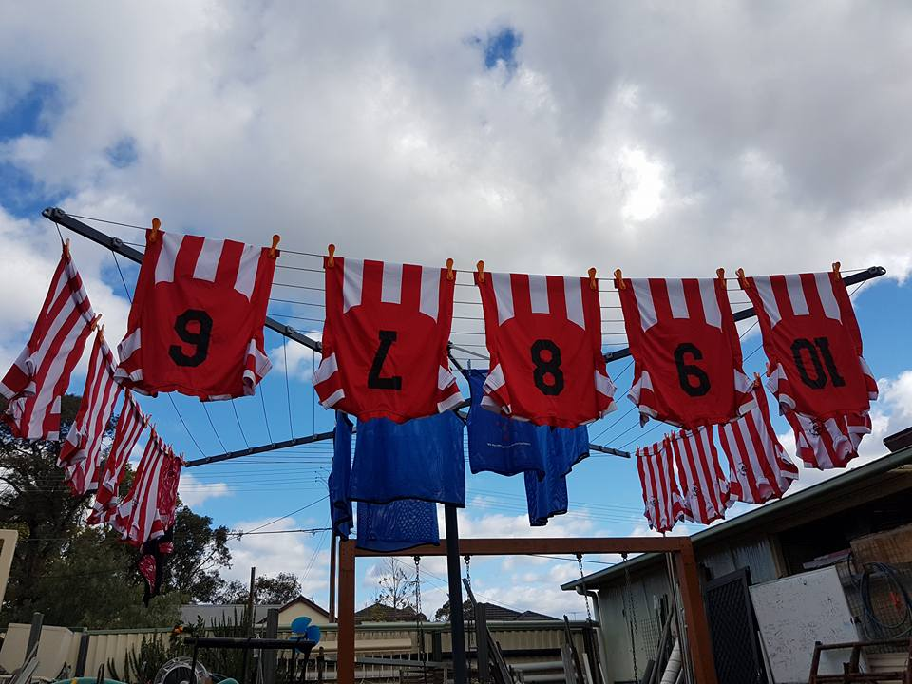
Football can be a treacherous game for the emotions. The loss today is hard to take. As the coach I can’t remember setting any goals for the team at the start of the season, maybe I should have and yet again maybe better that we didn’t. In my first year as a coach I am happy with what the team achieved out of the game and competition. At least the team now has some goals to match and to better in the future.
The game was a tight affair, with both teams obviously trying their best to get the result today. GMU appeared to be under pressure for most of the game. The attacking raids didn’t appear to be in GMU favor. Wentworthville scored an early goal when GMU let the defensive line open. The team then rallied, played some good football and came in at halftime down by only one goal. At the half time break the players were confident that they could win the game and went out for the second half to win the game. The second half was a far better performance from all the players. Up front, Paulo, Joseph, Lucy and Stella came looking for the ball instead of waiting for the ball to come to them. The defensive players, Alex, Hussain, Dylan, Thomas and Yusuf kept the defensive line intact. Taylor and Simon who played roles on the wing and also in the defensive line held their own. And Sam in goals kept well with some good saves. With all this good work, from all the players and with only a couple of minute to go in play, it looked like their efforts would be in vain. But with only a minute to go and attacking the goal, Paulo kicked the ball high lopping the ball over the tall goal keeper forcing it into the back of the net, drawing the game and sending the spectators into raptures and forcing the game into extra time.
At the full time break the team got together and we spoke about keeping the defence tight and for the forwards to come looking for the ball during extra time. I asked the question of the team if they wanted to play in the grand final and they all said yes. They wanted to go the next step.
Extra time was under way and before the third minute was up Wentworthville got the break from what appeared to be an off side play and their best player beat our keeper and the game was over with the golden goal rule. Confusion and disbelief from GMU players and supporters as we were under the assumption that the game would be played with two, five minute periods of extra time as I was informed by the referee after normal full time. No body mentioned golden rule goal before that.
Players of the match were Paulo for his spectacular equalizing goal and to Sam the goal keeper for his great efforts in goal. Thank you all for today’s effort.
Goal scorer - Paulo Santiago Penaia. 1
U11 vs Wentworthville Uniting 5 - 1
We started today's game with Sajjad scoring 3 goals in the first 5 minutes of the game. My nerves were at ease. The boys played well. They passed to each other and were really focused with what was going on. Second half wenty were on fire and put their only goal in but Guildford was roaring with hunger for more goals. Joshua and jean Paul both scored which gave us a 5-1 win. Good luck U11 in the final next week. Man of the match Sajjad
Goal scorers – Sajjad Karimi 3, Joshua Depares 1, Jean Paul Azar 1

U12 vs Auburn FC Black 1 – 2 (in extra time)
First half Mohammed cam through with a great goal from the mid field.Guildford was dominating in the first half with the score being 1-nil our way. Second half the opposition placed a good goal giving them the confidence to take the lead. The draw lasted until full time and we went through to extra time, when unfortunately the opposition scored another goal leaving them in the lead. Guildford didn't play to our full potential, but the other team were dominant on the day. Just to wanted to take this opportunity to say that Austin our goal keeper played exceptionally, with a lot of the pressures of free kicks and penalties and for blocking the majority of the goals
Goal scorer – Mohamed Matar 1

U13 season finished

U14/1 vs Auburn FC 2 – 0
We won the game today from the back. Being against the wind in the first half was a huge task with the back four and Aakrist held out any attacks that were thrown at them. Ibrahim was fantastic up front slotting a goal in the first 5 minutes from a break away and Jackson got on the scorecard for the first time for the club and what a time to do it. Man of the match - Umar for his vision and consistently passing to our team. Boys step 1 of 3 is complete, step 2 is next week beating Pendle Hill and showing them what we have.
Goal scorers - Ibrahim Koroma 1, Jackson Galea 1

U14/3 season finished

U16 vs Lidcombe Churches 1 – 0
We played really well today with the team really stepping up for the big game. Mehdi had his best game of the year and led from the front. Jeffrey was outstanding in midfield too. It is such a joy to see a player listen at training, not take offence when an area that he needs to develop is pointed out and then to see him work on it and improve it. No arguments, no excuses, just intelligence and effort. For these traits Jeffrey takes player of the match today in a team full of good players who played well.
Goal scorer – Ramez Shamoun 1

Sydney Cup Reserves vs St George Rowing 1 – 5
Goal scorer – Jeff Eker 1

Sydney Cup Firsts season finished

Premier Reserves season finished

Premier League vs St Barnabas Broadway 1 – 2
What an unfortunate end to what was an enjoyable season. 2 soft goals were our downfall but that's football. One of the boys said we were cripple FC and he's right with injuries like broken leg, torn ACL, torn Achilles throughout the squad. Nevertheless they will all be back next year fired up with the rest of the squad and I can't wait until next year.
Goal scorer - Angus Chance 1

All Age Ladies Div 3 season finished

Saturday 26th August

U6 White semi final vs OLQP Falcons Yellow at Marconi Stadium Outer field (Restwell Rd., Edensor Park)

9.00am Kickoff (meet at Marconi at 8.15am)

U6 Grand final (for winners of the two semis)

vs TBA at Marconi Stadium (Restwell Rd., Edensor Park)

12.00pm Kickoff

U7 White semi final vs OLQP Falcons Blue at Marconi Stadium Outer field (Restwell Rd., Edensor Park)

10.00am Kickoff (meet at Marconi at 9.15am)

U7 Grey semi final vs OLQP Falcons Red at Marconi Stadium Outer field (Restwell Rd., Edensor Park)

10.00am Kickoff (meet at Marconi at 9.15am)

U7 Grand final (for winners of the two semis)

vs TBA at Marconi Stadium (Restwell Rd., Edensor Park)
12.00pm Kickoff

U11 grand final vs Lidcombe Churches Gold at Marconi Stadium (Restwell Rd., Edensor Park)

11.00am Kickoff (meet at Marconi at 10.15am)

U12 prelim final vs Lidcombe Churches at Coleman 2 (Georges Ave., Lidcombe)
8.45am Kickoff (meet at Coleman at 8.15am)

U14/1 prelim final vs Pendle Hill Tigers at Coleman 2 (Georges Ave., Lidcombe)
10.15am Kickoff (meet at Coleman at 9.30am)

U16 prelim final vs Dundas United at Guildford West Sportsground 2 (Foray St., Guildford West)
10.00am Kickoff (meet at Guildford West at 9.15am)

