OTB 24/17

Club Secretary – Greg 9682 7779 President – Peter 9632 9203

Interested in sponsoring a team or advertising in this newsletter? – call one of the above numbers.

Check out our website and like us on Facebook.

www.mccredie.org.au/soccer

Thank you to all the coaches and managers who have already returned their gear and provided info for presentation. If you haven’t done this yet, can you please do so this week. Thanks.

Hoodies available for purchase – just $35

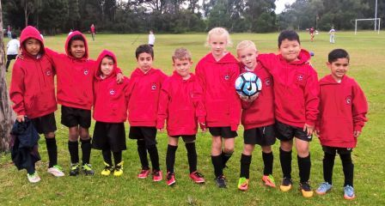

Under 7 Black – rocking their hoodies!

RESULTS – 26th August 2017

U6 White Knockout semi vs OLQP Falcons Yellow 1 – 1 (lost on corners)
Today was a disappointing end to a magnificent season. With only five players on the field with two out with illness (Lukacs and Noah) we couldn't smash our opposition in the usual way. Our player of the match was William who as goalie saved eight goals throughout the game. Without him we would have been in a much worse position. Our opposition today were determined to win and we did not have the power to fend them off all game. A special mention goes to Ahmad who scored our only goal of the match. Akshan and Julian did their best to keep the ball down our end but it was difficult as OLQP were just too strong today. Daniel tried his best to kick his usual superstar goals however he wasn't well himself and wasn't his tip top best however he played a good game despite not being well. Laura as usual did a tremendous job as our coach. Congratulations to her for getting a team of mostly first time players all the way to the semi final. She has been diligent and gentle in her training and the boys have all demonstrated progress and skill development thanks to her. A big thank you also goes to John Paul Azar and Shafick Agha who stepped up to act as coach on game days when Laura wasn't available. Without them the boys would have been in trouble!! It has been a fantastic season and we can't wait to see everyone come back next year to get to the grand final!! Well done Under 6 White's!!!
Goal Scorer: Ahmad Agha 1

U7 White Knockout semi vs OLQP Falcons Blue
No report

U7 White Knockout final vs OLQP Falcons Red 1 – 3
No report

U7 Grey Knockout semi vs OLQP Falcons Red 1 – 1 (lost on corners)
A very close game today against a side that has beat us twice earlier in the season. This shows how far we have come as a team, and you should all be proud of your efforts for making it to the semi-final. You all played your hearts out today and that makes a lucky coach like me very proud. Its been a wonderful journey this season, made up of some nail biters and big wins. It was so wonderful to see your skills develop each week, and I hope you all continue to grow into amazing soccer players (for Guildford McCredie ;) ). Team awards were given out today:
Golden Boot: Mohammed, Best Goal Keeper: Stefan, Most Dependable Player: Aaron
Most Versatile Player: Jason Toughest Defender Award: Nikolas Bravest Defender Award: Moussa
Most Improved/Most Energetic Player: Sarim
A very special thanks goes to the parents for their commitment, support and encouragement throughout the season. Thank you so much for a wonderful season! Hope to see the kids and you all next year.
Goal scorer: Mohammad Al Musawi 1

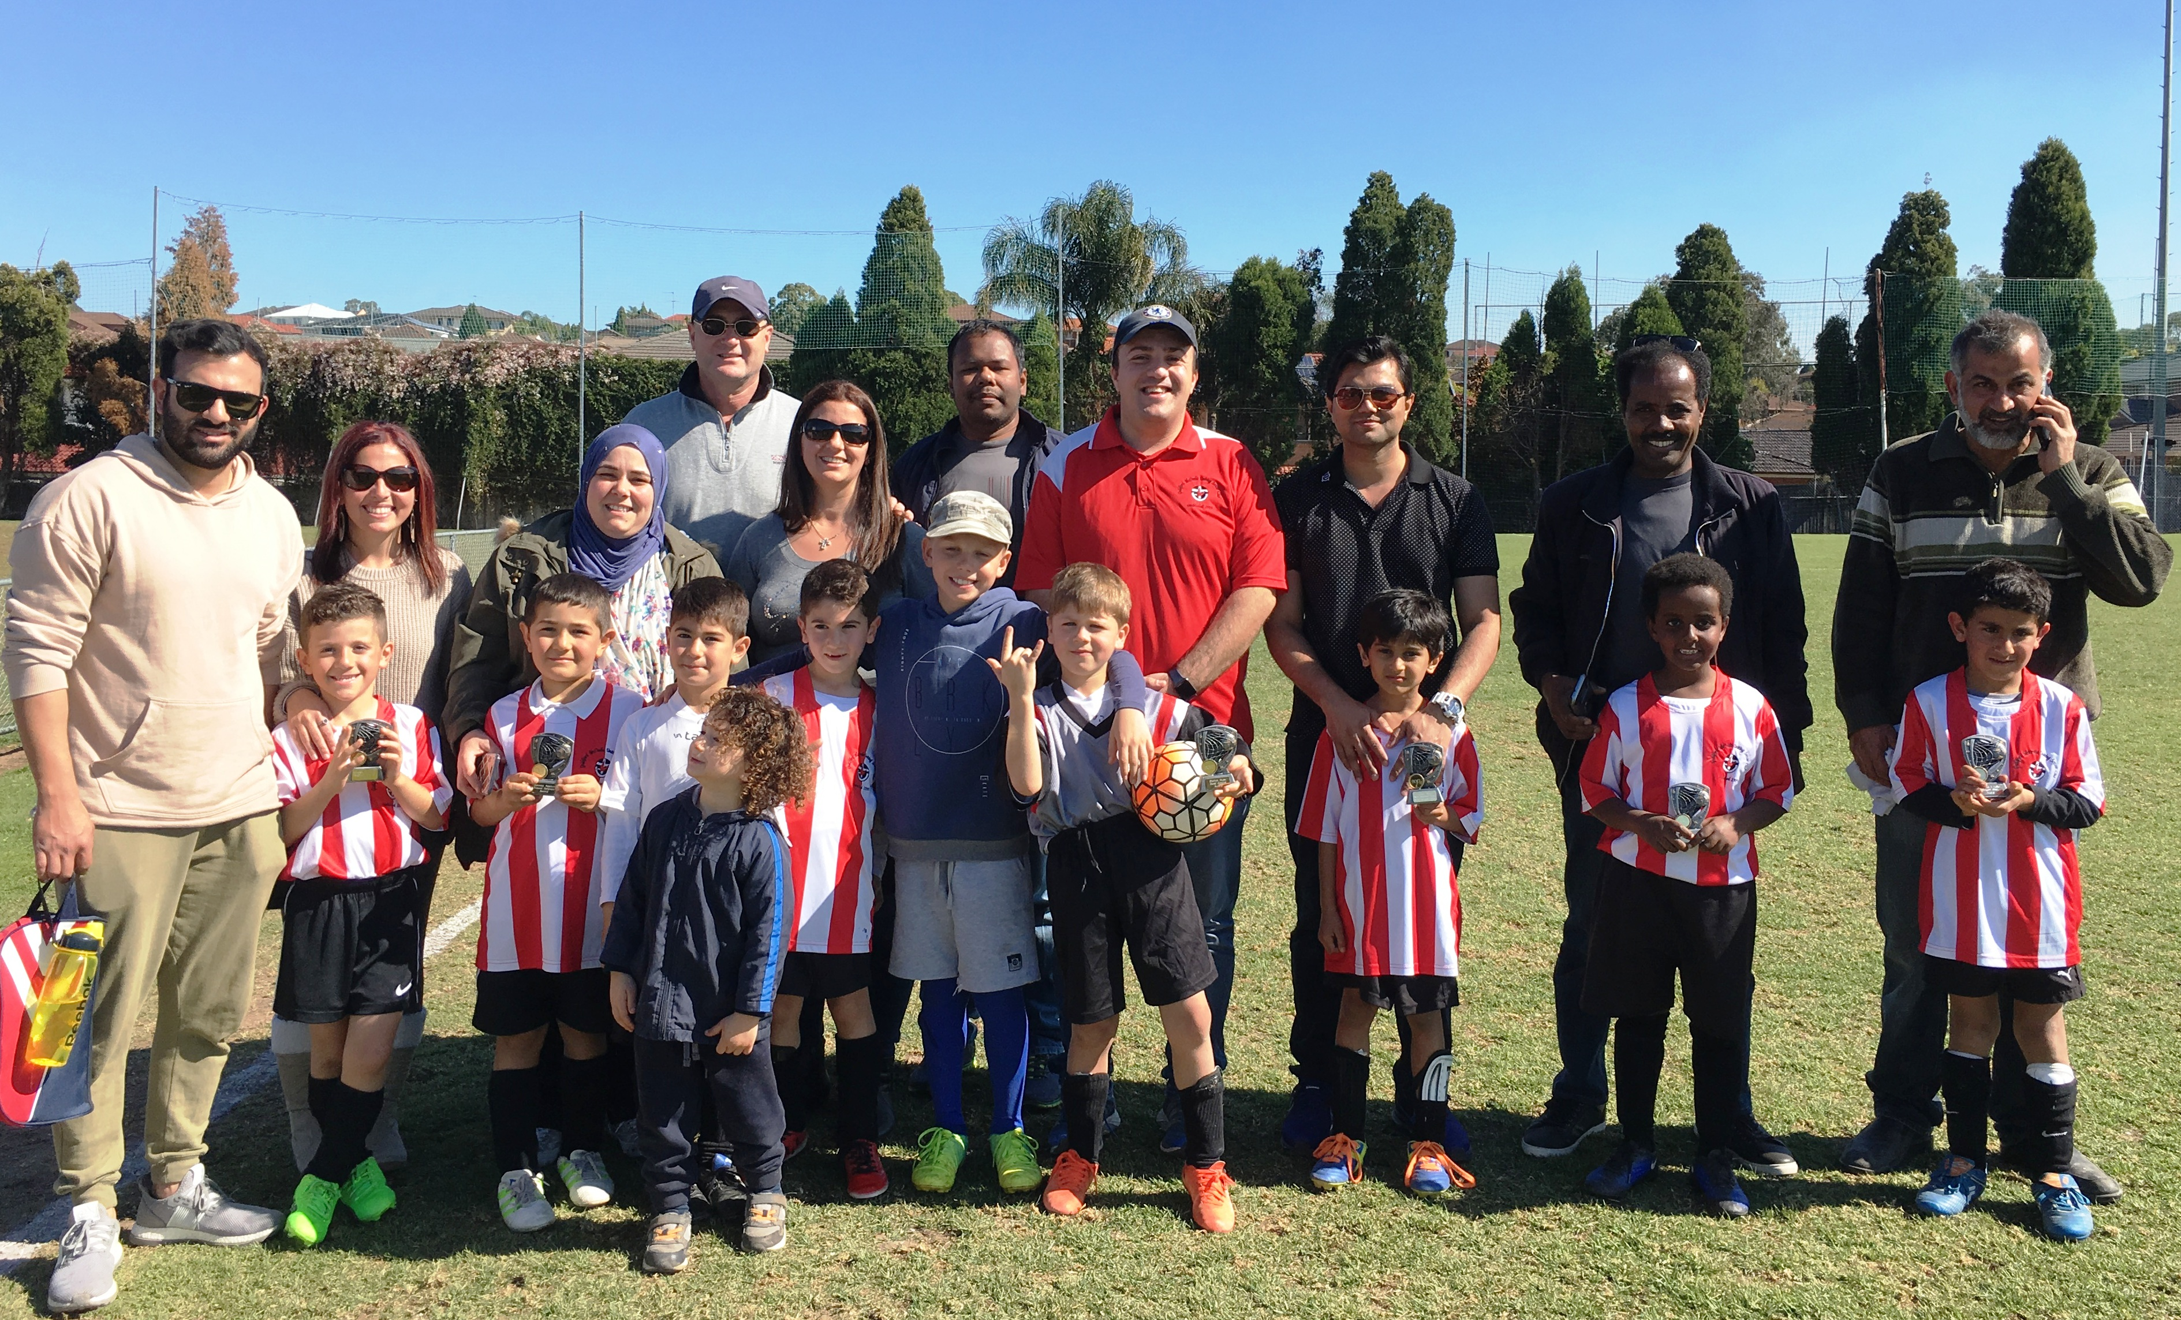
U11 Grand Final vs Lidcombe Churches Gold 1 - 0

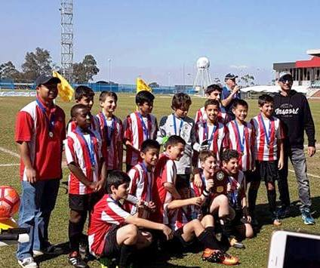
Grand final champions! Today the u11s deserved to win, and win they did. Their enthusiastic spirit and pure enjoyment of the game made them the u11 2017 champions. Well done!
Goal scorer – Joey Farah 1

U12 Preliminary final vs Lidcombe Churches 2 - 4
Goal scorers – Junior Penaia 2

U14/1 Preliminary final vs Pendle Hill Tigers 0 – 2
The only thing we didn't do better than Pendle Hill was score more goals. We had more possession, we had more opportunities and we simply wanted it more but we couldn't stop their two 6ft giants from scoring headers. I had a ball coaching these kids and considering we came second in div 2 in 2016, coming third in div 1 is something to be proud of beating the team who came first in div 2 last year. I hope these guys come back for another season as they are a great bunch of kids and play really good football together. See you all at presentation

U16 Preliminary final vs Dundas United 0 - 2
We gave it everything today, but were beaten by a better team on the day. After a great opportunity in the first minute , we had to wait until 5 minutes from time for our next clear chance. Meanwhile Dundas had scored two, the second a fantastic unstoppable strike from 15 metres. Thank you to all the players for a great season, we played some really good football at times, defeated or challenged all of our opponents and had a good time doing it. Looking forward to doing it all again next season. See you at presentation.

Saturday 2nd September

Sleep in!!

