OTB 5/17

Club Secretary – Greg 9682 7779 President – Peter 9632 9203

Interested in sponsoring a team or advertising in this newsletter? – call one of the above numbers.

Check out our website and like us on Facebook.

www.mccredie.org.au/soccer

IMPORTANT NOTICES
- If for any reason your child is unable to play or attend training you MUST inform your coach or manager AS SOON AS POSSIBLE.

- If you have questions regarding your team ask your manager.

- If it is raining on a Saturday morning call the team manager to see if the game is on. Most often games will still be on so do not just stay at home, you will be letting your child's team down!!!

- Please assist the coach and manager, they are working unpaid for your child. There may be nets to put up or pull down, corner posts to stick in, players to be picked up (particularly if a parent has more than one child playing in different teams) or shirts to wash.

- This Club, the NSW Churches Football Association and Granville District SFA have high expectations of our parents and players. Please support our teams, but no abuse of players or officials will be tolerated and bans or fines could result.

Greg Wark – Secretary 9682 7779

RAIN – WHAT TO DO

It’s raining, it’s Saturday!! Is the game on??

Your manager will know if the game is on, give them a call. Very rarely is a decision made before Friday evening. If I have not called your manager, the game is on, even if it is raining!

Most often games will still be on so do not just stay at home, you will be letting your child's team down!!!

It’s raining and it’s training tonight!! Is training on??

If the ground is closed you cannot train, even if it’s not raining!! Parents and players call the manager or coach.

Granville Park is now in Cumberland Council (not Parramatta) – wet weather line 9294 1418
__________________________________________________________________________________________

Team Coaches and Managers contact details

TEAM |  |  | Phone | Training
U6 RED | Mabel Chen | Manager | 0434 824 555 | Wednesday 5.00pm
U6 RED | Rana Karakus | Coach | 0434 488 457
U6 WHITE | Alison Bausse | Manager | 0410 668 213 | Wednesday 5.00pm
U6 WHITE | Laura Burden | Coach | 0449 830 652
U7 RED | Fiona Feher | Manager | 0435 720 413 | Wednesday 5.30pm
U7 RED | Andy Chung | Coach | 0414 757 682
U7 WHITE | Ola Hamed | Manager | 0405 070 007 | Wednesday 5.30pm
U7 WHITE | Henry Tangi | Coach | 0450 631 567
U7 BLACK | Zoe Webb | Manager | 0406 170 967 | Wednesday 6.00pm
U7 BLACK | Lee Buenen | Coach | 0405 314 218
U7 GREY | Need a volunteer | Manager |  | Tuesday 5.30pm
U7 GREY | Ahmad Hannouf | Coach | 0431 564 830
U8 | Sarah Dubois | Manager | 0435 820 232 | Wednesday 5.30pm
U8 | Elise Burrows | Coach | 0419 475 888
U9 RED | Vera Doueihi | Manager | 0439 063 155 | Wednesday 6.30pm
U9 RED | Andy Chung | Coach
U9 WHITE | Mathew Lu | Manager | 0402 872 478 | Tuesday 5.30 pm
U9 WHITE | Dean Duncan | Coach | 0402 661 786
U10 | Need a volunteer | Manager |  | Tuesday 5.30pm
U10 | Peter Sultana | Coach | 0413 318 962
U11 | Salma Germanos | Manager | 0415 137 733 | Wednesday 6.30pm
U11 | Louis Dolores | Coach | 0413 646 755
U12 | Elaha Hasani | Manager | 0438 606 657 | Wednesday 6.30pm
U12 | Bilal Elbizri | Coach | 0405 789 464
U13 | Brittany Ashford | Manager | 0413 054 649 | Tuesday 6.00pm
U13 | Corey Anderson | Coach | 0434 239 344
U14/1 | Lina Hadid | Manager | 0415 823 442 | Wednesday 6.00pm
U14/1 | William Wark | Coach | 0468 311 297
U14/4 | Stephen & Natalie Durbidge | Manager | 0418 962 893 | Wednesday 6.00pm
U14/4 | Willem Booker | Coach
U16 | Rosemary Farah | Manager | 0403 862 297 | Wednesday 5.15pm
U16 | Greg Wark | Coach | 9682 7779
All Age Ladies | Hendrika Sharwood | Manager | 0420 831 960 | Wednesday 6.45pm
All Age Ladies | Greg Wark | Coach | 9682 7779
Challenge Cup | Masud Shams | Manager | 0412 947 714 | Wednesday 7.30pm
Sydney Cup | Philip Rafter | Manager | 0414 461 371 | Wednesday 7.30pm
Premier League | Philip Rafter | Manager | 0414 461 371 | Wednesday 7.30pm
Premier League | Wil Wark | Captain | 0468 311 297

If for any reason you or your child is unable to play
you must ring your team manager ASAP
(who will relay this information to the coach).
If you have not yet supplied a copy of your child’s birth certificate or passport, please email or forward to your manager THIS WEEK. Your child cannot play until all requirements are met.

RESULTS – Round 1 8th April 2017

U6 Red vs Lidcombe Churches Blue 1 – 3
What an exciting start to the season with every player wanting a piece of the action! Mete did some amazing defending and kicking the ball far along the field multiple times. Charlie played with great enthusiasm. Christian, Emily and Logan did some super kicks during the game. Jeremias and Emaan took turns as goalkeeper with Emaan saving a goal with his handy work. Aiden ended the game scoring an awesome goal for the team! Thank you to all the parents for the 100% attendance despite the last minute changes. Much appreciated! Player of the match : Mete Bedir
Goal scorer – Aiden Sorojevic 1

U6 White vs OLQP Falcons Blue 12 – 0
Under 6’s White had a PHENOMENAL first game. We started strong with nearly all our players present. Our player of the match was Ahmad Agha who scored an amazing 11 goals during the game!! Other key players this week were Julian Azar who was key in setting up two goals and who almost scored himself one in the second half. Another star for the Under 6’s was Daniel Depares who scored a goal and was also instrumental in getting our ball to the goal with some great kicks. There was some great play by Akshan Maskey who put in a good effort along with Isaac Alameddine, William Livingstone and Lukacs Bausse who all put in their best efforts in defending our ball. Well done under 6’s, massive effort.
Goal scorers – Ahmad Agha 11, Daniel Depares 1

U7 Red vs Wentworthville Uniting Blue 17 – 0
No report
Goal scorers: Lual Deng 7, Abatar Gurung 4, Izaac Chung 4, Danielle Sleiman 2.

U7 White vs Bye

U7 Black vs Kings Old Boys 7 – 4
Everyone played a great game and Brendan was man of the match
Goal scorers – Yusuf Hadi 5, Bentley Buenen 2

U7 Grey vs Lidcombe Churches 4 - 0
Lidcombe forfeited today as only 3 of their players turned up. But we still organised a friendly so that the kids could have a run. Our team won the friendly 4-nil. For the first time playing together, our team did really well in communicating, passing and supporting each other during the game. Stand out performances were by Muhammed Al Musawi (2 goals), Jason Azar (1 goal) and Nikolas Dimitriou (1 goal). They each played the full game and kept the pressure on the opposing side for nearly all of the game. Our team also showed great sportsmanship as two of our players (Aimar Bayati & Aaron Kidane) agreed to help out Lidcombe to ensure that we could have a friendly game and everyone shook hands when the game was over. I would also like to thank the parents for ensuring that all our players were on time at the park in spite of the last minute changes. Great day and great work by everyone!
Goal scorers - Muhammed Al Musawi 2, Jason Azar 1, Nikolas Dimitriou 1

U8 vs Wentworthville Uniting Blue 0 - 4
It was our first time touching a ball after weeks of rain so, considering that, we weren’t too bad. However bunching together and a lack of listening cost us today and at training we’re going to work on that – so be ready! Otherwise, for everyone’s first game together, well done; you didn’t give up and tried your best! Our players of the match were Fidaa and Farhan - who played hard, ran with the ball and listened well. Noel and Christian had a great game in goals, stopping some very difficult shots. Good job everyone and we’ll see you Wednesday!

U9 Red vs Wentworthville Uniting Blue 6 – 0


We finally started. First game of the season and what a game!! The team was ready to conquer to field and they did. Everyone in his or her position did their best. In midfield hats off to Lachlan, Joseph and Simon for running well all game. Talitha, Wek and Zakariyah in defence made the opposition tremble. They kept our goal clean as. Adhar, Omar, Patrick and Omeid were on fire; shooting at every occasion. In total it was a team effort and a really good start.
Well done everyone, enjoy your holidays and stay happy, you are champions
Goal scorers – Adhar Yaac 3, Omeid Ahmadzy 2, Omar Elbizri 1

U9 White vs St Columbas Castle Hill 16 – 1
The boys played a great game today winning 16-1
Goal scorers – Samuel Shamoun 11, Mark Sorojevic 2, Lochlan Duncan 1, Badih Ayoub 1, Rylan Roebeck 1

U10 vs OLQP Falcons Blue 6 - 0

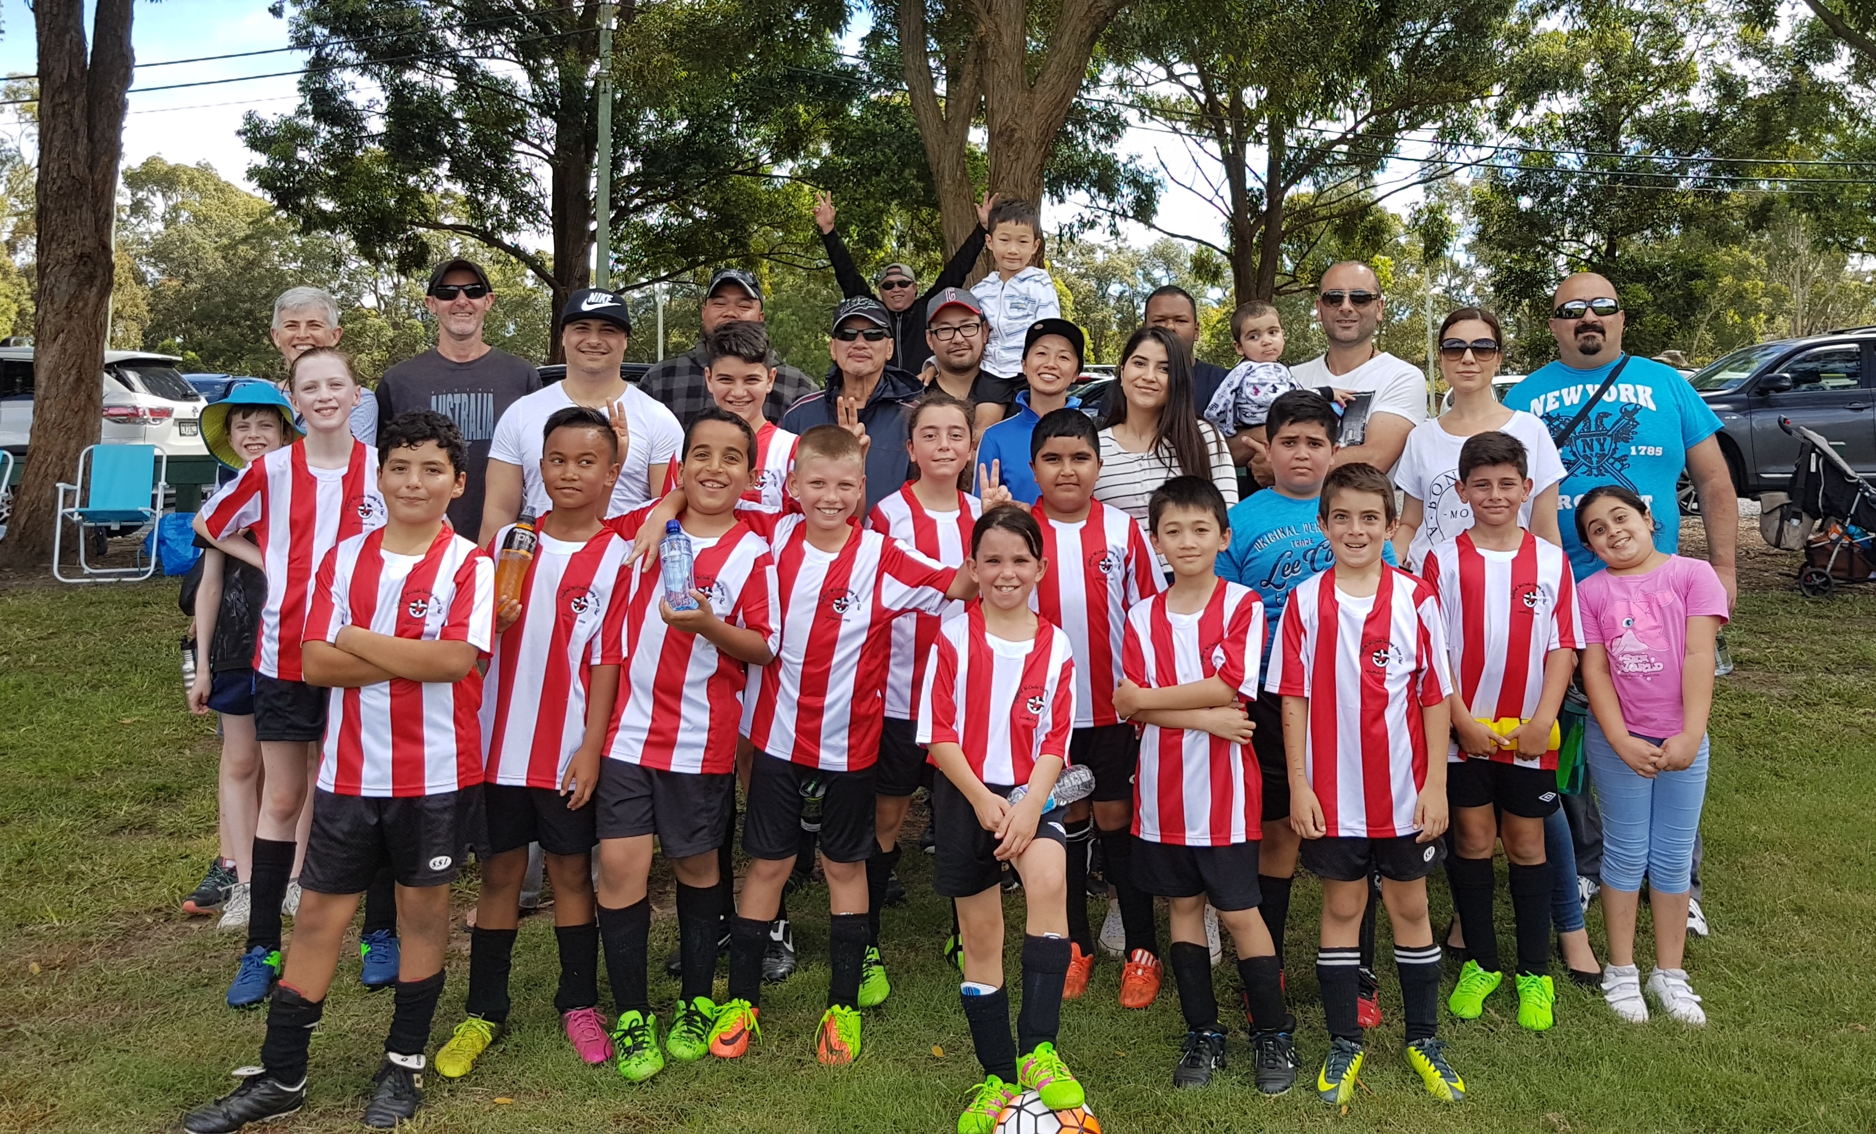

After all the rain and storms leading up to the start of the soccer season, the season finally got underway, albeit, a week later than scheduled and with many changes to starting times and playing venues. Despite all these distractions the under 10 side got together to play their first game of the season against OLQP Falcons Blue at Eric Mobbs Reserve at Castle Hill. The season has started with a very good win, winning 6 goals to nil. The team, made up of players with varying experience in playing soccer were able to string a few passes together, show us what they are capable of and show the supporters that they are very keen to play and learn more about the game. All the players impressed today to try and make the starting 9 in the next game. The player of the match was Paulo Santiago Penaia, scoring four goals on debut and entertaining the supporters with his play in controlling the midfield. Our two goal keepers, Sam Hannouch (first half) and Simon Elzain (2nd half) both kept clean sheets. The midfield and forward line comprising of Alexandru, Joseph, Stella and Paulo created many opportunities for scoring and showed that they are able to pass the ball around to each other and create space. The defence made up of Taylor, Lucy, Hussain and Dylan kept the defence tight making it difficult for the opposition to create scoring chances. The starting reserves this week, Koray, Thomas, Simon and Yusuf also performed when on the field. In conclusion, great effort by all players and supporters on the day. Next week we will try and learn better positional play.
Goal scorers – Paulo Santiago Penaia 4, Jason Semaan 1, Alexandru Rusu 1

U11 vs Lidcombe Churches Blue 8 – 0
Winners are grinners! Great start to the season. The boys were on fire. It must of been the anticipation of playing. Lots of passes and concentration by all players. Goal after goal and than it was all over with a 8-0 win. Good game boys keep it up. Man of the match - Daniel
Goal scorers – Daniel Kvesic 3, Sajjad Karimi 1, Fouad Ayoub 1, Joshua Depares 1, Joey Farah 1, Ali Fatlawi 1

Challenge Cup vs OLQP Falcons 12 - 1
Always difficult to keep disciplined against an opposition playing short and we really should have scored much more.
Goal scorers: - Omer Abdelaziz 4, Ridwan Rahmatullah 2, Abdul Barghachoun 1, Basit Mohammed 1, Belal Khurasani 1, Hedayat Mohammed 1, Irfan Rahmatullah 1, Muhammed Mehcur 1

Sydney Cup Reserves vs St Barnabas Broadway 2 – 2
A little disappointing that we didn’t have 11 players until kick-off. We started strongly despite our lack of organisation but lost shape right at the end to concede. We fought back equalised but also conceded again early in the second half. The second equaliser from Ahmed was a spectacular volley from just inside their half. We were unfortunate not to walk away with all 3 points as we had 2 goals disallowed towards the end of the game. Overall, we should be happy with our result as this was our first run together as a team.
Goal scorers – An Dao 1, Ahmed Abdul Hamid 1

Sydney Cup vs St Barnabas Broadway 2 – 1
The guys from our Challenge squad made up the majority of players as their match is scheduled for Thursday night due to the lack of available grounds by council; which we were very grateful for. Though the majority of the guys know each other it was once again their first proper run together. They created plenty of opportunities around the 18 yard box but lack of match time meant we didn’t capitalise on those opportunities. Unfortunately, the opposition took their first chance late in the first half as we were still getting used to each other. Started off the second half well and got the goals we deserved. The final score probably doesn’t reflect how much we dominated the game but missing opportunities in our first competition match together can be forgiven once we don’t let it become a habit
Goal scorer - Ridwanullah Rahmatullah 2

Premier Reserves vs Greystanes United 2 - 3
Considering that we were wiping 6 months worth of cobwebs and rust, we played quite well. The new players clicked with the returning players and some lovely football was displayed. Not a bad start against last year’s premiers. Paul’s first time hit outside the box was also a sight to see
Goal scorers – Stan Wong 1, Paul Zacharia 1
Premier League vs Greystanes United 5 - 0
Not a bad start to the season with a solid win however we need to work on being more clinical in front of goal and we can turn these 5-0 wins into 9 or 10.
Goal scorers – Adem Stevens 2, Mick Massih 1, Mohammed Shukur 1, Virinder Chaggar 1

Monday 17th April 2017

All Age Ladies TRIAL vs Wentworthville Uniting at Freame (Rees St., Mays Hill)
2.00pm kick off (meet at Freame at 1.15pm)

Saturday 22nd April 2017

U6 Red vs Kings Old Boys at Everley (mini) (Everley Rd., South Granville)

9.00am Kickoff (meet at Everley at 8.00am to set up field)

U6 White vs Parramatta St Patricks Grey at PH Jeffrey (Barton St., North Parramatta)
10.00am Kickoff (meet at PH Jeffrey at 9.30am)

U7 Red vs St Columbas Castle Hill at Everley (mini) (Everley Rd., South Granville)

10.00am Kickoff (meet at Everley at 9.30am)

U7 White vs OLQP Falcons Blue at Everley (mini) (Everley Rd., South Granville)

11.00am Kickoff (meet at Everley at 10.30am) (dismantle field)

U7 Black vs OLQP Falcons Red at Daniel Street 2 (Daniel St., Greystanes)
10.00am Kickoff (meet at Daniel at 9.30am)

U7 Grey vs Kings Old Boys at Homelands (mini) (Homelands Ave., Telopea)
10.00am Kickoff (meet at Homelands 9.30am)

U8 vs OLQP Falcons Blue at Daniel Street 1 (Daniel St., Greystanes)
11.00am Kickoff (meet at Daniel at 10.30am)

U9 Red vs Lidcombe Churches at Everley 2 (Everley Rd., South Granville)

11.00am Kickoff (meet at Everley at 10.00am to set up field)

U9 White vs Wentworthville Uniting Gold at Freame (Rees St., Mays Hill)
11.00am Kickoff (meet at Freame at 10.30am)

U10 vs Wentworthville Uniting Gold at Everley 2 (Everley Rd., South Granville)

12.00pm Kickoff (meet at Everley at 11.30am) (dismantle field)

U11 vs Wentworthville Uniting at Jones 1 (Banks St., Merrylands)
8.35am Kickoff (meet at Jones at 8.00am)

U12 vs Lidcombe Waratah at Coleman 1 (Georges Ave., Lidcombe)
9.00am kick off (meet at Coleman at 8.30am)

U13 vs Guildford County at Ron Mondy (Marian St., Guildford)

11.30am Kickoff (meet at Ron Mondy at 11.00am)

U14/1 Trial game vs Newbury Bulls at Everley 2 (Everley Rd., SouthGranville)

9.30am Kickoff (meet at Everley at 8.30am to set up field)

U14/3 vs Wentworthville Uniting at Everley 1 (Everley Rd., South Granville)

9.30am Kickoff (meet at Everley at 8.30am to set up field)

U16 vs Pendle Hill Black at Everley 1 (Everley Rd., South Granville)

10.45am Kickoff (meet at Everley at 10.00am)

Challenge Cup (Moey) vs Darling Street Anglican at PH Jeffrey (Barton St., North Parramatta)
3.15pm Kickoff (meet at PH Jeffrey at 2.45pm)

Sydney Cup (Phil) vs Wentworthville Uniting Blue at Everley 1 (Everley Rd., South Granville)
(Reserves Kick off at 1.15pm Firsts at 3.15pm) (Meet at Everley at 12.45pm) (dismantle field)

Premier League (Adem/Wil) vs St Barnabas Broadway at Tempe 4 (Holbeach Ave., Tempe)
(Reserves Kick off at 1.15pm Firsts at 3.15pm) (Meet at Tempe at 12.45pm)

Sunday 23rd April 2017

All Age Ladies vs Parklea at Morgan Power 10 (Vardys Rd., Kings Langley)
12.00pm kick off (meet at Morgan Power at 11.15am)

Tuesday 25th April 2017

Challenge Cup (Moey) vs Columna at Beaumont (Bexley Rd., Kingsgrove)
3.15pm Kickoff (meet at Beaumont at 2.45pm)

Sydney Cup (Phil) vs Kings Old Boys at Homelands (Homelands Ave., Telopea)
(Reserves Kick off at 1.15pm Firsts at 3.15pm) (Meet at Homelands at 12.45pm)

Premier League (Adem/Wil) vs Castle Hill Baptist at Everley 1 (Everley Rd., South Granville)
(Reserves Kick off at 1.15pm Firsts at 3.15pm) (Meet at Everley at 12.45pm) (set up & dismantle field)

LAPATHON

The annual lap-a-thon will be held on Wednesday 17th May 2017.

More details in next newsletter.

