OTB 8/17

Club Secretary – Greg 9682 7779 President – Peter 9632 9203

Interested in sponsoring a team or advertising in this newsletter? – call one of the above numbers.

Check out our website and like us on Facebook.

www.mccredie.org.au/soccer
8th May
Referees Course is Monday at 7pm at Dooleys Club, Silverwater Rd, Silverwater
Interested parents, teenagers or senior players - Before you attend the Association Referee course and exam, you must complete the online Laws of the Game Exam. Once you have successfully complete this, you will need to print out your certificate and bring to the Associate referees course. Note: without this certificate you will not be able to complete the Associate Referees course. Web site link https://laws.myfootballclub.com.au/users/signup

9th May
Sydney Cup catch up match 7pm Jones Park, Merrylands

10th May
Challenge Cup catch up match 7pm Jones Park, Merrylands

17th May
Annual LAPATHON – sponsorship form at the end of this newsletter

20th May
Team Photos - U7 Grey, U7 Red, U7 White, U9 Red, U10, U12, U16, PL

21st May
Team Photos –AAL & our U14s begin their State Cup campaign.

27th May
Team Photos – U6 Red, U6 White, U7 Black, U8, U9 White, U11, U13, U14/1, U14/3, CC, SC

27th May
Junior catchup round – teams (U6,7,8,9,10,11) will play two games that day

And in June – six a side on the long weekend for all players and also National Titles trials commence for U14, 16, 18, 23, AAM, AAL – see end of newsletter for details of this event



IMPORTANT NOTICES
- If for any reason your child is unable to play or attend training you MUST inform your coach or manager AS SOON AS POSSIBLE.

- If you have questions regarding your team ask your manager.

- If it is raining on a Saturday morning call the team manager to see if the game is on. Most often games will still be on so do not just stay at home, you will be letting your child's team down!!!

- Please assist the coach and manager, they are working unpaid for your child. There may be nets to put up or pull down, corner posts to stick in, players to be picked up (particularly if a parent has more than one child playing in different teams) or shirts to wash.

- This Club, the NSW Churches Football Association and Granville District SFA have high expectations of our parents and players. Please support our teams, but no abuse of players or officials will be tolerated and bans or fines could result.

Greg Wark – Secretary 9682 7779

RESULTS – catch up match 3rd May 2017

Premier Reserves vs Wentworthville Uniting 2 - 2
Goal scorer - Virinder Chaggar 2

Premier League vs Wentworthville Uniting 3 - 1
Goal scorers - Angus Chance 2, Mohammed Rahimi 1

RESULTS – 6th May 2017

U6 Red vs Wentworthville Uniting 4 – 1

What a game! The Reds played so well today showing that training this week had paid off. Lucky #7 Mete scored his 1st (of many!) hat tricks of the season. Aiden had a golden moment, putting a beautiful left footer in for us during the 2nd half. Christian, Amir and Charlie did some awesome running in our midfield today. It's hard to forget the outstanding defending that came from Logan. The team has definitely shown improvement! A proud coach and manager this week. Player of the match: Mete
Goal scorers: Mete Bedir 3, Aiden Sorojevic 1

U6 White vs Lidcombe Churches 3 - 0
Today’s game was another success for our unstoppable Under 6’s! We held possession for the majority of both halves, but the opposition put up a great effort. Ahmad was instrumental in keeping the ball down at the goal at each opportunity. Daniel took charge a number of times and scored two goals during the game, ensuring our win this week. Lukacs was really involved this week kicking and running the ball as well. Julian scored a fantastic goal in the second half of the game and ran some great balls today also. Isaac continues to make solid progress each week and gets right into play and William also did some great defending and goal keeping in the second half. Our man of the match was Akshan Maskey today. He kicked some great balls and helped to take the game away from the opposition a number of times. He put in a really great effort today! Our team is working well together and building their skills each week. Well done boys!!!
Goal scorers – Daniel Depares 2, Lukacs Bausse 1

U7 Red vs St Columbas Castle Hill Black
What a sunny start to the weekend . All our players were on time and had a great warm up with coach Andy. With no referee it saw coach Andy change hats for the game and become the ref, which was a little confusing for our team however they handled themselves extremely well under the guidance of Sue Sleiman. The under 7 red team had a new player start this week and we welcome Jacob who had a ball on the field with his new teammates. Coach Andy has been focusing on goal keeping skills and passing in training which proved that the children had been listening . Jerome started as a goal keeper and was focused. Danielle, abatar, and Lual consistently had the ball. Nevaeh and Carissa supported their team mates on and off the field. Our weekly award winners are Player of the week Izaac chung for amazing passing and goal scoring. Izaac was a great overall player this week, consistently chasing back and being helpful to his team mates. Coachs award - Lachlan Feher - Hegarty for his fantastic effort as a goal keeper, he made amazing saves and he stayed focused and was a goal keeper for the entire 2nd half of the game. Goal scorers - Izaac Chung 5, Lual Deng 2, Danielle Sleiman 1, Jerone Johnson 1, Abatar Gurung 1, Own goal 1

U7 White vs McCredie Grey 1 - 2
No report Goal scorer – ?

U7 Black vs Wentworthville Uniting Gold 5 – 2
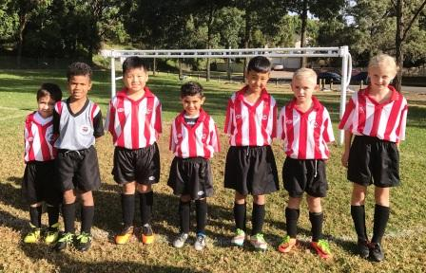
We all played a great game of soccer today. It was a very tough match with a 5/2 win. Yusuf scored another 3 great goals and Bentley slotted 2 in. Well done to our player of the week Brandon who was always chasing down the ball and his defence all our players should be proud of the way you are playing together - keep it up team.
Goal scorers – Yusuf Hadi 3, Bentley Buenen 2

U7 Grey vs McCredie White 2 – 1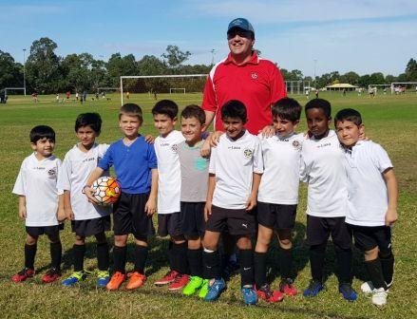
A very entertaining match as both teams played well. It was a great team effort today. The Whites kept Stefan busy as goal keeper throughout the match, but he made some wonderful saves. Aaron and Jason played well at the front, each scoring a goal. Aimar, Muhammed and Nikolas had great runs with the ball through the middle. Sarim, Moussa and Aysam also put in a great effort in defence. I would also like to mention our parents for their consistent encouragement, support and assistance. Well done everyone! Goal Scorers: Aaron Kidane 1, Jason Azar 1.

U8 vs Lidcombe Churches 6 - 6
Great job today by all the boys! We started off great with an early goal thanks to a beautiful pass by Sundes and awesome positioning by Noah, Noah was able to score our first goal of the day. Lidcombe was right on our toes scoring right after us. This continued throughout the game, goal for goal, til we finished up 6-6. Sundes was amazing as striker slotting in 5 goals 3 of which he ran half the field to score. Christian and Sunday were amazing, passing and running all around the field, defending and attacking. The score would of been higher for the other team if it wasnt for Noel's defending and marking and Nour's excellent goal keeping skills, saving 3 shots on goal like a Pro in the last 3 minutes, securing our draw. Noah was our player of the match today: he did not stop running, he kept his position and set up 2 of our goals and scored one himself. Great job Noah! Goal scorers - Sundes Thapa 5, Noah Bosanac1

U9 Red vs McCredie White 5 – 0
Good game U9R. Well done on the win. A few of the goals were just lucky, with the ball just slipping through. But we also had a few missed opportunities today, getting the ball to their goal, but not having someone at the back post ready for a shot. That's why positioning is so important! We also let the opposition break through to attack because our defenders didn't protect the sidelines enough. Thankfully we chased back quick enough, especially Patrick (Coach's Award) & Wek, to protect our goals. Well done also on some good saves, Omar & Simon in goals.
Besides some lucky goals, we also scored a few with some strong attack & shooting, especially Adhar (Player of the Match). Good shooting & support from Wek, Omar, Joey, Omeid & Lachlan.
Goal scorers: Adhar Yaac 3, Wek Deng 1, Lachlan Lin 1, Joey Doueihi 1

U9 White vs McCredie Red 0 - 5
The Reds played very well today dominating the first half with 4 goals. We improved in the second half and will learn a lot from the last 2 weeks. Looking forward to getting back on the winning track.

U10 vs Bye

U11 vs Bye

U12 vs Auburn FC Black 3 - 8
No report Goal scorers - ?

U13 vs Auburn District 7 - 1
3 from 3! Another amazing team performance to come away with a 7-1 win. Although the score line doesn't show it this would have to be the toughest game we have played. The team played well from the first whistle taking a 2-0 lead early, and with some crazy luck managed a few more goals before half time. Auburn came hard at us early in the second half but great defending by Ali and Adam kept the team at bay. I still can't get over how well Katrina and Prashanna are linking up with some amazing passing and running plays to set up a few goals. Rody has lined up for a goal of the season contender with his chip shot from just outside the box. I can't explain how proud I am of today's performance and all the parents who came along and cheered the team on, you guys are the real MVP! Man of the match - Ali and Rody.
Goal Scorers: Rody Aboeid 2, Abdul Agha 2, Prashana KC 1, Mustafa (Neymar) Alizada 1, Gregory Farah 1.

U14/1 vs Auburn District 0 – 3
It wasn't the result we wanted but we were all glad we could see a great team our age play. However, they are not unstoppable nor unbeatable and now that we know how they play, we will be ready next time. The defence were fantastic today led by Aakrist in goals pulling off saves and Jackson sliding in and having the "no fear" attitude. Heads up boys, we will get them next time

U14/3 vs Toongabbie White 2 - 2
Within 2 minutes of kickoff we got the ball up and narrowly missed a goal. This set the scene for the rest of the game as we continued to find ourselves in the attacking third but struggling to score. We made it hard for ourselves by letting them score two soft goals but we dominated in possession and should have easily won this game. Elias did well to score two goals and the midfielders continued to show their strength in the middle of the pitch. But unfortunately we didn't get the win. Looking forward to our next game.
Goal scorer: Elias Matta 2

U16 vs Greystanes FC 5 – 2
Well we started much as we did last match and quickly went down 0 – 2. Fortunately the boys stepped it up defensively and the changes to the formation started to take effect. We weren’t to concede again and went into half time having clawed one back. Mahmoud (having missed training) didn’t play the first half, but his introduction to the game finished it for Greystanes. He was on fire today and scored 4 in the second half. Emtiaz and Nick had great games showing enormous improvement and really impressing the coach. Great game everyone.
Goal scorers – Mahmoud Jalloh 3, Joe Azzi 2

Challenge Cup vs Parramatta St Patricks 1 - 0
Hard to play a good game with no substitutes. Great effort from all the boys. Special mention to Omid Sidiqi who controlled the middle throughout the game. Goal scorer – Ridwan Rahmatullah 1

Sydney Cup
Hasn’t been their week. Lost cards. No card – no play. Hopefully things will be turned around now, with new regos, new cards and midweek catch up games.

Premier Reserves vs Wentworthville Uniting 1 – 0
Great to grind out the win as we always seem to be doing. When we went wide, we looked very dangerous on the wings and G scoring is always a highlight.
Goal scorer - Gerard McKeown 1

Premier League vs Wentworthville Uniting 3 – 0
Firsts v Wentworthville Uniting 3-0
Second time we played these guys in 4 days and great to see the same result. We worked as a team moving the ball around and it pays off with 3 goals. After round 1, we are in first place so you couldn't ask for more than that
Goal scorers - William Wark 2, Amarvir Batth 1

All Age Ladies Div 2 vs Pendle Hill Tigers 1 – 6
The ladies battled on today and were rewarded with our first goal of the season. Laura cannot be pushed off a ball and the finish was clinical. Nyanut played well all game, never giving up, Sayde showed enormous improvement in just her second game, but it is Kiwi at the back who is ensuring the opposition doesn’t have it all their own way. Bye next week and a week off training and hopefully in two weeks our 8 wounded players will be fit for a return.
Goal scorer – Laura Herbert 1

Tuesday 9th May 2017
Catch up matches

Sydney Cup (Phil) vs Wentworthville Uniting Gold at Freame (Rees St., Mays Hill)
(Reserves Kick off at 7.00pm Firsts at 8.15pm) (Meet at Freame at 6.30pm) (35 min halves)

Wednesday 10th May 2017
Catch up matches

Challenge Cup (Moey) vs Parramatta St Patricks at Jones 1 (Banks St., Merrylands)
7.00pm Kickoff (meet at Jones at 6.30pm to set up field) (35 min halves)

Saturday 13th May 2017

U6 Red vs Parramatta St Patricks Grey at PH Jeffrey (Barton St., North Parramatta)

10.00am Kickoff (meet at PH Jeffrey at 9.30am)

U6 White vs Kings Old Boys at Everley (mini) (Everley Rd., South Granville)

9.00am Kickoff (meet at Everley at 8.15am to set up field)

U7 Red vs Kings Old Boys at Homelands reserve (mini) (Homelands Ave., Telopea)

9.00am Kickoff (meet at Homelands at 8.30am)

U7 White vs Wentworthville Uniting Blue at Freame (Rees St., Mays Hill)

9.00am Kickoff (meet at Freame at 8.30am)

U7 Black vs St Columbas Castle Hill Orange at Eric Mobbs 2 (Excelsior Ave., Castle Hill)
11.00am Kickoff (meet at Eric Mobbs at 10.30am)

U7 Grey vs Wenworthville Uniting Gold at Everley (mini) (Everley Rd., South Granville)
10.00am Kickoff (meet at Everley at 9.30am)

U8 vs Kings Old Boys at Everley 2 (Everley Rd., South Granville)

11.00am Kickoff (meet at Everley at 10.00am to set up field)

U9 Red vs Wentworthville Uniting Gold at Freame (Rees St., Mays Hill)

12.00pm Kickoff (meet at Freame at 11.30am)

U9 White vs Wentworthville Uniting Blue at Everley 2 (Everley Rd., South Granville)
12.00pm Kickoff (meet at Everley at 11.30am) (dismantle field)

U10 vs OLQP Falcons Red at Daniel Street 1 (Daniel St., Greystanes)

12.00pm kick off (meet at Daniel Street at 11.30am)

U11 vs Lidcombe Churches Gold at Phillips 1 (Martin St., Lidcombe)
12.00pm kick off (meet at Phillips at 11.30am)

U12 vs Regents Park at Everley 1 (Everley Rd., South Granville)

8.30am Kickoff (meet at Everley at 7.45am to set up field)

U13 vs Toongabbie at Everley 1 (Everley Rd., South Granville) 9.45am Kickoff (meet at Everley at 9.00am)

U14/1 vs Auburn FC at Everley 1 (Everley Rd., South Granville) 11.00am Kickoff (meet at Everley at 10.15am)

U14/3 vs Toongabbie Black at Girraween 1 (Octavia Rd., Girraween)

10.30am Kickoff (meet at Girraween at 10.00am)

U16 vs Dundas United at Curtis 2 (Yates Ave., Dundas)
1.00pm Kickoff (meet at Curtis at 12.15pm)

Challenge Cup (Moey) vs OLQP Falcons at Everley 3 (Everley Rd., South Granville)
1.15pm Kickoff (meet at Everley at 12.15pm to set up field)

Sydney Cup (Phil) vs Gymea Baptist at Everley 1 (Everley Rd., South Granville)
(Reserves Kick off at 1.15pm Firsts at 3.15pm) (Meet at Everley at 12.45pm) (dismantle field)

Premier League (Adem/Wil) vs Greystanes Churches at Jones 1 (Banks St., Merrylands)
(Reserves Kick off at 1.15pm Firsts at 3.15pm) (Meet at Jones at 12.45pm)

Sunday 7th May 2017

All Age Ladies vs Bye

_________________________________________________________________________________

RAIN – WHAT TO DO

It’s raining, it’s Saturday!! Is the game on??

Your manager will know if the game is on, give them a call. Very rarely is a decision made before Friday evening. If I have not called your manager, the game is on, even if it is raining!

Most often games will still be on so do not just stay at home, you will be letting your child's team down!!!

It’s raining and it’s training tonight!! Is training on??

If the ground is closed you cannot train, even if it’s not raining!! Parents and players call the manager or coach.

Granville Park is now in Cumberland Council (not Parramatta) – wet weather line 9294 1418
__________________________________________________________________________________________

.
Clubs like ours are run by volunteers and charge the minimum fees possible to provide football for our community. During the off season our canteen was burgled and vandalized. We have had to purchase a new frig, freezer and pie oven at a cost of $2000. In addition the rain meant the cancellation of our trial matches where we usually make $3000 in canteen profits. This year’s only major fundraiser – our lapathon – takes on increased significance and it is hoped that every club member will actively seek sponsorship and participate.

LAPATHON

Sponsorship form

Wednesday 17th May, 2017

Name | Telephone number | Amount per lap  or the sponsor may choose to donate a total amount. | Total donation
Total amount collected

It is expected that players will complete not more than 30 laps

On the WEDNESDAY 17th May all teams will meet at Granville Park at 5.45 and run from 6pm to 7pm. (There will be no Tuesday or Wednesday training that week)

During the night all players will receive lollies and drinks and a BBQ will operate. This is our only significant fundraiser and it is expected that all players will participate and seek sponsorship prior to the night. This is how we are able to maintain the lowest fees in the district.

Players not attending will not be eligible for special awards at the end of the season.

2017 NATIONAL TITLES PLAYER TRIAL DATES
2017 NATIONAL TITLES PLAYER TRIAL DATES
The National Titles Player, Coach & Manager nominations for 2017 are now open.
The 2017 National Titles will be held at Sydney Academy of Sport
& Recreation at Narrabeen from 24th September to 28th September 2017
Players, Coaches and Managers will be expected to live at Narrabeen for the duration of the competition.
The cost of the competition will be $750 per person, this includes
Accommodation, linen, meals, player kit and tournament fee.
To trial for the National titles, please fill out the attached form and bring with you to the trials
http://cfasydney.com.au/2017-national-titles-player-trial-dates/
To be held at Jones Park, Banks St, Merrylands
Under 14 Boys –8th and 13th June, 7pm
Under 16 Boys – 19th and 20th June, 7pm
Under 18 Boys – 19th and 20th June, 7pm
Under 23 Men’s –30th May and 1st June, 7.30pm
Senior Men’s – 30th May and 1st June, 7.30pm
To be held at Freame Park, Rees St, Mays Hill
Under 16 Girls – 26th and 27th June, 6pm
Senior Ladies – 26th and 27th June, 7.30pm

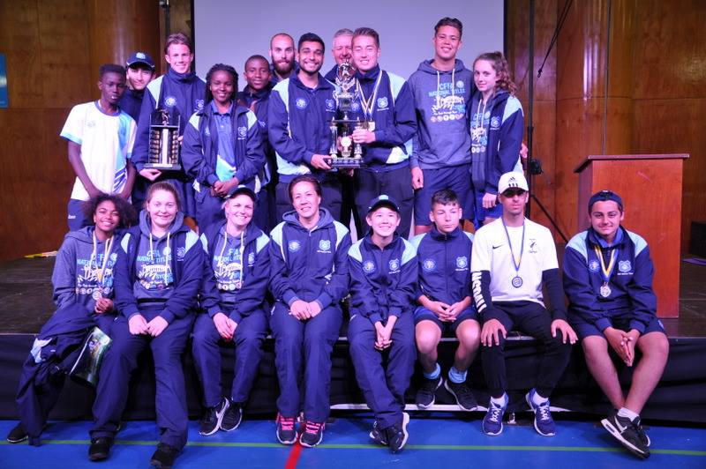

McCredie players and coaches at last year’s National Titles.

