OTB 9/17

Club Secretary – Greg 9682 7779 President – Peter 9632 9203

Interested in sponsoring a team or advertising in this newsletter? – call one of the above numbers.

Check out our website and like us on Facebook.

www.mccredie.org.au/soccer

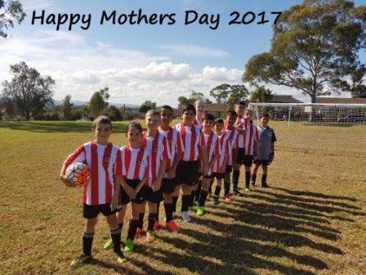

From our club to all the mums!
LAPATHON THIS WEEK



Please approach sponsors (neighbours, friends, family) before Wednesday and complete your sponsorship form.

4pm the field and Barbecue will be set up (any help would be appreciated)

5.30pm coaches and managers will meet and the expectations of the evening will be set out. (Hint: bring a chair and a pen) All coaches and managers are required.

5.45pm All players need to be at the ground with their teams

Whilst players run – lollies and drinks will be distributed to (running) PLAYERS ONLY (not past players’ second cousins!)

The BBQ will be in full swing as the players run feeding anybody at normal sausage sizzle prices.

A mobile disco will play music as the kids run and maybe as they eat their post running sausages.

Managers will count the laps that each child runs.

7pm Runners will stop.

Players not attending will not be eligible for major awards at the end of the season.

_____________________________________________________________________
Vale Betty Williams

Last week our club lost a valued and long time supporter as Betty Williams passed away. Betty was a member of Holroyd Uniting Church for decades and always asked how “the soccer was going”. In our early years as a club Betty was active in our club’s fundraising efforts, attended our club’s presentation and her husband Eric made most of the perpetual shields that we present each year at the end of the season. Our Junior Player of the Year Award is named the Williams Shield in recognition of both Eric and Betty and Betty was able to present this award to the recipient at times. The funeral will be held on Monday 22nd May at Pinegrove.

17th May
Annual LAPATHON – sponsorship form at the end of this newsletter

20th May
Team Photos - U7 Grey, U7 Red, U7 White, U9 Red, U10, U12, U16, PL

21st May
Team Photos –AAL & our U14s begin their State Cup campaign.

27th May
Team Photos – U6 Red, U6 White, U7 Black, U8, U9 White, U11, U13, U14/1, U14/3, CC, SC

27th May
Junior catchup round – teams (U6,7,8,9,10,11) will play two games that day

30th May
National Titles trials commence for U23, AAM @ Jones Park

8th June
National Titles trials commence for U14 boys @ Jones Park

10th June
six a side for U6, 7, 8, 9, 10, 11, 12 and AAL

12th June
Six a side for U13, 14, 15, 16, AAM, O35, AAL catch up round

18th June
Kings Sevens Tournament – interested coaches (U12 to 16 speak to Greg)

19th June
National Titles trials commence for U16 and 18 boys @ Jones Park

26th June
National Titles trials commence for U16 girls & AAL @ Freame Park



IMPORTANT NOTICES
- If for any reason your child is unable to play or attend training you MUST inform your coach or manager AS SOON AS POSSIBLE.

- If you have questions regarding your team ask your manager.

- If it is raining on a Saturday morning call the team manager to see if the game is on. Most often games will still be on so do not just stay at home, you will be letting your child's team down!!!

- Please assist the coach and manager, they are working unpaid for your child. There may be nets to put up or pull down, corner posts to stick in, players to be picked up (particularly if a parent has more than one child playing in different teams) or shirts to wash.

- This Club, the NSW Churches Football Association and Granville District SFA have high expectations of our parents and players. Please support our teams, but no abuse of players or officials will be tolerated and bans or fines could result.

Greg Wark – Secretary 9682 7779

RESULTS – catch up match 9th May 2017

Sydney Cup Reserves vs Wentworthville Uniting Gold 0 – 0
We dominated the game from the first whistle positionally, but couldn’t finish a goal. We probably needed them to cross halfway occasionally to open the game up, as it was we parked on the edge of the 18 yard box and had shots – most of which finished up in the car park.

Sydney Cup vs Wentworthville Uniting Gold 2 - 4
Welcome to the U16 cavalry who have answered the buglers call – you are most welcome! Outplayed here really, hanging with them to be 2-2 at half time, but unable to maintain the effort.
Goal scorer – Abdul Abdul Hamid 2

RESULTS – catch up match 10th May 2017

Challenge Cup vs Parramatta St Patricks 2 - 3
They scored late to win.
Goal scorers: Ridwan Rahmatullah 1, Basit Mohamed 1

RESULTS – 13th May 2017

U6 Red vs Parramatta St Patricks 0 - 2
An extremely frustrating match for our team playing on an exceptionally smaller field than what they are used to at PH Jeffrey Reserve in North Parramatta. The team had plenty of opportunities with the ball however every kick took the ball straight out of the field. Mete, Aiden and Emaan did all they could to keep the ball away from the opposition's goal. While Emily made some excellent saves as goalie. Logan did a great job as defender again this week and also showed everyone his dance moves on the field (he didn't learn it from his mum😂). Unfortunately we let St Pats score 2 goals but given the situation and the kids playing on unfamiliar ground size they put in a awesome effort this week! We'll try our best next week when hopefully our remaining team members return from sick leave. Player of the match: Logan Chen

U6 White vs Kings Old Boys 7 - 5
What a game today. Our Under 6 WHITE’s came very close to our first defeat……but we fought back and took the win!!! Noah played his first game with us after his holiday and put in a great effort today, saving a goal and kicking well. In the first half we had Isaac score his very first goal, joined by Ahmad kicking his first goal in the first half. We sustained a few injuries in this game as our opponents were good players and tough to boot. Ahmad went down in the first half but managed after a short break to get back on the field and score another goal in the second half. Daniel Depares score an amazing four goals today and was our player of the match for his brilliant efforts. Akshan continues to show great promise with his confidence growing each week; Lukacs got in and tried to take control of the ball, saving our possession on a few occasions. Julian also continued to play well this week and took charge of the ball to get it to our goal. Well done boys, another tremendous effort to come back from two down to win the game for the victorious Under 6’s WHITE’s!!!
Goal scorers – Daniel Depares 4, Ahmad Agha 1, Isaac Alameddine 1

U7 Red vs Kings Old Boys 7 - 2

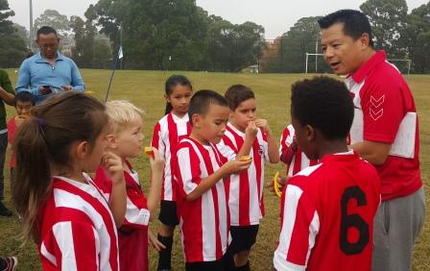
A very early and foggy start for our team we were light on numbers to start , no subs for 20 minutes and the players that started did so well. We played against a team which had some very strong players. Danielle started as a goal keeper and made some great saves as well as getting the ball. Our newest player Jacob was in the pack and kicked well, Nevaeh supported her team mates, Jerone and Lual are fast and furious little boys and are great on the field. Lochie was our goal keeper for a large part of the game after Danielle and made 3 amazing saves. Our rock star of the match was Abatar scoring 6 goals. We have an amazing team and our mum and dads are so supportive with all our players.
From coach andy-
It was really important to play in your positions today and some of you did that really well. Izaac did an amazing job I told him to play in the back and he played in the back and he stayed there even though he is strong in the front or in the middle; he stayed in the back & saved a lot of goals. I think Abatar did play the best game well done Abatar player of the match because you played​ strong in attack but when I put you in the middle you did play in the middle and you defended, and a lot of the times you ran back to help in defence that was amazing. Jacob & Nevaeh,u guys did some amazing big Kicks that was some of the biggest kicks you've done, well done. I'll give the coaches award to Izaac for playing hard in the back and following my instructions really well Izaac thank you for doing that cause that really helped the team
Goal scorer – Abatar Gurung 6, Jerone Johnson 1

U7 White vs Wentworthville Uniting Blue 12 - 2
Our first six goals were scored in the first half. The team had a dynamic start with Charbel as goalie and first 3 goals scored in the first 5 minutes. Steady stream of goal scoring and good defence, often turning the ball back our side. Subs on the sidelines were cheering in unison....it was very cute.
Goal scorers - Zen Shamaa 3, George Tangi 3, Daniel Alouche 3, Simon Taouk 1, Alex Azar 1

U7 Black vs St Columbas Castle Hill Orange 6 - 1
Well done under 7 blacks with a 6-1 win. Everyone played a great game. Our goal scorers were again Yusuf with 3 Bentley with 2 n a big congratulations to Ferooz with his first goal. Our man of the match was Ayden who pulled off some great saves. Our little team is improving each week, keep it up guys
Goal scorers – Yusuf Hadi 3, Bentley Buenen 2, Farooz Maqsoodi 1

U7 Grey vs Wentworthville Uniting Gold 3 – 4
A great team effort today. The score does not reflect how well everyone played today. We had good possession of the ball for most of the game, and had some great runs and shots, but got unlucky at times. We were passing and 'calling-out' for the ball more in this game than previously, which is a nice improvement. Well done to Nikolas, Aaron and Mohammed for each scoring a goal. Stefan was once again fearless in goals and made some amazing saves. It was too hard to identify a 'man of the match' as I felt everyone contributed their best efforts.
Goal Scorers: Aaron Kidane 1, Mohamed Al Musawi 1, Nikolas Dimitriou 1.

U8 vs Kings Old Boys 2 – 1
WE WON!!! Congratulations to the whole team for our first official win of the season! You could clearly see on the field today that all of our hard work at training has paid off. Our defending was key today - as last week we discovered we could score but it was clear our defending needed work. Nour and Noel were moved into the back and it was an awesome decision. Both boys played amazingly; jockeying, marking and tackling all game. Telissa did not stop running, even when all the boys were worn out, she was still going. Sunday was spectacular and very essential in the midfield, defending, attacking and always moving back to his position. And what about Sundes! He is unstoppable - literally- he ran through the whole opposition team after the first kick off and scored in the first 30 seconds. When the other team struck back Sundes kicked off again and again, running around the whole team on his own, scored another amazing goal! Today's players of the match were Sunday and Noel. The boys both worked extremely hard and took direction well throughout the game. Great job Noel and Sunday!
Goal Scorer: Sundes Thapa 2

U9 Red vs Wentworthville Uniting Gold 2 – 0
Another beautiful sunny day at the park that ended with a great win. It was an enjoyable game to watch. Strong defence from both teams. First half quickly finished and still no goals, even though we were controlling the ball most of the time our attempts to score kept missing. We needed to be quicker and take the shot at the first chance. In the second half we knew better and Adhar didn't hesitate to grab his first chance as well as the second to score 2 wonderful goals and finish the game with a win. Every single player did an awesome job today. They played from their heart and pushed till the last whistle. Man of the match trophy was given to Talitha for her continuous effort to bring back the ball to us and coach award was given to Omar for trying his best to score at every chance.
Goal scorer – Adhar Yaac 2

U9 White vs Wentworthville Uniting Blue 1 – 7
Tough game to lose today with our kids going down 1-7. Samuel scoring our only goal.
Goal scorer: Samuel Shamoun 1

U10 vs OLQP Falcons Red 3 – 0
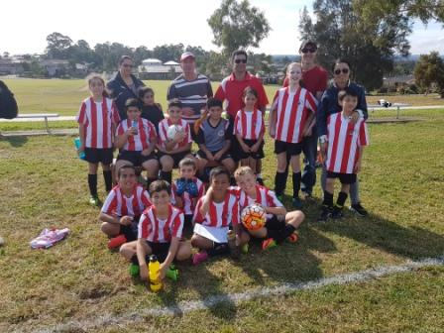
Very happy with the efforts that the team put together today to record a good win and the way the players held their positions during the game. The defensive line controlled by Hussain in the centre back position and assisted by Joseph, Stella and Thomas held firm, not allowing many balls to go through to Simon, the goal keeper. The forward line led by Dylan and Alex today worked hard to create scoring chances with Lucy and Taylor playing on the wings. The game changed when Paulo, Sam and Koray with fresh legs were interchanged leading to our first goal. The team controlled the game for most part of the game and this was evident by the three goals to nil win. Player of the match today went to Hussain for his positional play in the centre back position and holding the defensive line firm.
Goal scorer - Paulo Santiago Penaia. 3

U11 vs Lidcombe Churches Gold 2 – 2
The team played well with lots of attempts at scoring. Sebastian scored a long shot from outside the box. Anthony saved heaps of goals in second half. Man of match Sebastian
Goal scorers – Sebastian Kerr 1, Joey Farah 1

U12 vs Regents Park 6 - 2
Great game this week at Everley. The team really played well with communicating and clearing the ball through to the front. Matthew put in three well organised goals, Mohammed made two goals, and junior made one great goal. The team honestly put in lots of effort and had a great performance. Our team goal keeper Austins made some really good saves that really helped the team. The defender and the midfield really worked hard to keep the score in our favour. Really good overall effort by the whole team.
Goal scorers - Matthew Youssef 3, Mohammed Matar 2, Junior Penaia 1

U13 vs Toongabbie 1 - 5
It is hard for any coach to bring up words after a loss but today I feel that we were very unlucky. We were a much better side than the score indicates and there were many decisions not going our way. Offside decisions are what knocked our team down today. The team should be proud and keep their heads up as no one wins the finals from round 4. All parents and players know it'll be a different outcome next time round. So we just need to keep training hard and working as a team. Player of the match : Katrina
Goal Scorer: Katrina Tamano 1

U14/1 vs Auburn FC 3 - 4
It was one of those days that just didn't go our way. A huge offside goal from Auburn and a couple of silly mistakes cost us 3 goals so when we look at it that way, the 3 points should definitely be ours. Ryan was man of the match as he was excellent in the back making crucial tackles and also netting a header from a great corner
Goal scorers - Atilla Yalcinkaya 2, Ryan Booker 1

U14/3 vs Toongabbie Black 0 - 1

U16 vs Dundas United 1 – 4
There is no question that the better side won today, but there really wasn’t much in it. We were two nil down at half time but a well taken goal from Mahmoud in the first minute of the second half had us back in it. Unfortunately they scored a speculator from wide out and then a mix up between sweeper and keeper allowed a 4th. Jeffrey was very good today as was Mahmoud. Mohamed also had a very strong game in central midfield and never stopped trying.
Goal scorers – Mahmoud Jalloh 1

Challenge Cup vs OLQP Falcons won on forfeit

Sydney Cup Reserves vs Gymea Baptist 2 - 1
Hopefully the lesson of the 1st half will stick with us. In the second half we actually played like a team and we got the win we deserved.
Goal Scorers: M. Salloukh 1, Z. Hamze 1

Sydney Cup Firsts vs Gymea Baptist 1 – 5
Once again lack of preparation cost us early and we conceded 2 early goals. Once we found our shape we were able to go toe-to-toe with them. Unfortunately we struggled to convert our chances and after they got a 3rd goal in the second half we pushed forward which allowed them to get 2 more. Very confidently taken penalty. Thanks to the Challenge Cup players for helping us out.
Goal Scorer: Mahmoud Jalloh 1

Premier Reserves vs Greystanes United 0 – 0
Definitely had the chances but we did well to hold off the numerous Greystanes attacks after being reduced to 10. Good effort from the boys and showed heart all the way till the whistle

Premier League vs Greystanes United 1 – 5
Hopefully this is the one and only bad game of the season
Goal scorer – Mohamed Rahimi 1

All Age Ladies Div 2 vs Bye
State Cup Round 1
Thursday 18th May 2017

Premier League (Adem/Wil) vs Columna at Jones 1 (Banks St., Merrylands)
8.00pm Kickoff (Meet at Jones at 7.30pm) (dismantle field)

Saturday 20th May 2017

U6 Red vs OLQP Falcons Yellow at Everley (mini) (Everley Rd., South Granville)

9.00am Kickoff (meet at Everley at 8.30am for your team photo) set up field

U6 White vs Wentworthville Uniting at Freame (Rees St., Mays Hill)

9.00am Kickoff (meet at Freame at 8.30am)

U7 Red vs OLQP Falcons Blue at Everley (mini) (Everley Rd., South Granville)

11.00am Kickoff (meet at Everley at 10.00am for your team photo)

U7 White vs Lidcombe Churches at Everley (mini) (Everley Rd., South Granville)

12.00pm Kickoff (meet at Everley at 11.00am for your team photo) (dismantle field)

U7 Black vs St Columbas Castle Hill Black at Eric Mobbs 2 (Excelsior Ave., Castle Hill)
10.00am Kickoff (meet at Eric Mobbs at 9.30am)

U7 Grey vs St Columbas Castle Hill Orange at Everley (mini) (Everley Rd., South Granville)
10.00am Kickoff (meet at Everley at 9.15am for your team photo)

U8 vs Bye

U9 Red vs Wentworthville Uniting Blue at Everley 2 (Everley Rd., South Granville)

9.00am Kickoff (meet at Everley at 8.15am for your team photo) set up field

U9 White vs St Columbas Castle Hill at Eric Mobbs 2 (Excelsior Ave., Castle Hill)
11.00am Kickoff (meet at Eric Mobbs at 10.30am)

U10 vs OLQP Falcons Blue at Everley 2 (Everley Rd., South Granville)

10.00am Kickoff (meet at Everley at 9.00am for your team photo) set up field

U11 vs Lidcombe Churches Blue at Phillips 1 (Martin St., Lidcombe)
12.00pm kick off (meet at Phillips at 11.30am)

U12 vs Toongabbie at Everley 1 (Everley Rd., South Granville)

8.30am Kickoff (meet at Everley at 7.45am to set up field and have team photo at 8.00am)

U13 vs Toongabbie White at Girraween 3 (Octavia Rd., Toongabbie) 11.45am Kickoff (meet at Girraween at 11.00am)

U14/1 vs Pendle Hill Tigers at Binalong 1 (Binalong Rd., Old Toongabbie) 9.45am Kickoff (meet at Binalong at 9.00am)

U14/3 vs Wentworthville Uniting White at Jones 1 (Banks St., Merrylands)

9.40am Kickoff (meet at Jones at 9.10am)

U16 vs Merrylands SFC at Everley 1 (Everley Rd., South Granville)

10.45am Kickoff (meet at Everley at 9.45am for team photo)

Challenge Cup (Moey) vs Darling Street Anglican at Tempe 6 (Holbeach Ave., Tempe)
3.15pm Kickoff (meet at Tempe at 2.45pm)

Sydney Cup (Phil) vs Wentworthville Uniting Gold at Jones 2 (Banks St., Merrylands)
(Reserves Kick off at 1.15pm Firsts at 3.15pm) (Meet at Jones 2 at 12.45pm)

Premier League (Adem/Wil) vs St Barnabas Broadway at Everley 1 (Everley Rd., South Granville)
(Reserves Kick off at 1.15pm Firsts at 3.15pm) (Meet at Everley at 12.45pm)
PHOTO AT 2.45pm (dismantle field)

Sunday 21st May 2017

U14/1 Round 2 State Cup vs Hurlstone Park Wanderers at Bennett Park 3 (Karne St., Roselands)
10.15am kick off (meet at Bennett Park at 9.30am)

All Age Ladies vs Glenwood Redbacks at Robin Thomas 1 (Macarthur St., Parramatta)
1.00pm kick off (meet at Robin Thomas at 12pm for photo)

State Cup Round 1
Wednesday 24th May 2017

Sydney Cup (Phil) vs Parramatta St Patricks at Jones 1 (Banks St., Merrylands)
6.30pm Kickoff (Meet at Jones at 6.00pm) (set up field)

_________________________________________________________________________________

RAIN – WHAT TO DO

It’s raining, it’s Saturday!! Is the game on??

Your manager will know if the game is on, give them a call. Very rarely is a decision made before Friday evening. If I have not called your manager, the game is on, even if it is raining!

Most often games will still be on so do not just stay at home, you will be letting your child's team down!!!

It’s raining and it’s training tonight!! Is training on??

If the ground is closed you cannot train, even if it’s not raining!! Parents and players call the manager or coach.

Granville Park is now in Cumberland Council (not Parramatta) – wet weather line 9294 1418
__________________________________________________________________________________________.
Clubs like ours are run by volunteers and charge the minimum fees possible to provide football for our community. During the off season our canteen was burgled and vandalized. We have had to purchase a new frig, freezer and pie oven at a cost of $2000. In addition the rain meant the cancellation of our trial matches where we usually make $3000 in canteen profits. This year’s only major fundraiser – our lapathon – takes on increased significance and it is hoped that every club member will actively seek sponsorship and participate.

LAPATHON

Sponsorship form

Wednesday 17th May, 2017

Name | Telephone number | Amount per lap  or the sponsor may choose to donate a total amount. | Total donation
Total amount collected

It is expected that players will complete not more than 30 laps

On the WEDNESDAY 17th May all teams will meet at Granville Park at 5.45 and run from 6pm to 7pm. (There will be no Tuesday or Wednesday training that week)

During the night all players will receive lollies and drinks and a BBQ will operate. This is our only significant fundraiser and it is expected that all players will participate and seek sponsorship prior to the night. This is how we are able to maintain the lowest fees in the district.

Players not attending will not be eligible for special awards at the end of the season.

2017 NATIONAL TITLES PLAYER TRIAL DATES
2017 NATIONAL TITLES PLAYER TRIAL DATES
The National Titles Player, Coach & Manager nominations for 2017 are now open.
The 2017 National Titles will be held at Sydney Academy of Sport
& Recreation at Narrabeen from 24th September to 28th September 2017
Players, Coaches and Managers will be expected to live at Narrabeen for the duration of the competition.
The cost of the competition will be $750 per person, this includes
Accommodation, linen, meals, player kit and tournament fee.
To trial for the National titles, please fill out the attached form and bring with you to the trials
http://cfasydney.com.au/2017-national-titles-player-trial-dates/
To be held at Jones Park, Banks St, Merrylands
Under 14 Boys –8th and 13th June, 7pm
Under 16 Boys – 19th and 20th June, 7pm
Under 18 Boys – 19th and 20th June, 7pm
Under 23 Men’s –30th May and 1st June, 7.30pm
Senior Men’s – 30th May and 1st June, 7.30pm
To be held at Freame Park, Rees St, Mays Hill
Under 16 Girls – 26th and 27th June, 6pm
Senior Ladies – 26th and 27th June, 7.30pm

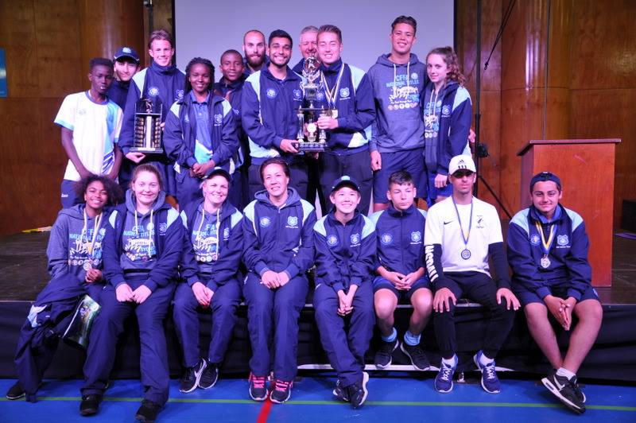

McCredie players and coaches at last year’s National Titles.

