OTB 2/18

Club Secretary – Greg 9682 7779 President – Peter 9632 9203

Interested in sponsoring a team or advertising in this newsletter? – call one of the above numbers.

www.mccredie.org.au/soccer

Like us by clicking the Facebook symbol



IMPORTANT NOTICES
- If for any reason your child is unable to play or attend training you MUST inform your coach or manager AS SOON AS POSSIBLE.

- If you have questions regarding your team ask your manager.

- If it is raining on a Saturday morning call the team manager to see if the game is on. Most often games will still be on so do not just stay at home, you will be letting your child's team down!!!

- Please assist the coach and manager, they are working unpaid for your child. There may be nets to put up or pull down, corner posts to stick in, players to be picked up (particularly if a parent has more than one child playing in different teams) or shirts to wash.

- This Club, the NSW Churches Football Association and Granville District SFA have high expectations of our parents and players. Please support our teams, but no abuse of players or officials will be tolerated and bans or fines could result.

Greg Wark – Secretary 9682 7779

RAIN – WHAT TO DO

It’s raining, it’s Saturday!! Is the game on??

Your manager will know if the game is on, give them a call. Very rarely is a decision made before Friday evening. If I have not called your manager, the game is on, even if it is raining!

Most often games will still be on so do not just stay at home, you will be letting your child's team down!!!

It’s raining and it’s training tonight!! Is training on??

If the ground is closed you cannot train, even if it’s not raining!! Parents and players call the manager or coach.

Granville Park is now in Cumberland Council (not Parramatta) – wet weather line 9735 1299
__________________________________________________________________________________________

Team Coaches and Managers contact details

TEAM |  |  | Phone | Training
U6 RED | Adeel bin Khalid | Manager | 0402 571 834 | Wednesday 5.30pm
U6 RED | Destiny Hutchin-Connor | Coach | 0423 739 887 | Field 1
U6 RED | Gabriel Alalikin | Assistant Coach
U6 WHITE | Sharon Commodore | Manager | 0415 140 086 | Tuesday 5.30pm
U6 WHITE | Peter Sultana | Coach | 0413 318 962 | Field 5
U7 RED | Mabel Chen | Manager | 0434 824 555 | Wednesday 5.30pm
U7 RED | Rana Karakus | Coach | 0434 488 457 | Field 1
U7 WHITE | Alison Bausse | Manager | 0410 668 213 | Mondays 6.30pm
U7 WHITE | Laura Burden | Coach | 0449 830 652 | Field 1
U8 RED | Jennifer Griffiths | Manager | 0466 099 036 | Wednesday 6.00pm
U8 RED | Andy Chung | Coach | 0414 757 682 | Field 5
U8 WHITE | Ola Hamed | Manager | 0405 070 007 | Tuesday 5.30pm
U8 WHITE | Henry Tangi | Coach | 0450 631 567 | Field 5
U8 ONYX | Zoe Webb | Manager | 0406 170 967 | Monday 6.00pm
U8 ONYX | Ahmad Hannouf | Coach | 0431 564 830 | Field 1
U9 RED | Sarah Dubois | Manager | 0432 356 627 | Tuesday 6.30pm
U9 RED | Elise Burrows | Coach | 0419 475 888 | Field 5
U9 WHITE | Shirley Revano | Manager | 0432 307 496 | Tuesday 5.00pm
U9 WHITE | Robert French | Coach | 0412 762 373 | Field 5
U10 RED | Leisel Chung | Manager | 0404 852 612 | Wednesday 5.30pm
U10 RED | Bilal Elbizri | Coach | 0405 789 464 | Field 2
U10 WHITE | Mathew Lu | Manager | 0402 872 478 | Wednesday 6.00pm
U10 WHITE | Tahlia McCabe | Coach | 0432 384 048 | Field 1
U11 RED | Jenna Nowlan | Manager | 0400 730 758 | Wednesday 6.30pm
U11 RED | Darren Allen | Coach | 0421 148 530 | Field 5
U11 GIRLS | Karla Sewell | Manager | 0407 617 352 | Tuesday 6.30pm
U11 GIRLS | Peter Sultana | Coach | 0413 318 962 | Field 5
U12 RED | Salma Germanos | Manager | 0415 137 733 | Wednesday 6.30pm
U12 RED | Louis Dolores | Coach | 0413 646 755 | Field 1
U12 WHITE | Hendrika Sharwood | Manager | 0420 831 960 | Wednesday 6.00pm
U12 WHITE | Ali Chami | Coach | 0410 280 299 | Field 5
U13 | Vera Achkar | Manager | 0422 593 790 | Wednesday 5.30pm
U13 | Duy An Dao | Coach | 0439 063 155 | Field 2
U14 |  |  |  | Wednesday 6.30pm
U14 | Sam Agha | Coach | 0413 940 810 | Field 5
U15/1 | Tim Booker | Manager | 0425 369 138 | Wednesday 6.00pm
U15/1 | William Wark | Coach | 0468 311 297 | Field 2
U15/3 | Stephen & Natalie Durbidge | Manager | 0418 962 893 | Mons & Weds 5.30pm
U15/3 | Glenn Dick | Coach | 0434 885 877 | Field 2
U16 | Rosemary Farah | Manager | 0403 862 297 | Wednesday 5.15pm
U16 | Greg Wark | Coach | 9682 7779
Sydney Cup | Philip Rafter | Manager | 0414 461 371 | Wednesday 7.30pm
Sydney Cup Reserves | Philip Rafter | Manager | 0414 461 371 | Wednesday 7.30pm
Premier League | Mick Massih | Coach |  | Wednesday 7.30pm
Premier League | Amarvir Baath | Manager | 0421 757 818 | Field 1
Premier League | Wil Wark | Captain | 0468 311 297
Premier Reserves | Gerard McKeown | Captain | 0409 710 717 | Wednesday 7.30pm
All Age Ladies | Hendrika Sharwood | Manager | 0420 831 960 | Wednesday 6.45pm
 | Greg Wark | Coach | 9682 7779 | Field 2

Round 1 Reports
Sunday 26th March

U11 Girls vs Newington Gunners 7 – 1
Very hot on the field but great game.
Goal scorers – Stella Fitzgerald 6, Talitha Chung 1

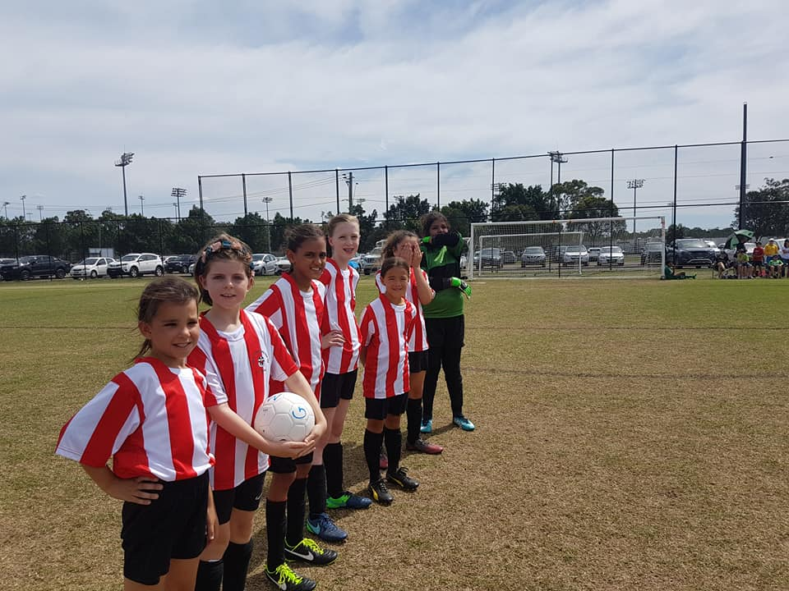

All Age Ladies vs St Patricks washed out
Some late changes to the draw have been highlighted

Saturday 7th April 2018

U6 Red vs OLQP Falcons Red at Everley (mini) (Everley Rd., South Granville)
9.00am Kickoff (meet at Everley at 8.15am to set up field) (dismantle field)

U6 White vs OLQP Falcons Blue at Daniel 2 (Daniel St., Greystanes)

9.00am Kickoff (meet at Daniel at 8.30am)

U7 Red vs Wentworthville Uniting at Freame (mini) (Rees St., Mays Hill)
10.00am Kickoff (meet at Freame at 9.30am)

U7 White vs Bye

U8 Red vs OLQP Falcons Blue at Freame (Rees St., Mays Hill)
9.00am Kickoff (meet at Freame at 8.30am)

U8 White vs OLQP Falcons Red at Everley 2 (Everley Rd., South Granville)

10.00am Kickoff (meet at Everley at 9.00am to set up field)

U8 Onyx vs Western City FC at Phillips 1 (Martin St., Lidcombe)
10.00am Kickoff (meet at Phillips at 9.30am)

U9 Red vs Wentworthville Uniting Gold at Freame (Rees St., Mays Hill)
10.00am Kickoff (meet at Freame at 9.30am)

U9 White vs Wentworthville Uniting Blue at Everley 2 (Everley Rd., South Granville) 11.00am Kickoff (meet at Everley at 10.30am) (dismantle field)

U10 Red vs Bye

U10 White vs Western City FC at Phillips 1 (Martin St., Lidcombe)
12.00pm Kickoff (meet at Phillips at 11.30am)

U11 Red vs Wentworthville Uniting Gold at Everley 1 (Everley Rd., South Granville)
12.00pm Kickoff (meet at Everley at 11.00am to set up field)

U12 Red vs Auburn District at Everley 3 (Everley Rd., South Granville)

9.35am Kickoff (meet at Everley at 9.00am)

U12 White vs Greystanes FC at Everley 3 (Everley Rd., South Granville)
8.30am Kickoff (meet at Everley at 7.45am to set up field)

U13 vs Parramatta City at Primrose Park 1 (John St., Rydalmere)
11.30am Kickoff (meet at Primrose at 11.00am)

U14 vs Rydalmere FC at Everley 3 (Everley Rd., South Granville)

10.40am Kickoff (meet at Everley at 10.10am)

U15/1 vs Auburn District at Progress 2 (Killeen St., Auburn)
11.30am Kickoff (meet at Progress at 10.45am)

U15/3 vs Greystanes FC at Everley 3 (Everley Rd., South Granville))
11.55am Kickoff (meet at Everley at 11.25am) (dismantle field)

U16 vs Rydalmere FC at Rydalmere 3 (South St., Rydalmere)
1.30pm Kickoff (meet at Rydalmere at 12.45pm)

Sydney Cup vs Wentworthville Uniting Blue at Freame (Rees St., Mays Hill)
Reserves kick off at 1.00pm, firsts kick off at 3pm (meet at Freame at 12.30pm)

Premier League vs Greystanes United at Everley 1 (Everley Rd., South Granville)
Reserves kick off at 1.00pm, firsts kick off at 3pm (meet at Everley at 12.30pm)
(dismantle field)

Sunday 8th April 2018

U11 Girls vs Parklea at Morgan Power 7 (Vardys Rd., Kings Langley)
9.00am Kickoff (meet at Morgan Power at 8.30am)

All Age Ladies vs Riverstone at Merrylands 4 (Burnett St., Merrylands)
10.15am Kickoff (meet at Merrylands at 9.30am)

If for any reason you or your child is unable to play
you must ring your team manager ASAP
(who will relay this information to the coach).
Please help.

