OTB 3/18

Club Secretary – Greg 9682 7779 President – Peter 9632 9203

Interested in sponsoring a team or advertising in this newsletter? – call one of the above numbers.

www.mccredie.org.au/soccer

Like us by clicking the Facebook symbol



IMPORTANT NOTICES
- If for any reason your child is unable to play or attend training you MUST inform your coach or manager AS SOON AS POSSIBLE.

- If you have questions regarding your team ask your manager.

- If it is raining on a Saturday morning call the team manager to see if the game is on. Most often games will still be on so do not just stay at home, you will be letting your child's team down!!!

- Please assist the coach and manager, they are working unpaid for your child. There may be nets to put up or pull down, corner posts to stick in, players to be picked up (particularly if a parent has more than one child playing in different teams) or shirts to wash.

- This Club, the NSW Churches Football Association and Granville District SFA have high expectations of our parents and players. Please support our teams, but no abuse of players or officials will be tolerated and bans or fines could result.

Greg Wark – Secretary 9682 7779

RAIN – WHAT TO DO

It’s raining, it’s Saturday!! Is the game on??

Your manager will know if the game is on, give them a call. Very rarely is a decision made before Friday evening. If I have not called your manager, the game is on, even if it is raining!

Most often games will still be on so do not just stay at home, you will be letting your child's team down!!!

It’s raining and it’s training tonight!! Is training on??

If the ground is closed you cannot train, even if it’s not raining!! Parents and players call the manager or coach.

Granville Park is now in Cumberland Council (not Parramatta) – wet weather line 9735 1299
__________________________________________________________________________________________

Team Coaches and Managers contact details

TEAM |  |  | Phone | Training
U6 RED | Adeel bin Khalid | Manager | 0402 571 834 | Wednesday 5.30pm
U6 RED | Destiny Hutchin-Connor | Coach | 0423 739 887 | Field 1
U6 RED | Gabriel Alalikin | Assistant Coach
U6 WHITE | Sharon Commodore | Manager | 0415 140 086 | Tuesday 5.30pm
U6 WHITE | Peter Sultana | Coach | 0413 318 962 | Field 5
U7 RED | Mabel Chen | Manager | 0434 824 555 | Wednesday 5.45pm
U7 RED | Rana Karakus | Coach | 0434 488 457 | Field 1
U7 WHITE | Alison Bausse | Manager | 0410 668 213 | Mondays 6.30pm
U7 WHITE | Laura Burden | Coach | 0449 830 652 | Field 1
U8 RED | Jennifer Griffiths | Manager | 0466 099 036 | Wednesday 6.00pm
U8 RED | Andy Chung | Coach | 0414 757 682 | Field 5
U8 WHITE | Ola Hamed | Manager | 0405 070 007 | Tuesday 5.30pm
U8 WHITE | Lina Azar | Acting Manager | 0421 931 264
U8 WHITE | Henry Tangi | Coach | 0450 631 567 | Field 5
U8 ONYX | Zoe Webb | Manager | 0406 170 967 | Monday 6.00pm
U8 ONYX | Ahmad Hannouf | Coach | 0431 564 830 | Field 1
U9 RED | Sarah Dubois | Manager | 0432 356 627 | Tuesday 6.30pm
U9 RED | Elise Burrows | Coach | 0419 475 888 | Field 5
U9 WHITE | Shirley Revano | Manager | 0432 307 496 | Tuesday 5.00pm
U9 WHITE | Robert French | Coach | 0412 762 373 | Field 5
U10 RED | Leisel Chung | Manager | 0404 852 612 | Wednesday 5.30pm
U10 RED | Bilal Elbizri | Coach | 0405 789 464 | Field 2
U10 WHITE | Mathew Lu | Manager | 0402 872 478 | Wednesday 6.00pm
U10 WHITE | Tahlia McCabe | Coach | 0432 384 048 | Field 1
U11 RED | Jenna Nowlan | Manager | 0400 730 758 | Wednesday 6.30pm
U11 RED | Darren Allen | Coach | 0421 148 530 | Field 5
U11 GIRLS | Karla Sewell | Manager | 0407 617 352 | Tuesday 6.30pm
U11 GIRLS | Peter Sultana | Coach | 0413 318 962 | Field 5
U12 RED | Salma Germanos | Manager | 0415 137 733 | Wednesday 6.30pm
U12 RED | Louis Dolores | Coach | 0413 646 755 | Field 1
U12 WHITE | Hendrika Sharwood | Manager | 0420 831 960 | Wednesday 6.00pm
U12 WHITE | Ali Chami | Coach | 0410 280 299 | Field 5
U13 | Vera Achkar | Manager | 0422 593 790 | Wednesday 5.30pm
U13 | Duy An Dao | Coach | 0439 063 155 | Field 2
U14 |  |  |  | Wednesday 6.30pm
U14 | Sam Agha | Coach | 0413 940 810 | Field 5
U15/1 | Tim Booker | Manager | 0425 369 138 | Wednesday 6.00pm
U15/1 | William Wark | Coach | 0468 311 297 | Field 2
U15/3 | Stephen & Natalie Durbidge | Manager | 0418 962 893 | Mons & Weds 5.30pm
U15/3 | Glenn Dick | Coach | 0434 885 877 | Field 2
U16 | Rosemary Farah | Manager | 0403 862 297 | Wednesday 5.15pm
U16 | Greg Wark | Coach | 9682 7779
Sydney Cup | Philip Rafter | Manager | 0414 461 371 | Wednesday 7.30pm
Sydney Cup Reserves | Philip Rafter | Manager | 0414 461 371 | Wednesday 7.30pm
Premier League | Mick Massih | Coach |  | Wednesday 7.30pm
Premier League | Amarvir Baath | Manager | 0421 757 818 | Field 1
Premier League | Wil Wark | Captain | 0468 311 297
Premier Reserves | Gerard McKeown | Captain | 0409 710 717 | Wednesday 7.30pm
All Age Ladies | Hendrika Sharwood | Manager | 0420 831 960 | Wednesday 6.45pm
 | Greg Wark | Coach | 9682 7779 | Field 2

Results Saturday 7th April 2018

U6 Red vs OLQP Falcons Red 1 – 10
Sireen Adeel was nominated as the player of the match (decided by the coach). She was good at throw ins and kick-offs. Mohamad Shakib Jamei and Ahmed Karkar saved goals while playing at the goal keeper position. Mawein (Angau Deng) played well as a defender and Muhammad Tahir played well at the attacker position. Ghani and Zakkariah worked well in defence blocking attacks.
Goal scorer – Aakash Gurung 1

U6 White vs OLQP Falcons Blue 0 – 6
For our first game, the score may not have gone our way but the team tried for the whole match. Our player of the match was John Tawk.
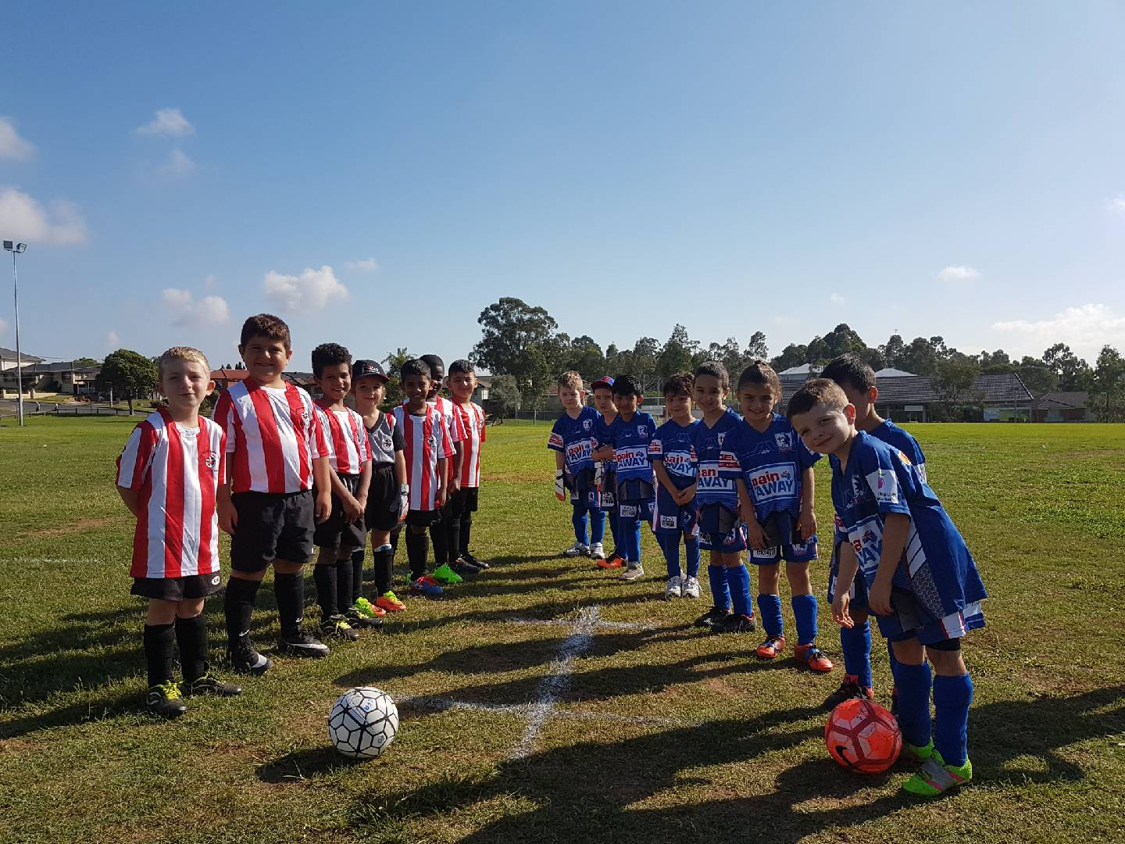

U7 Red vs Wentworthville Uniting 3 – 4
What an exciting first game for the U7 Reds! The game started off with the opposition scoring an early goal, catching us off guard but it wasn't long until the Reds found their footing and started scoring some screamers back! A very happy coach today with Sebasjin who has stepped out of his comfort zone and participated in the game today, his efforts were a major part of our game. Hasib, Ameer and Aiden had great games today with their attempts at goal. Logan and Antonio teamed up in our defensive line and gave Wenty a hard time. Christian was awesome as usual, he did some great work in goal. Akeel was phenomenal, whether it was attacking or defending, Akeel was all-in, which is what soccer is all about! Well done Reds!
Player of the match: Akeel
Goal scorers: Akeel Al Amidi 2 and Ameer-Ahmad Khan 1

U7 White vs Bye

U8 Red vs OLQP Falcons Blue 3 – 2
It was a very warm and muggy morning game today. The team were in attack mode right from the start. Lual broke free and scored a goal. Abatar and Yusuf worked really well together pushing the ball forward. Jacob, Stefan, Mardin, Aaban and Brandon held the defense line and blocked really well. Goalie Gethyn and Danielle made some good saves at the front of the penalty box. Izaac’s pinpoint corner found Yusuf in front of the goal and he easily converted. Hussein and Ahmed came in with fresh legs to tackle and block. Player of match: Izaac for always thinking ahead, which helped him to be at the right place at the right time to kick push the ball forward.
Coach’s award: Aaban for listening and doing as instructed, holding his position
Thank you Hussein (Yusuf’s dad) for coaching today
Goal scorers: Yusuf Hadi 2, Lual Deng 1

U8 White vs OLQP Falcons Red 0 - 3
We started off strong and aggressive being the first official game for the season. George T., Zen and Alex were strong in defence from the the back while Josh, Liyana, Mya, Kaan, Danton and George E. were able to control the ball nicely from the front. We were down 1-nil at the break but everyone was still determined come second half. We kept pushing hard but with the heat and no reserves, fatigue got the better of us in the end with 2 more late goals scored against us. Tough first game for the team but we know where to improve and no doubt will bounce back.

U8 Onyx vs Western City FC 2 - 0
Great way to start the season with a win, but the score line does not reflect the many opportunities that we failed to capitalise on. On the field we missed tackles, failed to communicate and pass the ball to each other, and took too long to shoot in front of goal. However, there were some positive highlights as well. Everyone pushed through the heat and showed great sportsmanship at the end of the game. Mohammed and Jason each got a goal. Bentley and Nikolas made some wonderful runs down the wing and had shots at goal. Farouz was the player of the match for his defensive efforts, including marking opposition players and shutting down their attack (this ensured that Stefan and Aydin were not kept busy as goalkeepers). It was also great to welcome Yonathan to our team today. Thank you to the parents for your support at training and the game today, in spite of the heat and lighting issues at Granville Park. This game showed that we still have some learning to do, but I feel we will get stronger as a team as the season progresses.
Goal scorers: Mohammed Al Musawi 1, Jason Azar 1.

U9 Red vs Wentworthville Uniting Gold 4 – 2
Great way to start off the season with everyone there and a well-deserved win. All the team did their absolute best defending and attacking and it was good to see most players really sticking to their positions. Alisena who is one of 2 new children to the team had a great game in defense and attack and was lucky to slot in 2 very nice goals one from 20 meters out. We also saw great goals from Siar and Husein. Good job everyone. Player of the match- Alisena.
Goals Scores Alisena Mirzaei 2, Siar Hassanzadeh 1, Husein Abdikarin 1

U9 White vs Wentworthville Uniting Blue 0 – 5
No report received

U10 Red vs Bye

U10 White vs Western City FC 7 – 0
What a start to the season. Not having ever played this club before in prior years the team were wary of their opponents. But it was great to have the majority of the players from last year returning and also welcoming a couple of new faces. The kids were excited to play their first game and Coach Tahlia's preseason training paid off, with the kids playing such a fantastic team orientated game. With Sebastian getting 2 goals, Rylan 2 goals and Lochlan, Mark and Badih also getting a goal each. Ethan and Daniel shared goal keeping duties and didn't let a single goal in. Ryan was solid in defence, supported by Matthew and Xavier played an all round excellent game at both ends of the park, earning him player of the match. It was a great game to watch seeing the kids organised on the field passing well and playing with purpose. Well done U10 Whites. Good signs for the rest of the season.
Goal scorers: Sebastian El Katrib 2, Rylan Roebeck 2, Mark Sorojevic 1, Lochlan Duncan 1, Badih Ayoub 1

U11 Red vs Wentworthville Uniting Gold 0 – 1
U11 match report against Wenty- lost 1-0 Great efforts for our first game of the season. Unfortunately we left half time down 1-0 from an own goal! The second half we held possession but couldn’t finish with a goal. We can only improve from here. Bring on next week. Man of the match- Gabra Baram

U12 Red vs Auburn District 1 – 1
Good first game today. Boys must watch their offside and work more on their passing. Overall good performance by the team Mom: Mohammad al Kanaani
Goal scorer - Sajjad Karimi 1

U12 White vs Greystanes FC 6 – 0
For our first game we were all over the opposition. A great run from from Ricky to score 2nd goal.
Nice pass from Sebastian to Jayson who scored 3rd goal. We went on to win 6-0. Nice defending from Mariella. Everyone else played very well in all areas. Great to see the support and encouragement from the parents too.
Goal scorers - Anthony Allam 3, Jayson Nguyen 2, Ricky Dang 1
U13 vs Parramatta City 0 – 8
Yessss not the start that we were hoping for. The score might be disappointing but the effort those boys put into the game was tremendous. It was all about defending our goal and hold on to our positions and supporting each other. The opposition was faster and more eager to score which kept us in our zone for almost the whole game. We knew that we are facing a bigger challenge this season and we will do our best to win it. Commitment to Training and focused team work are the basic rules.

U14 vs Rydalmere FC 3 – 4
No report received

U15/1 vs Auburn District 3 – 7
Up against the minor premiers of last year, we were always expecting a hard day at the office however when Krish went down in the box after 2 minutes, we couldn't have asked for a better start. Losing our keeper for 25 minutes in the first half due to injury didn't help but didn't overshadow our great scrambling and die-hard attitude to end the first half at 1-3. Funnily enough they are 14 just like us, and they made some silly mistakes under pressure which gifted us a couple of goals, however we were nice enough to have done those identical mistakes earlier in the game. Strong games from Aakrist and Bilal and man of the match was Adam.
Goal scorers - Jackson Galea 1, Krish Shrestha 1, Mounir Hadid 1

U15/3 vs Greystanes FC 2 – 3
Greystanes went up 2-0, before we managed to peg back a goal when the team worked the ball nicely up field to Aurelly who then put a nice ball through for Elias to finish it off with his right foot. So we went into half time 2-1 down. The match was still evenly poised, even after Greystanes scored again. With 5 minutes to go we scored another nice team goal when Ali put Sajjad into some space who then finished the movement off nicely. We continued to attack but just couldn’t score another goal. The boys put in a good effort in the heat.
James was our player of the match. He worked hard in defence. His last ditch effort to kick the ball off the goal line saved a certain goal.
Goal Scorers: Elias Matta 1, Sajjad Mousawi 1

U16 vs Rydalmere FC 7 – 1
An impressive start for a team that despite having 4 returning players in key positions, is essentially a new side of first timers. M Naseri was asked to play at sweeper in his first competition game and did really well controlling the defence. Behind him Joel met the rest of the team at kick off and made some great saves in goals to make sure they remembered him. M Alizada controlled the game and up front we are potent with Joe, Mehdi and Mahmoud terrorizing the opposition’s defence. To completely bury Rydalmere we sank two direct free kicks from 25 metres. Congrats also to Shaka – awesome in her return and Zakir and Ameer who listened and tried really hard to do as the coach asked. Zakir’s effort in the second half tracking his opponent back 40 metres to be there when the cross came through and disrupt them, was particularly impressive.
Goal scorers – Joe Azzi 3, Mahmoud Jalloh 1, Mohamed Alizada 1, Mehdi Jaffari 1, Mohamed Naseri 1

Sydney Cup Reserves vs Wentworthville Uniting Blue 2 – 6
Tough afternoon against some young and quick opposition. Unfortunately, our lack of team work was our undoing and not the opposition as in parts we were better than them. All things considered this wasn't a bad result considering we are mostly a new team and our opponents have played all through juniors together. That said we didn't really help ourselves by rocking up late to our very first game with a whole bunch of new players.
Goal scorers: - Ahmad Abdul Hamid 1, Mohamed Abdul Hamid 1

Sydney Cup vs Wentworthville Uniting Blue 6 - 0
We had a number of new players like reserves but our structure meant we started the game on the right foot. Our early domination meant we were never really troubled. The second half was a write off as we descended to their level. We should have worked on our combinations and structure as we will play much tougher opposition. I hope the bad habits we picked up in the second half don't continue into the next game.
Goal scorers: - Virinder Chaggar 2, Steven Ghadieh 2, Abdul Abdul Hamid 1, own goal 1

Premier League vs Greystanes United 0 – 0
Not a terrible result playing against the premiers of last year, unfortunately we just couldn't find the back of the net.

Premier League vs Greystanes United 1 - 2
Really disappointing result as we were very short on numbers (thanks to all reserves graders who helped out) and could've easily had got the result we wanted if we had our full strength side. Next round hopefully we set things right.
Goal scorer - William Wark 1

Results Sunday 8th April 2018

U11 Girls vs Parklea 10 – 0
Congratulations to Lucy who has been playing soccer for GMU for 7 years and scored her very first goal today. All the girls played really well. Also a special mention to the goal keeper Huda for stopping the other team from scoring any goals.
Goal scorers – Stella Fitzpatrick 7, Anika Penitani 2, Lucy Sultana 1

All Age Ladies vs Riverstone 3 – 3
We were probably fortunate to grab a draw, but it doesn’t seem so when with 3 minutes to go we had stolen the lead. Giving it up in the last minute was very frustrating. Jenna and Hendrika were outstanding and lead our defence which was under pressure all match. We created very few goal scoring opportunities so Mika taking advantage of them twice is also worth mentioning. Tahlia and Talisha in their debuts today were impressive central midfielders in the making.
Goal scorers – Mika Oo 2, Tahlia McCabe 1
20th Anniversary Dinner

We are looking for interested people to assist in the organising of our 20th anniversary dinner in August.

Please send me an email or speak to me in person if you are interested.

Thanks,

Greg

Saturday 14th April 2018

U6 Red vs Bye

U6 White vs Kings Old Boys at Everley (mini) (Everley Rd., South Granville) 9.00am Kickoff (meet at Everley at 8.30am) (set up field)

U7 Red vs International Soccer Academy at Everley (mini) (Everley Rd., South Granville) 10.00am Kickoff (meet at Everley at 9.30am) (dismantle field)

U7 White vs Lidcombe Churches Gold at Phillips 1 (Martin St., Lidcombe)
10.00am Kickoff (meet at Phillips at 9.30am)

U8 Red vs McCredie Onyx at Everley 2 (Everley Rd., South Granville) 10.00am Kickoff (meet at Everley at 9.30am)

U8 White vs St Columbas Castle Hill Black at Everley 2 (Everley Rd., South Granville)

9.00am Kickoff (meet at Everley at 8.00am to set up field)

U8 Onyx vs McCredie Red at Everley 2 (Everley Rd., South Granville) 10.00am Kickoff (meet at Everley at 9.30am)

U9 Red vs Wentworthville Uniting Blue at Freame (Rees St., Mays Hill)
10.00am Kickoff (meet at Freame at 9.30am)

U9 White vs OLQP Falcons Red at Everley 2 (Everley Rd., South Granville) 12.00pm Kickoff (meet at Everley at 11.30am) (dismantle field)

U10 Red vs International Soccer Academy at Phillips 1 (Martin St., Lidcombe)
12.00pm Kickoff (meet at Phillips at 11.30am)

U10 White vs OLQP Falcons at Everley 2 (Everley Rd., South Granville)
11.00am Kickoff (meet at Everley at 10.30am)

U11 Red vs Wentworthville Uniting Blue at Everley 3 (Everley Rd., South Granville)
11.00am Kickoff (meet at Everley at 10.00am to set up field) (dismantle field)

U12 Red vs Greystanes at Bathurst Street 1 (Bathurst St., Greystanes)

9.25am Kickoff (meet at Bathurst Street at 8.55am)

U12 White vs Wentworthville Uniting at Jones 1 (Banks St., Merrylands)
8.30am Kickoff (meet at Jones at 8.00am)

U13 vs Pendle Hill Tigers at Everley 1 (Everley Rd., South Granville)

8.30am Kickoff (meet at Everley at 7.45am to set up field)

U14 vs Regents Park at Princes Park 1 (Princes Rd., Auburn)

10.20am Kickoff (meet at Princes at 9.50am)

U15/1 vs Wentworthville Uniting at Everley 1 (Everley Rd., South Granville)

9.45am Kickoff (meet at Everley at 9.00am)

U15/3 vs Granville Waratah at Robin Thomas 1 (Macarthur St., Parramatta)
11.30am Kickoff (meet at Robin Thomas at 11.00am)

U16 vs Merrylands SFC at Everley 1 (Everley Rd., South Granville)

11.10am Kickoff (meet at Everley at 10.30am)

Sydney Cup vs St George Rowing at Yatama (Alfred Rd., Clemton Park)
Reserves kick off at 1.00pm, firsts kick off at 3pm (meet at Yatama at 12.30pm)

Premier League vs Kings Old Boys at Everley 1 (Everley Rd., South Granville)
Reserves kick off at 1.00pm, firsts kick off at 3pm (meet at Everley at 12.30pm)
(dismantle field)

Sunday 15th April 2018

U11 Girls vs Guildford County at Binalong 1 (Binalong Rd., Old Toongabbie)
11.00am Kickoff (meet at Binalong at 10.30am)

All Age Ladies vs Greystanes at Binalong 6 (Binalong Rd., Old Toongabbie)
9.00am Kickoff (meet at Binalong at 8.15am)

If for any reason you or your child is unable to play
you must ring your team manager ASAP
(who will relay this information to the coach).

