OTB 4/18

Club Secretary – Greg 9682 7779 President – Peter 9632 9203

Interested in sponsoring a team or advertising in this newsletter? – call one of the above numbers.

www.mccredie.org.au/soccer

Like us by clicking the Facebook symbol



IMPORTANT NOTICES
- If for any reason your child is unable to play or attend training you MUST inform your coach or manager AS SOON AS POSSIBLE.

- If you have questions regarding your team ask your manager.

- If it is raining on a Saturday morning call the team manager to see if the game is on. Most often games will still be on so do not just stay at home, you will be letting your child's team down!!!

- Please assist the coach and manager, they are working unpaid for your child. There may be nets to put up or pull down, corner posts to stick in, players to be picked up (particularly if a parent has more than one child playing in different teams) or shirts to wash.

- This Club, the NSW Churches Football Association and Granville District SFA have high expectations of our parents and players. Please support our teams, but no abuse of players or officials will be tolerated and bans or fines could result.

Greg Wark – Secretary 9682 7779

RAIN – WHAT TO DO

It’s raining, it’s Saturday!! Is the game on??

Your manager will know if the game is on, give them a call. Very rarely is a decision made before Friday evening. If I have not called your manager, the game is on, even if it is raining!

Most often games will still be on so do not just stay at home, you will be letting your child's team down!!!

It’s raining and it’s training tonight!! Is training on??

If the ground is closed you cannot train, even if it’s not raining!! Parents and players call the manager or coach.

Granville Park is now in Cumberland Council (not Parramatta) – wet weather line 9735 1299
__________________________________________________________________________________________

LAPATHON

Sponsorship form

Wednesday 2nd May, 2018

Name | Telephone number | Amount per lap  or the sponsor may choose to donate a total amount. | Total donation
Total amount collected

It is expected that players will complete not more than 30 laps

On the WEDNESDAY 2nd May all teams will meet at Granville Park at 5.45 and run from 6pm to 7pm. (There will be no Tuesday or Wednesday training that week)

During the night all players will receive lollies and drinks and a BBQ will operate. This is our only significant fundraiser and it is expected that all players will participate and seek sponsorship prior to the night. This is how we are able to maintain the lowest fees in the district.

Players not attending will not be eligible for special awards at the end of the season.

Results Saturday 14th April 2018

U6 Red vs Bye

U6 White vs Kings Old Boys 4 - 2
Today the team played against Kings Old Boys who won 13 nil last week and we were coming off a 6 nil loss. The aim today as it should always be is to perform better than the week before. The game was a tight affair and the result could have gone either way. Kings got the scoring started today and led twice in the first half before coming in at half time at 2 goals apiece. In the second half the team finally hit the lead with Jeremias scoring his third goal of the day. Kings came close to scoring but the defence of Michael and Johnny and the goal keeping of Emily kept Kings at bay. Jeremias finally got a fourth goal and the team held on to finish winners at 4 goals to 2. Player of the match was Michael Commodore for his defensive and attacking efforts throughout the game. Johnny played well once again, being very good in defence. Zion, Sudev and Arad show signs of improvement every week and ran well today chasing the ball and getting in the oppositions way to deny them attacking opportunities. Jeremias ran well all game and was rewarded with 4 good goals while Emily kept a clean sheet in the second half.
Goal scorer – Jeremias Ezenwa-Ndukaky 4

U7 Red vs International Soccer 0 - 16
We were matched up against an extremely strong opposition today and unfortunately lost the game without a goal scored. The team put in their best effort in defending and were unable to stop the opposition's goal scorers. Our players were shy on tackling for the ball today but we should see them build up more confidence in their play over time with training. When we can get a week with full team participation, I'm sure we will have a better opportunity to play at the team's fullest potential! Good effort U7 Reds! And thanks to Logan's dad for refereeing the game today. Although, he needs to learn to blow the whistle harder.
Player of the match this week goes to Ameer for his relentless defending.

U7 White vs Lidcombe Churches Gold 5 – 3
Under 7 White were victorious today in Round 2 of the competition. We had some awesome goals scored by Ahmad Agha (2) and Mahmoud Hussien (2) and Julian Azar (1). Our team played very well defensively. Daniel Depares showed great ball control and also thoughtfully passed the ball during the game. Lukacs played a strong defensive game with some strong kicks from the back line. Anthony was a good goal keeper in the first half but was unlucky with the opposition success at scoring. Akshan and William both played well using strong ball skills to keep the ball in play. Ahmad Zein played a good game as well and proved to be a good kicker. Everyone played well today. We were all very exited to get our first game underway and our enthusiasm showed on the field. Well done boys, we're off on a winning streak. Player of the Match: Mahmoud Hussien
Goal Scorers: Ahmad Agha 2, Mahmoud Hussien 2, Julian Azar 1

U8 Red vs McCredie Onyx 0 - 3
The reds were playing a very loose defensive game today. Stefan, Aaban, Ahmed, Gethyn, and Mardin worked hard to tackle and block. Brandon and Jacob were in the thick of things pushing the ball forward. Good effort by Hussein to defend our goal. In the second half, Danielle took control of the defenders and made sure the line was secure. Abatar and Lual were charging and falling all over the place. Izaac and Ahmed were good controlling and moving the ball out of our danger zone. We played more on the attack, but players were too tired defending. Player of match: Danielle for sharing her knowledge and showing leadership Coach’s encouragement award: Hussein for improved tackling and control

U8 White vs St Columbas Castle Hill Black 1 – 0
The team started strong and their confidence grew as the game progressed. Having reserves certainly helped and the team remained fresh and energetic to the end. Though some more focus is needed on playing in the midfield, every player has certainly proven their enthusiasm and skill in the positions they played. Alex and George T were loyal defenders at the back, George E, Danton, Zen, and Joshua had strategic passes and great defense that kept the opponents alert. Both Liyana and Abdullah rejoined the game after their injuries stronger and more determined to win. Mohammed and Mya’s great sportsmanship on and off the field was encouraging and supportive of the team. Saif’s 3 near-goals were just as exciting as his actual goal, which led to our win! Our strong start this season is definitely encouraging.
Goal Scorer- Saif Al-Kanaani 1

U8 Onyx vs McCredie Red 3 - 0
Everyone put in a superstar effort today - including the parents cheering from the sidelines. We didn't have any substitutes, but everyone played their heart out and got a well deserved victory. Today's game was such an improvement from last week. We played more like a team, by communicating, passing and supporting each other. Our ball control was also much better, which meant we kept pressure on our opponents. Bentley, Mohammed, Nikolas and Jason had a great game up front, kicking through balls and making runs up the wing. Moussa, Sarim and Rushil played an awesome defensive game, by clearing and tackling relentlessly. Stefan is also maintaining a clean sheet so far this season. The Player of the Match was today's Captain, Ayden. Ayden never stopped chasing the ball. Any time our opponents tried to break through, he was there to stop the attack and get the ball forward. He was also instrumental in setting up our second goal from a free kick. Well done everyone!
Goal scorers: Mohammed Al Musawi 1, Jason Azar 1, Nikolas Dimitriou 1.

U9 Red vs Wentworthville Uniting Blue 0 - 1
A disappointing result. A lack of players at kick off and players not playing their positions early on caused an own goal in the first minute. (This is why we turn up early to discuss positions and ensure everyone is there at kick off.) Telissa had an absolutely amazing game playing in defence for the first time today.( A position the coach wasn’t sure of for her at kick off but man did it pay off.) Without her great tackling I am sure the score would have been higher. Bunching in the mid fields and forwards meant our own team was getting in the way of our shots and we will focus on positions once again this week at training. Player of the Match Telissa.

U9 White vs OLQP Falcons Red 1 - 4
It was a lovey windy day of the game. All the players put their best and effort into the game.
They showed the best passing ball ever as well as shown up on the right position while the ball land. After 4 games in the passed few weeks boys were getting the senses how to play. We saw a great defined from Alex and Charbel. Mohamed, Ali, Akram and Sharo were doing the best try to get the ball moving into the front. In the front line John was really willing try to get to ball into the goal. After a few tries he did score one goal. That made the first goal since the season started. Well done boys. The player of the day went to Jong Singca. Well done boys.
Goal scorer – John Singca 1
U10 Red vs International Soccer 1 - 3
A great game to watch today for U10Red’s first game of the season! The kids all did really well, and there were a number of impressive moves and plays from lots of players. We spent a lot of the first half defending and our backs did a great job - as goalie Omaid made some great saves, and Talitha and Wek both worked really well in defence tackling and chasing down the ball to keep the opposition to just 1 goal at half time. Patrick and Andrew worked hard playing in the backs as well.
The second half saw the ball in our possession in attack a lot more, with the forwards working really well together as a team. Lachlan, Wek and Adah made some great plays, setting each other up and making a number of shots at goal but unfortunately none of them got through until right on full time when Wek managed to score, supported by Lachlan. Unfortunately the second half also saw the opposition getting 2 more goals. Joey worked really hard all game in the midfield, never slowing his game. Great game from all our new players George, Andrew, Amir and Laith who all listened well to the coach, tried new things, worked hard and kept their positions well.
Thanks to Andy for stepping in as coach for the next few weeks. Fantastic first game everyone - looking forward to an awesome season with you all!
Player of the match - Omaid. For working hard as goalkeeper in the first half and in defence in the second half.
Coaches award - Laith. First game today and he did an awesome job of always being where he should have been. He kept in his position well even when he changed positions during the game. Great work.
Goal scorer - Wek Deng 1

U10 White vs OLQP Falcons 4 – 0
Another top class performance by our young men. Managing to score 2 goals in each half and keeping OLQP away from any threat of a goal. Something special is happening with the kids as they are playing for each other and not a single sense of selfishness exists on this team. They are not a team dominated by anyone one or two players but rather the talent and efforts are spread across the whole team. So nice to see. Matthew Monga played an outstanding game in defence, managing to stop many of the opposition attacking runs by being at the right place at the right time and putting in great kicks up the field or to the sides. This earnt him a star performance for the day. Player of the week selected by coach was Mark for an excellent performance all through the game and at training. Mark also scored 2 excellent goals, one off a free kick which pierced through their defence and the other an amazing goal from the right side of the field on the burst followed by a thundering kick towards goal which the goalie just couldn't stop. Rylan also is proving to become very slippery for the opponents as he was able to sliver through the defence all game, scoring 2 high quality goals. All the boys were just great playing for each other, such a pleasure to watch.
Goal scorers: Rylan Roebeck 2, Mark Sorojevic 2

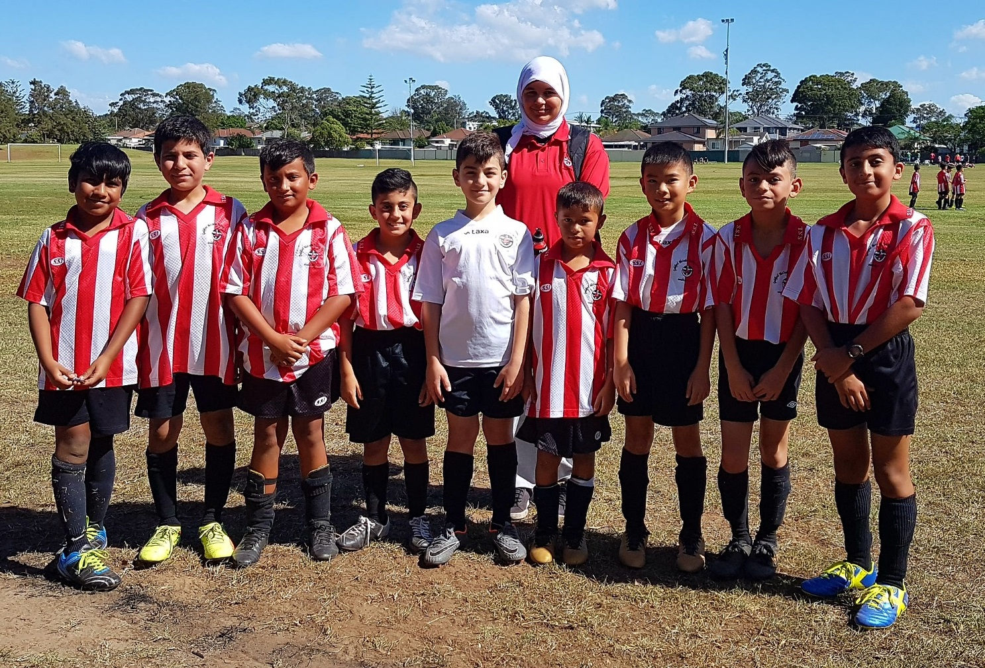

U11 Red vs Wentworthville Uniting Blue 1 – 1
No report

U12 Red vs Greystanes 6 – 1
Today’s game had attitude. Our boys played with excitement and positive attitude towards soccer as usual. That positive attitude always shines through especially today with a 6-1 win. We need to watch our offside and keep our fitness training up so we can play the whole game without being worn out. We play for a great club with a great attitude towards soccer. Good play today boys no matter what attitude our opponents have. Player of the match Seena Hazara
Goal scorers – Daniel Kvesic 2, Fouad Ayoub 1, Samir Abas 1, Joey Farah 1, Joshua Depares 1

U12 White vs Wentworthville Uniting 3 - 6
Disapointinting score but could have been worse if it weren’t for our goal keeper Ibrahim who had several great saves. Welcome to new player Alisena who scored in his debut game. We struggled in defence in the first half. Second half was better but then we lost the midfield to move the ball forward.
Good to see passing is getting better.
Goal scorers – Hassan Mirzaei 2, Alisena Karimi 1
U13 vs Pendle Hill Tigers 4 - 7
We started with the opening goal, strong and aggressive. Mohammed and Alex at the front were nicely liaising with eachother. Victor Matthew and Charbel were strong in defence from the back while woody Fraz and tony were able to protect the wings. Peter done a outstanding job connecting the team together from the centre along with salman which for both it was the first game. Armin in goal keeping was able to stop many goals almost breaking the opposition score to half. At the second half the team went back in more determined and we scored our 3 goals. We kept pushing hard but with no reserves, fatigue got the better of us in the end with 2 more late goals scored against us. Good game for the team but we know where to improve and no doubt will bounce back.
Goal scorers – Mohammed Matar 3, Alex Basha 1

U14 vs Regents Park 1 - 5
No report received

U15/1 vs Wentworthville Uniting 2 – 1
Today can be summarised by the saying "result football is sometimes better than attractive football". We had to battle the weather today more than the opponent as the wind sucked a lot of our energy. These are the kind of games that make you feel a little uneasy but relieved that the result went your way. Hamid finished a lovely penalty and Krish scored a great chip from 30 yards out. Strong games from Jackson who was solid in the back and Bilal (man of the match) who marked their best player out of the game.
Goal scorers - Hamid Azimi 1, Krish Shrestha 1

U15/3 vs Granville Waratah 2 – 1
Our first win for the season. We were 2-0 up till the last minute. Sajad scored from a Ali assist & Elias scored from a Aurelly assist, both goals in the 2nd half. We also had 1 goal disallowed for offside. We Hit the crossbar 3 times & post once, with numerous other shots going over the goals. James had another strong game, with the twins, Angus & Jude much improved. Ruben had a good game & saved a 1 on 1 certain goal which resulted in a Free kick our way. Victor was Man of the Match
Goal Scorers: Elias Matta 1, Sajjad Mousawi 1

U16 vs Merrylands SFC 2 - 2
We played poorly today. I don’t know if everyone was just a bit off or if we were disrupted beyond repair by two no shows and a player an hour late. The stupidity of getting sent off when leading by two goals certainly cannot be explained. We have a bit to learn about being part of a team.
Goal scorers – Joe Azzi 1, Salman Khan 1

Sydney Cup Reserves vs St George Rowing 5 - 1
Most players there ahead of time so we started the game more organised and reaped the rewards. We had the wind in the first half and made it count by being 4 - 1 up at half time. We held our shape well in the second half and managed to score against the wind to finish the game off comfortably despite a few injuries. Special mention to Mahdi who played well and scored on his debut game after signing up on Wednesday night.
Goal scorers: - Goran Gesovski 1, Mic Di Marti 1, Abdul Abdul Hamid 1, Ahmad Abdul Hamid1, Mahdi Karimi 1

Sydney Cup vs St George Rowing 1 - 2
Very disappointing result. We played an experienced team who were more skilful than us and who have played together for a number of years. We are a new team with most players not playing together before this game. The opposition are a top 4 side so we needed to be disciplined and the wind was a major factor. Against the wind we defended well, kept our shape and didn't panic. To go into the second half nil nil with both sides restricting the chances the other had meant we still had a good chance at coming away with the points. We talked about continued defensive discipline and playing to our strengths instead of making an individual contest which the opposition wanted during the break. We started the second half staying true to this and were rewarded with a beautiful through ball to Virinder which he finished well.
Then we lost our heads. We scored 1 goal with 30 minutes remaining against a quality side and we had the wind. We collectively but especially our midfield showed a level of naivety that bordered on being brain dead. To push that far up the field chasing a goal we didn't need was insane. The opposition were going to have to chase a goal and were playing against the wind. They were going to have to be more aggressive and push into our half which would create chances for our striker on their last man which is our strength and is what got us our goal in the first place. For our midfield to try and stand up beside him crowded the area and made them defending us so much easier for them. It restricted the space for Virinder on the few occasions he was subsequently given the ball which meant we had no goal scoring chances for the remainder of the match despite half our team being up there. And with our central midfield being completely out of position it mean the opposition were able to stroll through our centre with little to no resistance. It is only due to the efforts of our defenders and the heroics of Yousif in goals we weren't punished more. Yes we should make semis as we have a quality team but we wont get past the first semi guaranteed if we don't show a bit of positional awareness and play for the benefit of the team instead of chasing individual glory attempting to score a goal.
Goal scorer: Virinder Chaggar 1

Premier League vs Kings Old Boys 5 - 1
It's an easy game when the opposition plays the first half with 8 players however we ironically played better when they had 11 in the second half, still winning that half 2-1. It is awesome to get the 3 points and quite a comfortable way to do so.
Goal scorers - William Wark 1, Hassan Shukur 1, Malvyn Walton 1, Vadly Atmadja 1, Matthew Hunter 1

Premier League vs Kings Old Boys 1 - 2
This afternoon was heartbreaking. Playing the team that is the best structurally in the competition and super fit, we spent a lot of time defending and battling their numerous attacks. 25 minutes in, Tim hits a sweet half volley from 30 yards out which was unbelievable and we were 1-0. 10 minutes into the second half, we were reduced to 10 men but our defensive shape was still intact and weathering the constant pressure from Kings. Unfortunately they scored with 10 minutes to go and scored off a corner with the last kick of the game. Our defensive three should be commended for their numerous successful offside traps and Daz was again fantastic between the sticks.
Goal scorer - Tim Rosandi 1

Please remember that we are ALL volunteers.

Coaches and managers require your assistance.

Please assist them setting up and dismantling fields when required. It is clearly marked below what teams are required.

It is also of great assistance if you arrive on time for games.

Results Sunday 15th April 2018

U11 Girls vs Guildford County 1 - 3
Tough game today and the strong winds didn’t help. The team didn’t give up and Stella scored 1 goal in the final minutes against their 3 goals. Well done Stella. Players of the match Anika and Lucy kept the ball moving and played strong and aggressively through out the game. Millen, Taylor, Tamara and Marie Jo defended well. Huda stopped more goals being scored with the help of other defenders Alethia and Tamana. Our newest player Baneen was fast and played well too.
Goal scorers – Stella Fitzpatrick 1

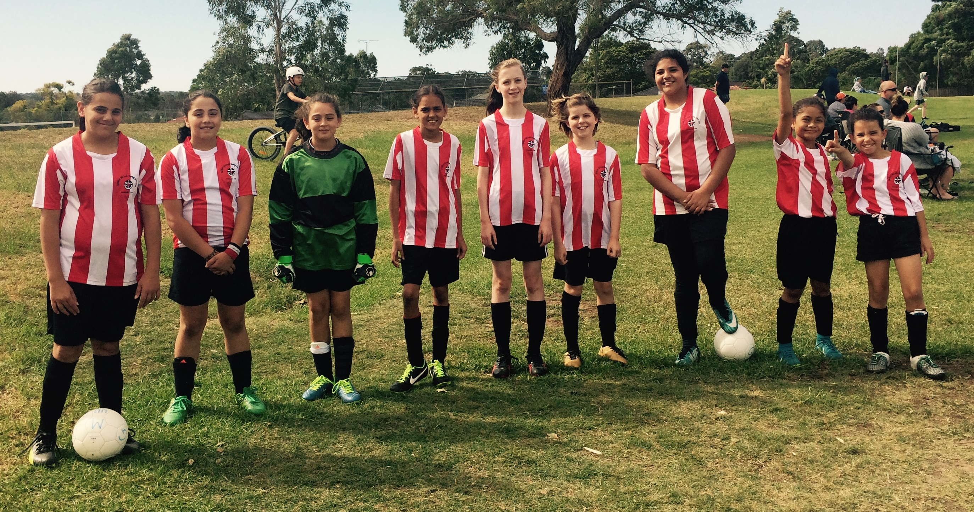

All Age Ladies vs Greystanes FC 4 - 1
We only scored one goal more than last week but we strung a lot more passes together, looked a different team with both our strikers playing, and continued the strong defence we showed last week in patches, for the full match. Mika played well up front creating problems for their defence every time she got the ball. Destiny worked hard and tackled well today. The players of the match were Jenna and Nyanut who were simply awesome. (I reckon we also strung the nicest passage of play together that we have ever done, to score our 4th goal.)
Goal scorers – Mika Oo 2, Laura Herbert 2
20th Anniversary Dinner

We are looking for interested people to assist in the organising of our 20th anniversary dinner in August.

Please send me an email or speak to me in person if you are interested.

Thanks,

Greg

Saturday 21st April 2018

U6 Red vs Lidcombe Churches at Everley (mini) (Everley Rd., South Granville) 9.00am Kickoff (meet at Everley at 8.30am) (set up field)

U6 White vs St Columbas Castle Hill Black at Eric Mobbs 2 (Excelsior Ave., Castle Hill)

8.30am kick off (meet at Eric Mobbs at 8.00am)

U7 Red vs Lidcombe Churches Blue at Phillips 1 (Martin St., Lidcombe)
9.00am Kickoff (meet at Phillips at 8.30am)

U7 White vs Kings Old Boys at Everley (mini) (Everley Rd., South Granville) 10.00am Kickoff (meet at Everley at 9.30am) (dismantle field)

U8 Red vs Western City FC at Everley 2 (Everley Rd., South Granville) 11.00am Kickoff (meet at Everley at 10.00am to set up field)

U8 White vs St Columbas Castle Hill Orange at Eric Mobbs 2 (Excelsior Ave., Castle Hill)

9.20am kick off (meet at Eric Mobbs at 8.50am)

U8 Onyx vs Wentworthville Uniting at Freame (Rees St., Mays Hill) 12.00pm Kickoff (meet at Freame at 11.30am)

U9 Red vs Bye

U9 White vs Wentworthville Uniting at Freame (Rees St., Mays Hill) 11.00am Kickoff (meet at Freame at 10.30am)

U10 Red vs Lidcombe Churches at Everley 2 (Everley Rd., South Granville)

12.00pm Kickoff (meet at Everley at 11.30am) (dismantle field)

U10 White vs St Columbas Castle Hill Black at Eric Mobbs 2 (Excelsior Ave., Castle Hill)

11.00am kick off (meet at Eric Mobbs at 10.30am)

U11 Red vs Western Sydney Youth at Tom Uren (Karani Ave., Guildford West)
12.00pm Kickoff (meet at Uren at 11.30am)

U12 Red vs Pendle Hill Tigers at Binalong 3 (Binalong Rd., Old Toongabbie)
10.00am Kickoff (meet at Binalong at 9.30am)

U12 White vs Ermington United at George Kendall 2 (Trumble St., Ermington)
8.30am Kickoff (meet at Kendall 8.00am)

U13 vs Auburn District at Progress 2 (Chisolm Rd., Auburn) 11.40am Kickoff (meet at Progress at 11.10am)

U14 vs Newington Gunners at Everley 1 (Everley Rd., South Granville) 8.30am Kickoff (meet at Everley at 7.45 to set up field)

U15/1 vs Pendle Hill Tigers at Everley 1 (Everley Rd., South Granville)
9.45am Kickoff (meet at Everley at 9.00am)

U15/3 vs Pendle Hill Tigers at Everley 1 (Everley Rd., South Granville)

12.35pm Kickoff (meet at Everley at 12.00pm)

U16 vs Wenty Waratah at Everley 1 (Everley Rd., South Granville)

11.10am Kickoff (meet at Everley at 10.30am)

Sydney Cup Reserves vs Bye

Sydney Cup Firsts vs St Columbas Castle Hill at Everley 1 (Everley Rd., South Granville) 3.00pm kick off (meet at Everley at 2.30pm) (dismantle field)

Premier League vs Ultimate Soccer at Fairfield High School (The Horsley Dve., Fairfield))
Reserves kick off at 1.00pm, firsts kick off at 3pm (meet at Fairfield at 12.30pm)

Sunday 22nd April 2018

U11 Girls vs Quakers Hill Tigers at Ted Burge 2 (Centenary Rd., South Wentworthville)
8.30am Kickoff (meet at Ted Burge at 8.00am)

All Age Ladies vs Wenty Waratah at Ted Burge 3 (Centenary Rd., South Wentworthville)
1.55pm Kickoff (meet at Ted Burge at 1.10pm)

If for any reason you or your child is unable to play
you must ring your team manager ASAP
(who will relay this information to the coach).

